ME 3200 Mechatronics Laboratory
Lab Exercise 4: Introduction to Handy Board

Introduction
The purpose of this lab is to give you experience with microcontrollers. Their small size, relatively inexpensive price, and ever increasing speed makes them ideal for control applications where a large computer is not necessary or the space is not available. They are now used in such areas as control of automobile engines, microwave ovens, robotics, and many other applications. The microcontroller we will use is the Handy Board. The information presented in this lab only introduces the Handy Board. More detailed information can be found at the Handy Board web site www.handyboard.com.

The Handy Board is a small experimental board developed by Fred Martin of the MIT Media Laboratories. The main features of the Handy Board are a Motorola 68HC11 microprocessor chip, four DC motor outputs, seven 8-bit analog inputs, nine digital inputs, and a 16x2 LCD screen, as well as other features. It is easily programmable using Interactive C (a C programming language) developed by Randy Sargent of MIT. A diagram of the Handy Board with labeled features is shown below in Figure 1.
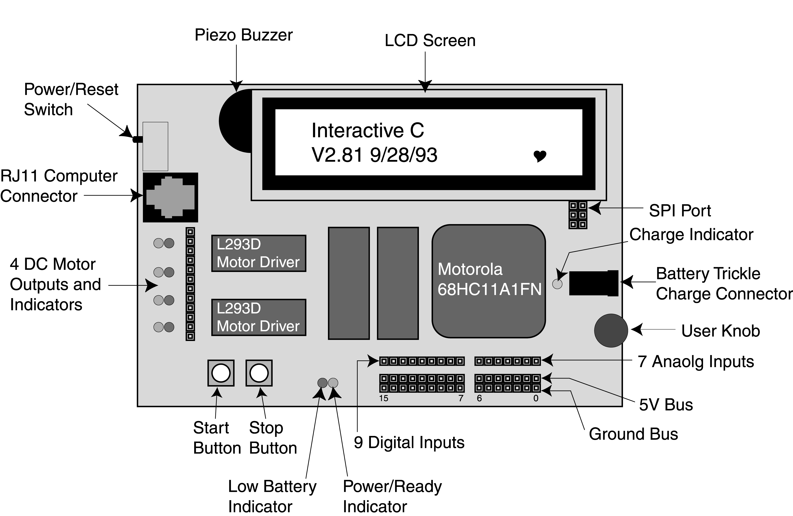
Figure 1. Handy Board labeled features.

Starting the Handy Board

Before starting the Handy Board, make sure the following are done:

The Handy Board is connected to the computer.

One end of the RJ11 modular cable (looks like a telephone cable) should be plugged into the computer connector port on the Handy Board (see Figure 1).
- The other end of the RJ11 modular cable should be plugged into the Serial Interface & Battery Charger Board, a separate small interface printed circuit board located at each computer workstation.
- From the Serial Interface Board, a serial cable should be connected to the serial port of the computer. If a connection cannot be made between the Handy Board and the computer, a loose connection here is a likely cause.
- Make sure that the computer is in MSDOS mode or that a DOS command window is opened. To put the computer into DOS mode, activate the Windows "Start" button and select Shutdown/ Restart in MSDOS mode. A DOS command window can be opened from the Windows START menu.
- Change to the c:\handy directory by typing cd c:\handy at the DOS prompt. All future work should be performed in this directory.
- Insert the plug-in transformer into a wall outlet. Insert the other end into the receptacle on the Handy Board battery trickle-charge connector (see Figure 1). This step will keep the batteries on the Handy Board charged while you are working on it, but is not necessary if the batteries are fully charged.

Loading the Operating System (PCODE)
Sometimes it is necessary to reload the operating system (pcode). To reload the pcode, do the following:
- Type dl pcode_hb.s19 at the C:\HANDY prompt and press <enter>.
- Turn the Handy Board off and turn it back on while you hold down the STOP button. This procedure places the Handy Board in download mode. It is critical that the Handy Board is in this mode to reload the operating system code.
- Follow the instructions on the computer screen.
- Once the download process is complete, restart the Handy Board. If everything is working well, the LCD screen should appear as in Figure 2 with the heart beating. If the download process is unsuccessful, then ask your TA for help.
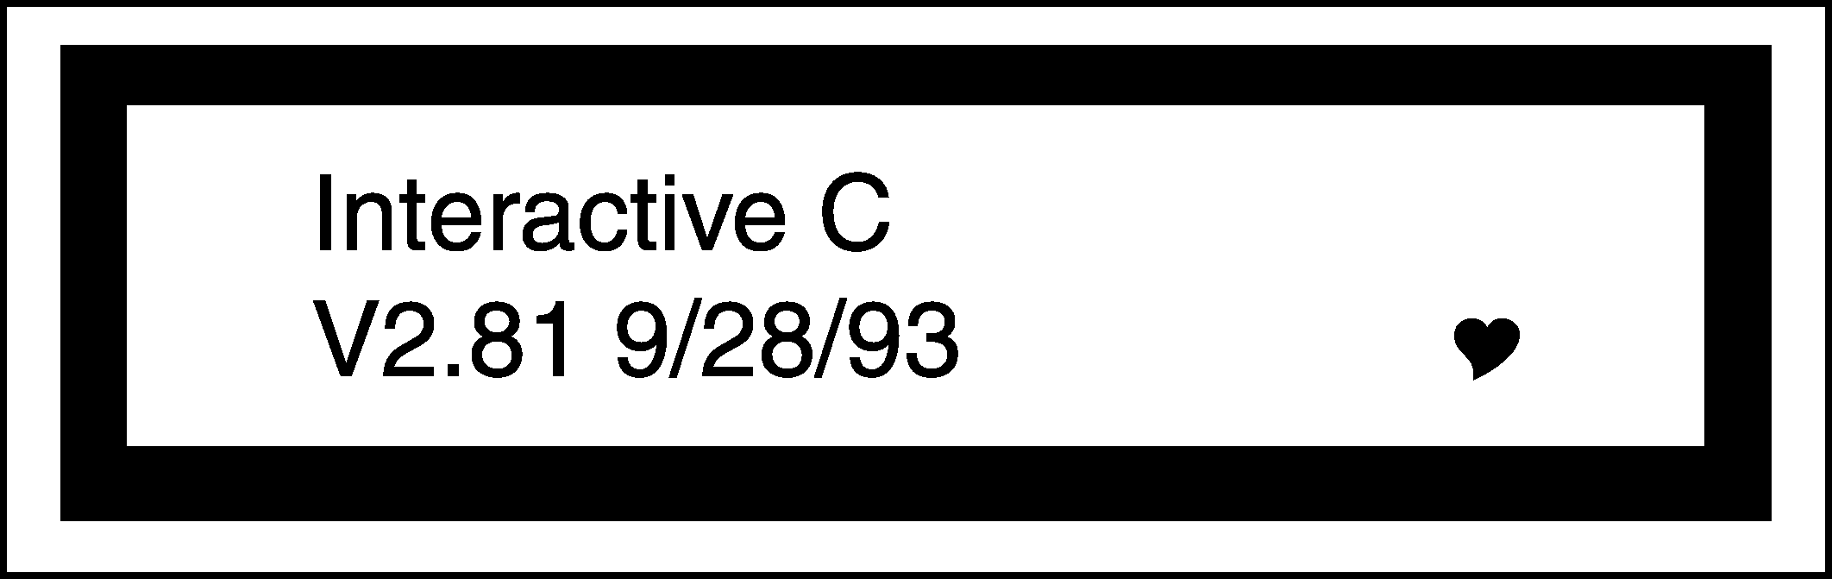
Figure 2. Healthy Handy Board LCD screen at startup.

Running the Handy Board directly from the PC (Interactive Mode)
The Handy board is now ready for interactive mode. Otherwise, to start the Handy Board in interactive mode, hold down the START button as you switch on the Handy Board. To interface the computer to the Handy Board, type ic<enter> at the DOS prompt. You will either see the board synchronizing with the computer, or some error. If the board properly synchronizes with the computer, you should see a C> prompt appear on the computer screen. You are now in the interactive mode for the Handy Board. The Handy Board is now ready to use. If the board does not synchronize with the computer, try again. If this does not work, get help from your TA.

Commands to the Handy Board can be sent directly to it from the host computer in Interactive Mode. For example, at the C> prompt, try typing:

printf("Hello World!\n"); <enter>

The screen on the Handy Board should read Hello World! The character \n at the end of the string signifies end-of-line. When an end-of-line character is printed, the LCD screen will be cleared when a subsequent character is printed.

Now type beep();<enter>. You should hear a short tone coming from the piezo buzzer (see Figure 1). Try typing tone(800.,5.);<enter>. You should hear a tone at 800 Hz for 5 seconds. Other commands are included at the end of this lab handout. Explore them later.

To quit the interactive mode, type one of the following: quit, bye, or exit <enter>.

Downloading Programs to the Handy Board
We are now ready to write a program to download to the Handy Board. From a text editor such as DOS edit or Windows Notepad, save a file named sample.c in the c:\handy directory. Type the following in your program:

void main(){
printf("You now know how to download\n");
}

Save your file, exit the editor, and start up interactive mode IC as in step 4 above.
At the C> prompt type load sample.c <enter>. When the load command is called, the C code written is compiled and loaded into the memory of the Handy Board. If the download was successful, you should not see any error messages. Now to start the program, reset the Handy Board by turning it off and then back on. The screen should read, “You now know how to download”. Each time the board is turned off and then back on, the program will be executed until it is replaced or the Handy Board is started in interactive mode or download mode.
Remark: The program can be named any name allowable by Dos (up to 8 characters with certain characters being restricted) but must have a .c DOS file extension. Multiple programs can be loaded (up to 32K) onto the Handy Board, but only one can have the function main(). It will be this program that is run on start up of the Handy Board. The other programs are callable either from the program containing the function main(), other functions, or from the interactive mode. This feature allows the Handy Board to perform multitasking, or run several subroutines simultaneously.

Handy Board Functions
There are many commands that can be used to control the Handy Board. You have seen three of them, printf, beep, and tone. These commands can be given directly in the interactive mode (as in step 3) or used as function calls in a C program (as in step 4) and downloaded to the Handy Board. We will be mainly writing programs and downloading them to the Handy Board.
A brief description of the more useful functions and how to use them are given below. For a more complete listing of the functions, see the Interactive C Manual available on the Handy Board web site.

printf(format-string, [arg-1], . . . , [arg-N])
Printing information to the screen can be a useful debugging tool. Suppose the value of parameter x is needed for testing the code. The printf command would be used as follows:
printf("Value is %d\n",x);.
The special form %d is used to format the printing of a floating-point number in decimal form. A listing of other formats is given below in Table 1.
Table 1. Number printing formats.
Format Command | Data Type | Description
%d | int | decimal number
%x | int | Hexadecimal number
%f | float | floating point number
%s | char | character array (string)

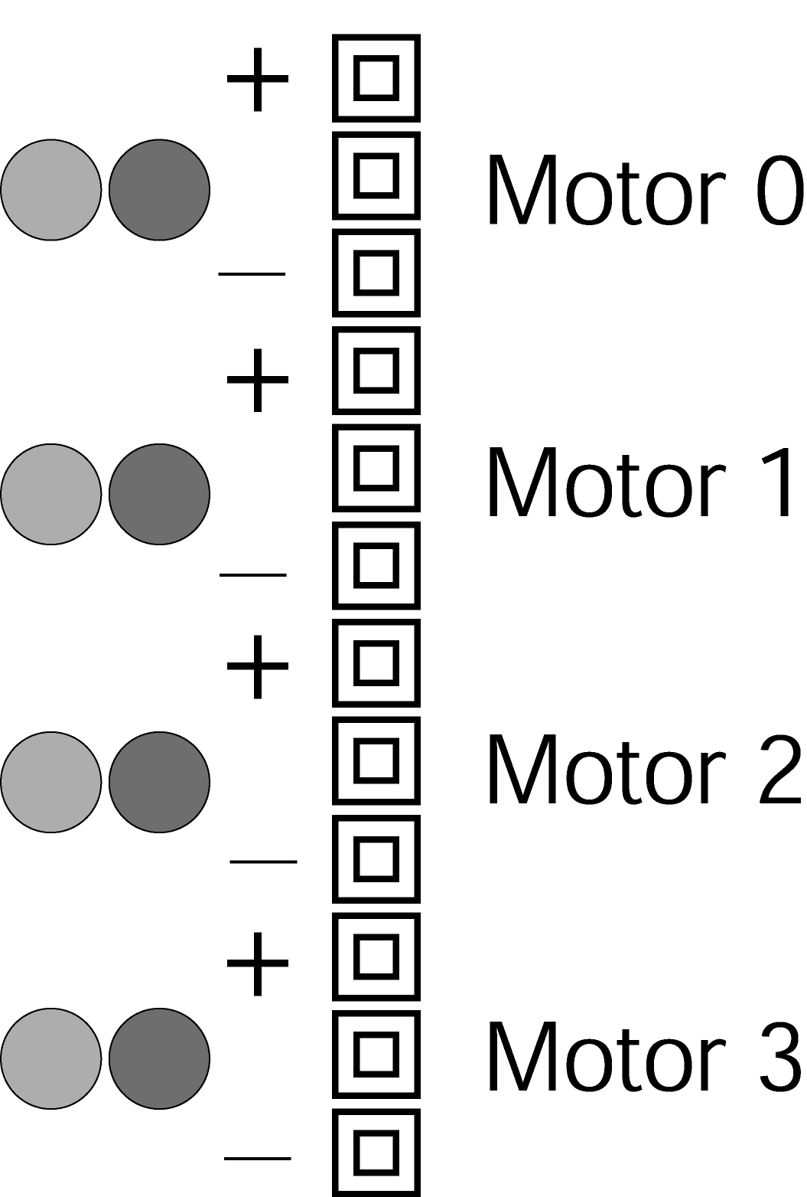
motor(int m, int p)
Turns on motor port m at power level p. There are four motor ports on the Handy Board, labeled Motor-0, Motor-1, Motor-2, Motor-3 (see Figures 1 and 3 for location). The power level ranges from 100 for full on forward to –100 for full power in reverse. Although the range of power levels goes from –100 to 100 in increments of 1, there are actually only 15 motor speeds (See Table 2 below).
The motor driver chips (L293D on the Handy Boards) are capable of putting out up to 9.6 volts and 600 mA. A higher current demand is required for loaded DC motors, and an additional motor driver circuit must be used. Refer to the class web site for additional information on external motor driver circuits.
Figure 3. Motor ports designation. Note that the middle slot for each motor is used just for spacing and does not carry any signal.
The motor drivers use pulse width modulation (PWM) to control the voltage output. This means that full voltage is switched on and off at high frequency for varying lengths of time. The effective voltage seen by a motor (which has a slow response time compared to the frequency of the PWM) is proportional to the average time spent in the high state (full voltage). Note that if you measure the output with an oscilloscope, you will see a high frequency signal.

Table 2. Motor output levels.
Power Level * | Forward Motor Speed  *A negative power level corresponds to the appropriate Motor Speed, but in reverse.
0-10 | off
11-24 | 1
25-38 | 2
39-52 | 3
53-66 | 4
67-80 | 5
81-94 | 6
95-100 | 7

alloff() or ao()
Turns off all motors.

off(int m)
Turns off motor m.

digital(int p)
An active low digital input bus that returns the value of the digital sensor in digital sensor port (7-15). If zero volts are applied to the port, it returns true (1). If over 2.5 volts are applied, the value returned is false (0).

analog(int p)
A function that reads the voltage level on the specified port (0-6) on the analog input bus, which is connected to an 8-bit analog-to-digital converter. The value returned is between 0 and 255. Zero applied voltage returns a value of 0, while a level of 5 volts returns a value 255.
Refer to Figure 1 for the location of the analog and digital ports. Note that these ports are the top of the three strips in that area, and are numbered from right to left. The bottom strip is ground, and the middle strip is a +5 supply voltage that can be used to power sensors. The top strip is for the sensor signal (this is the value that will be read by the analog and digital functions).
Another thing to note about the analog input ports is the internal pull-up resistor. There is a 10-kΩ resistor internal to the analog input bus. A potential of 5 volts is applied to one end of the resistor, while the other end of the resistor is connected to the analog input ports. When one lead of an analog sensor is inserted into analog input and the other into ground, a voltage divider is created. The voltage across the internal pull-up resistor is what gives the sensory reading.

knob()
A function that returns the position of the user knob (see Figure 1) as a value between 0 and 255. The knob is a potentiometer whose wiper is connected to an 8-bit analog-to-digital converter.

start_button()
Returns the value of the button labeled "Start" (see Figure 1). Returns 1 if pressed and 0 if released.

stop_button()
Returns the value of the button labeled "Stop" (see Figure 1). Returns 1 if pressed and 0 if released.
Example: (Note that the “!” means logical NOT.)
/* Wait until start button is pressed */
while(!start_button()){}

Other Functions and Additional Information
There are many other functions that might be useful in programming the Handy Board. A complete listing is given on the following page. For a complete description of these functions, see The Interactive C Manual for the Handy Board on the Handy Board web site. This reference contains a basic C programming tutorial for those who are not familiar with C programming. Further information about The Handy Board, ranging from schematics, modifications, new functions, and much more is available on the World Wide Web at www.handyboard.com.

===============================================================
List of Handy Board Functions
LCD Screen Printing
printf(format-string, [arg-1], . . . , [arg-N])
DC Motors
void fd(int m)
void bk(int m)
void off(int m)
void alloff()
void ao()
void motor(int m, int p)
Servo Motors
void servo_a7_init(n)
int servo_a7_pulse
void servo_a5_inti(n)
int servo_a5_pulse
Sensor Input
int digital(int p)
int analog(int p)
User Buttons and Knob
int stop_button()
int start_button()
void stop_press()
void start_press()
int knob()
Infrared Subsystem
int sony_init(1)
int sony_init(0)
int ir_data(int dummy)
Time Commands
void_reset_system_time()
long mseconds()
float seconds()
float sleep(float sec)
void msleep()
Tone Functions
void beep()
void tone(float frequency, float length)
void set_beeper_pitch(float frequency)
void beeper_on()
void beeper_off()
Multi-Tasking
start_process(function-call(. . .), [TICKS],[STACK-SIZE])
int kill_process(int pid)
Process Management
void hog_processor()
void defer()
Arithmetic
float sin(float angle)
float cos(float angle)
float tan(float angle)
float atan(float angle)
float sqrt(float num)
float log10(float num)
float log(float num)
float exp10(float num)
float exp(float num)
(float) a^(float) b
Memory Access
int peek(int loc)
int peekword(int loc)
void poke(int loc, int byte)
void pokeword(int loc, int word)
void bit_set(int loc, int mask)
void bit_clear(int loc, int mask)

Laboratory Exercises
Read through the microcontroller introduction handout in lab and learn how to use the Handy Board. You must demonstrate your code to the TA and answer any questions.
- Generate a tone that is dependent on knob position. Save this program in a file whose name is of your choosing. Remember to give it the proper DOS file extension .c.
- Measure knob position and display the output so you can determine the range of knob output. There is no need to type in the comments, but it is good practice to use them when writing your codes.

int x; /*ALL variables used must be declared */
void main() /* Defining the main program */
{ /* Spacing delimiters like this can help you navigate the loops. */
while(!start_button()) /* Wait for START to be pressed */
{
printf("Press START\n");
} /* Closes the while loop. */
while(stop_button()==0) /* Notice ! and ==0 are equivalent. */
{
x=knob(); /* define x as the value read on the knob. */
printf("knob is at %d\n", x);
} /* Closes the while loop. */
main(); /* Calls main again after the STOP button is pressed. */
} /* Closes main. This program will never reach this point. */

- Modify this code to include a conditional statement for two tones using the if-else conditional statement as in the following code. Make the greater knob value sound off with a higher frequency tone, and the lesser knob value sound off with a lower frequency tone. Remember that the arguments for tone are the frequency and the duration, both floats. All floats must have a decimal point placed within.

int x;
void main()
{
while(!start_button())
{
printf("Press START\n");
}
while(stop_button()==0)
{
x=knob();
printf("knob is at %d\n", x);
if(x<128)
{
tone(250.,.1);
}
else
{
tone(550.,.1);
}
}
main();
}

- It is possible to convert an integer variable to a floating-point variable. This is accomplished by simply placing the word (float) in front of the variable as follows:
int x;
float f;
void main()
{
while(!start_button())
{
printf("Press START\n");
}
while(stop_button()==0)
{
x=knob();
printf("knob is at %d\n", x);
f=(float)x+150.;
tone(f,f/1000.);
}
main();
}

- Modify to only run for 20 seconds by modifying the while (stop_button()==0) statement to include a Boolean AND statement:

while (stop_button()==0 && (int)mseconds()<20000)
Recall that mseconds() returns a long format number, which is a 32-bit int format number. A Boolean logical operator can only compare numbers of the same format. It is for this reason that the mseconds() result requires conversion.

- Measure the time to read a data value (knob), perform a calculation, output the value to the tone generator, and then display the delay time on the screen. Resetting the millisecond counter at the start of the program does this.

float x,y;
void main()
{
reset_system_time();
y=(float)knob();
x=y*250./3.5+200.;
tone(x,0.01);
printf("Delay time is %d msec\n",mseconds());
}
Take note of how much time it took to run these commands. Modify the above code to measure the time it takes to print to the screen by repeating the printf statement at the end so it says it twice. How much time is lost? What is the percentage of time it took to print?
- Write your own program to control the tone from the knob. This time, the 0 position on the knob will give a 600 Hz tone, while the 255 position on the knob will give a 200 Hz tone. If the knob value is less than 128 have the tone last 50 msec. If it is greater than or equal to 128, have the tone last 100 msec. Display the frequency of the tone and the system time. Have your program shut off after 30 seconds.

