In this laboratory exercise, you will use photosensors in conjunction with the Handy Board to detect the presence of infrared light. You will then program a CutieBot to chase a light around the room.
Background:

Photosensors come in a variety of types, but the one thing that they all have in common is that they are used to detect the presence of light. Some are used to detect visible light, some detect ultraviolet light, but our photosensors detect infrared light. Some terms that are interchangeable with photosensors are infrared or IR detectors or sensors, and light sensors. The type of photosensors used in the lab is infrared detecting phototransistors as depicted in Figure 1 below.

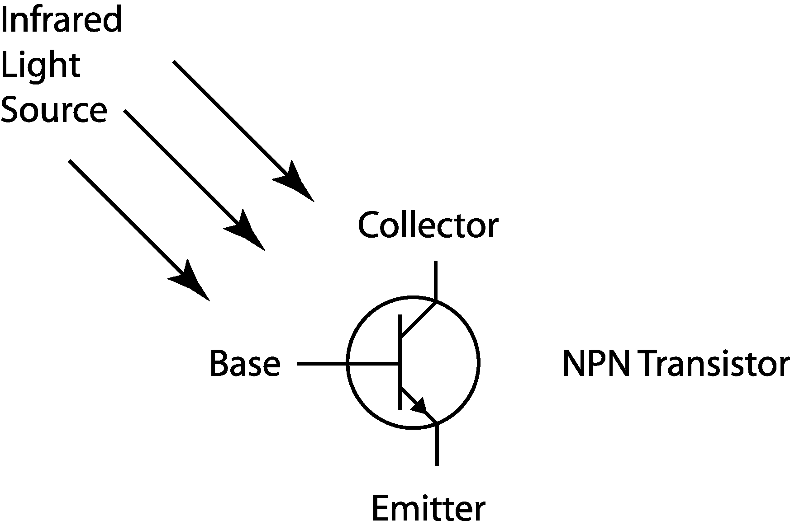
Figure 1. Schematic of an infrared detecting phototransistor.
As the base of the phototransistor is exposed to infrared light, it can be viewed as closing a switch between the collector and emitter. If a voltage difference is applied across the collector and emitter terminals, a current may be allowed to flow through them, depending on light level. The more infrared light exposure experienced by the IR detector, the more conductive the connection between collector and emitter, thus allowing more current through. Because of this phenomenon, the phototransistor can be viewed as an infrared dependent variable resistor. When there is no infrared light present, the resistance is relatively high. When the IR sensor is saturated with infrared light, the resistance should be much lower. This type of sensor is ideal for use in the Handy Board analog input ports. The data sheet for the IR sensors used in the lab is available on the class web page.
Laboratory Exercise:
Equipment needed: Handy Board, infrared light source, and photosensors.
- Interface the Handy Board to the computer and place it in interactive mode as you did in the Introduction to Microcontrollers experiment.
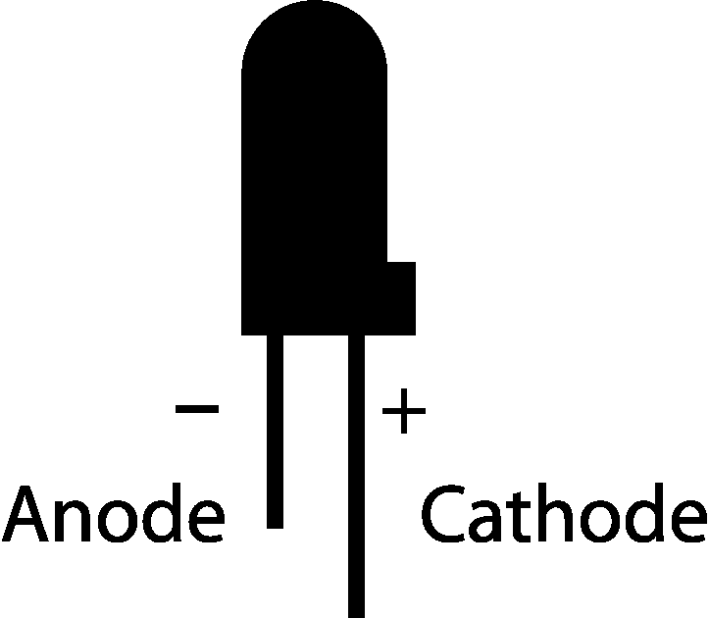
- Insert the cathode (collector) of an IR sensor into an analog input port, and insert the anode (emitter) of the sensor into the ground bus. Note which port is used for step 4 below. Refer to Figure 2 to help determine which lead is the anode and which is the cathode. It is wise to remember that the cathode lead is longer than the anode, and that the anode side of the sensor has a flat face.
Refer to Figure 3 to determine how the phototransistor is inserted into the Handy Board and to see how the anode and cathode are related to the collector and emitter.
Figure 2. An infrared detecting phototransistor.
- Once the sensor is in place, the internal voltage supply and pull-up resistor combine with the sensor to form a voltage divider to assist in measuring the sensory input. The analog voltage V_{A} created by the voltage divider is measured by the on-board analog-to-digital converter (ADC) so that the processor can handle the information. The Handy Board measures the infrared level as depicted in Figure 3 below.

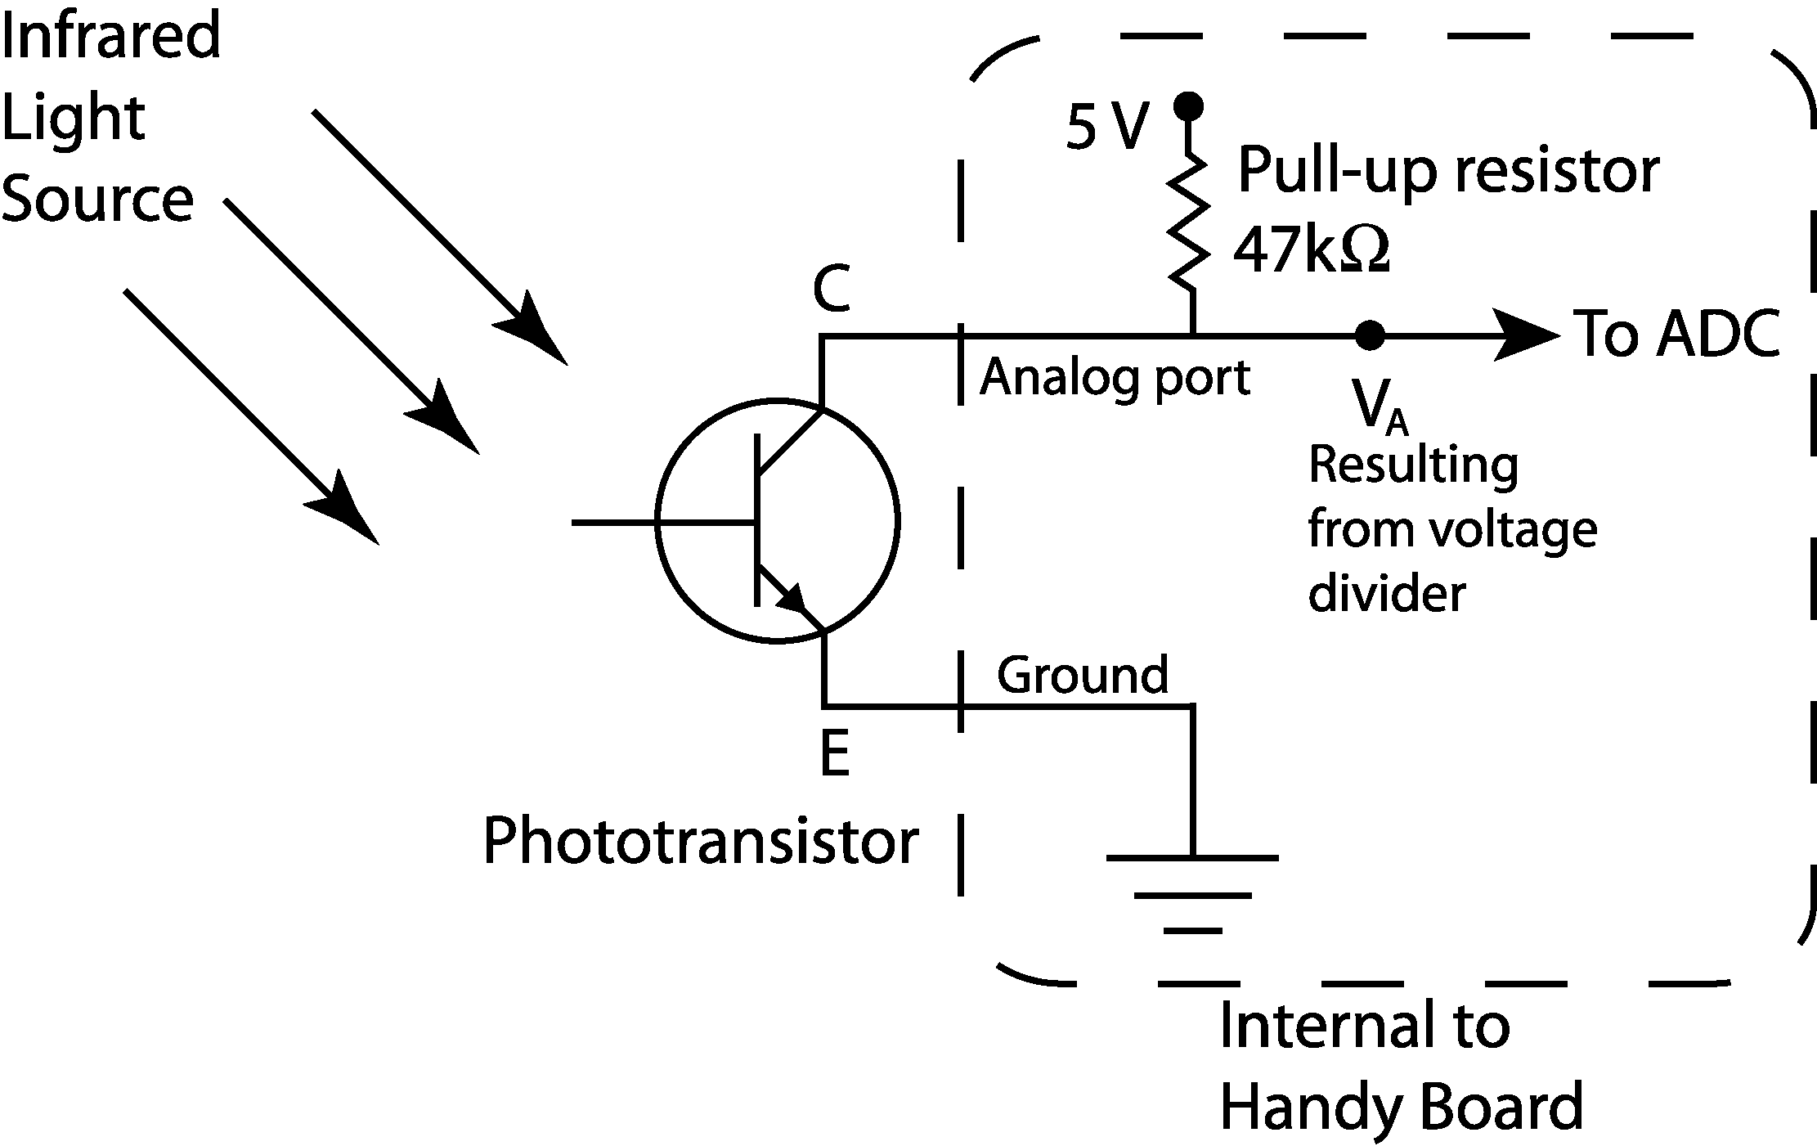

Figure 3. The photosensor and Handy Board combining to form a voltage divider.
- To read the ambient infrared light level, use the command analog(int p) where p is the port used. An integer will be returned that corresponds to the voltage drop across the internal pull-up resistor, which is proportional to the effective resistance of the light sensor. In other words, in the absence of infrared light, the effective resistance of the sensor will be relatively high returning a high integer; when the sensor is immersed in infrared light, the integer returned will be much lower. It may not be very intuitive, but the integer returned from the analog command is inversely proportional to the infrared level present. Recall that the analog-to-digital converter in the Handy Board is an 8-bit device. The integer returned will always be between 0 and 255.
- Turn on the flashlight at the workstation and try the analog(int p) command again. Notice the difference it makes in the integer returned. The florescent light in the ceiling produces very little infrared light, but the incandescent bulb in the flashlight produces quite a bit of infrared light.
- Write a program, based on the sample code in Figure 4, that averages an infrared level measurement. This program should contain a loop that takes the average of 10 readings and returns the result to the LCD screen. Load the program into the Handy Board and run it to make sure that it works.

int i, center; /* i is a counter, center holds value of center ir */

void main() {
printf("press start to read center ir");
while(start_button()) {} /* hold here until start is pressed */
while(1) { /* run in a continous loop */
center = 0; /* initialize center */
if(start_button()) { /* take readings if start is pushed */
for(i=0;i<10;i++) { /* loop for running 10 times */
center += analog(2); /* sums the value of the 10 runs */
}
center /= i; /* divide by i to take the average */
printf("c=%d\n", center, i); /* print the results */
}
}
}
Figure 4. Sample IR sensor code.
- Use a CutieBot to explore the IR detector characteristics. A CutieBot uses five IR sensors to detect the presence of light. These sensors are distributed in increments of 22.5° along the front of the CutieBot. The IR sensors from right to left are connected to analog ports 0 through 4 of the Handy Board.
Modify the program from step 6 to read and average the values in ports 1 and 2 and print them to the screen. Record the returned integers at 10 locations along the longitudinal axis of the sensor (0°), and at 22.5° using ports 2 and 1, respectively. The tiles on the floor of the lab are 1-foot squares. It is suggested that you put the robot down and move the flashlight measured in 1-foot increments. Turn the CutieBot 11.25° (eyeball it) and repeat the measurements for 11.25° and 33.75°. Use a plotting program such as MATLAB or EXCEL to generate a calibration curve that correlates the distance from the light source to the data measured by the Handy Board along each of these axes. Include these plots in your report. Compare your results to the information provided in the data sheet available on the class web page.
Table 1. IR Sensor data.
0°
11.25°
22.5°
33.75°
- Write and implement a program that will get a CutieBot to chase a flashlight. One idea is to average the values on the left side, average the values on the right side, and compare these with each other and the value in the center. Based on which region of sensors is experiencing the most light, have the motors favor that side. It is recommended that both motors run continuously. Just give one motor a higher signal level than the other side. In the case of the center sensor receiving the most light, give them the same. The left motor is controlled by motor port 1, and the right motor is controlled by motor port 2.
Questions
- Comment on variability of a single light sensor reading. How is an average of multiple readings at one point useful?

- Over what range of distances and angles can the IR sensors be used for predicting distance? How do these compare with the information on the data sheet?

- In step 7, you plotted the data that you recorded. What is the approximate relationship you observed (i.e., linear, inverse square, etc.)?

- Why does the Handy Board return a small value with high light levels and a high value with minimal light?

- Explain the strategy that you found most successful for making the CutieBot follow a light source.

