ME 3200 Mechatronics Laboratory
Lab Exercise 7: Operational Amplifiers

In this experiment you will explore some basic properties of operational amplifiers, better known as op-amps. These electronic devices are very useful in analog circuitry. As their name implies, they can perform mathematical operations on voltage signals, including algebraic and calculus operations.

PRE-LAB EXERCISES

Determine the output voltage V_{o} of the op-amp in Figure 1 as a function of the input voltage V_{i}, the resistance R, and the capacitance C. The methods developed in the following background section will provide you with the tools needed to perform this task. (Recall that the current through a capacitor is proportional to the time derivative of the voltage across it.)
Figure 1. Differentiator circuit.
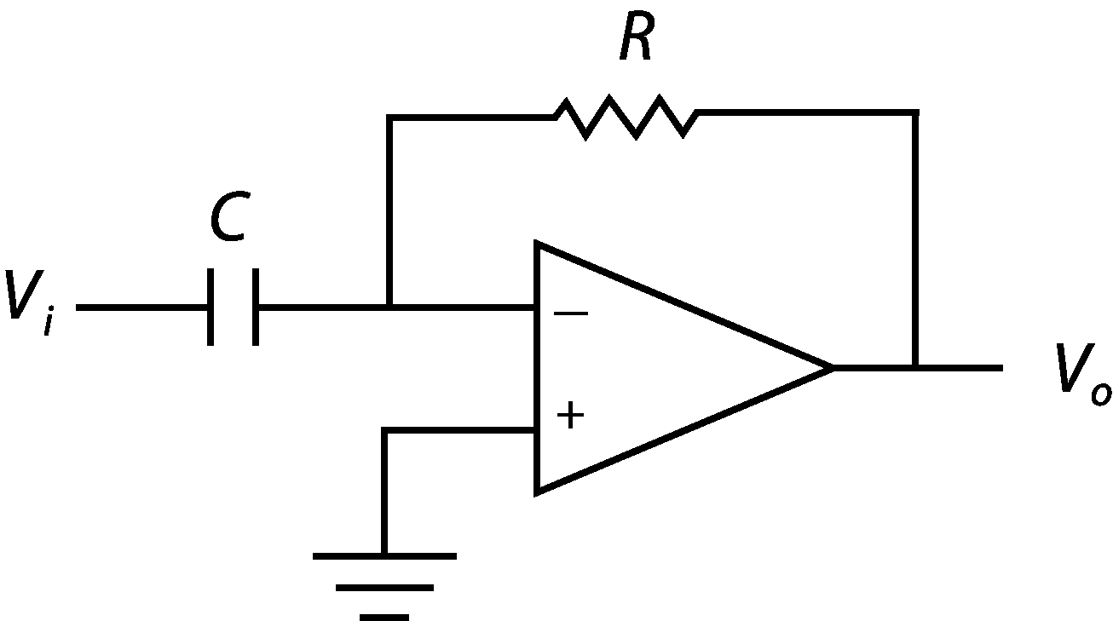
- Calculate the ideal output voltage V_{o} if the input voltage is equal to the following:
(1)
where A is the amplitude of the incoming signal in volts, ω is the frequency of the incoming signal in rad/sec, and t is time in seconds.
Background
An op-amp is a device with two inputs and one output. The two inputs are known as the non-inverting input v⁺ and the inverting input v⁻. The op-amp requires an external power source denoted V_{cc}, which for the op-amps used in the lab the bench power supply will provide your op-amps with ±V_{cc} = ±12 V. Note that the saturation voltage of an op-amp is lower than its V_{cc} (i.e. the op-amps used in the lab will not output more than 12 V or less than –12 V). Indeed, the absolute value of the saturation voltage for these devices is more like 10 V. It is common to drop the power connection from op-amp diagrams. A simplified schematic of an ideal op-amp is provided in Figure 2 below.

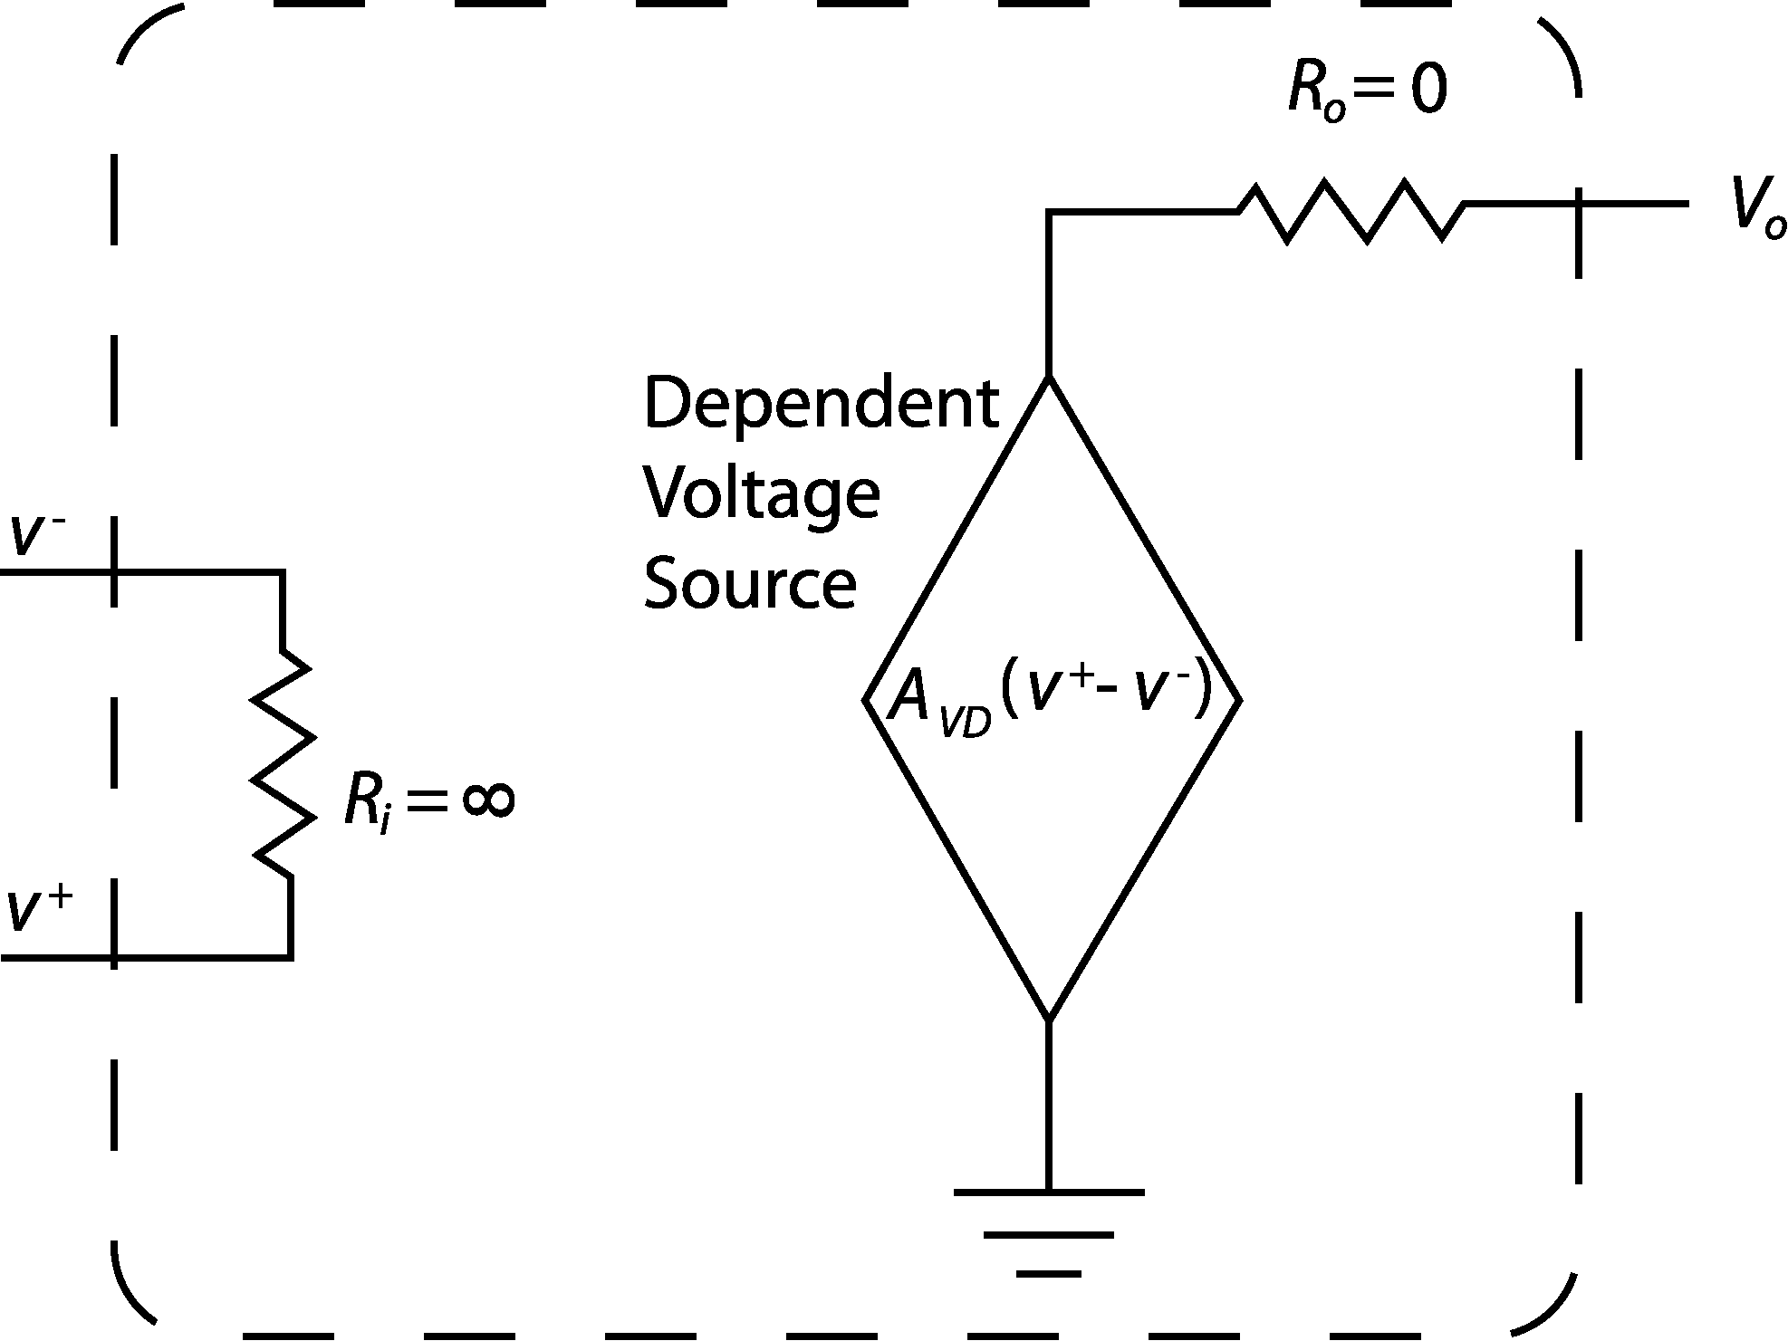

Figure 2. Simplified ideal op-amp schematic.

The basic features of an ideal op-amp can be seen. An infinite resistor connects the input voltages v⁺ and v⁻, causing zero current to go between the input leads, thus forcing them to be at the same voltage level according to Ohm’s law. The output lead is connected to a dependent voltage source. The voltage source depends on the difference of voltage between the input leads multiplied by the open-loop gain A_{VD}. The ideal op-amp has an infinite open-loop gain. The dependent voltage supply is connected to the output lead through a resistor of zero value, thus causing the output voltage V_{o} to be equal to the dependent voltage source according to the following equation:
(2)
In reality, infinitely large and small resistors are nonexistent. The input resistance R_{i} of the typical op-amp is on the order of 100 MΩ, which still allows very little current to pass through the input leads. The output resistance R_{o} of the typical op-amp is on the order of 10 Ω so that equation 2 is still an adequate approximation for the non-ideal op-amp, also making it possible for the device to provide substantial current. The open-loop low frequency gain A_{VD} of a typical op-amp is usually about 10⁵.

Example 1
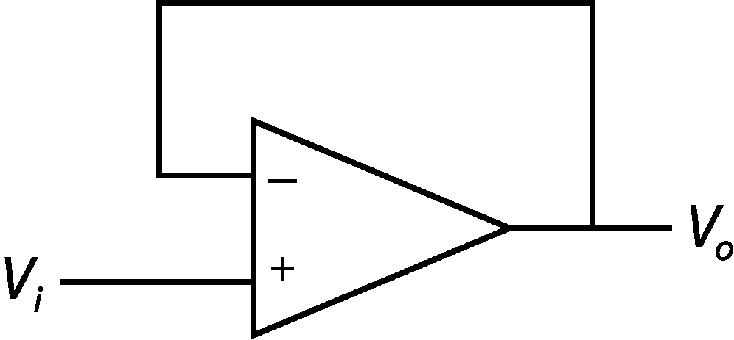
Determine the output voltage V_{o} of the op-amp in Figure 3 as a function of the input voltage V_{i}, given that the open-loop gain A_{VD} = 10⁵.

Figure 3. A voltage follower circuit.
The first step is to identify the voltage values at the input leads. The inverting input is tied to the output, and the non-inverting input is tied to the input voltage.

$v^{−}=V_{o}$ (3)
$v^{+}=V_{i}$ (4)
The next step is to substitute these values and the given value for the open-loop gain into Equation (2):
$V_{o}=\text{10},\text{000}\left(V_{i}−V_{o}\right)$ (5)
After some algebra, this becomes
$\begin{aligned}V_{o}=\frac{\text{10},\text{000}}{\text{10},\text{001}}V_{i} \\ V_{i}\end{aligned}$ (6)

The op-amp in Example 1 is known as a voltage follower because the output voltage is essentially equal to the input voltage. This circuit is also known as a buffer. The American Heritage Dictionary [www.dictionary.com] defines a buffer as “Something that lessens or absorbs the shock of an impact.” Remembering the rules set forth above, it becomes apparent that this is indeed what this circuit does. Recall that there is no current between the input leads. Since the input voltage is applied to the non-inverting input, any current coming from that input is blocked from the output. The output is tied to the inverting input, and since there is no current between the input leads, there is no current in the wire connecting the output to the inverting input (this connection is known as the feedback path). Any current that is required for the device connected to the output of the buffer will be provided from the op-amp itself. This effectively separates the input device from the output device as far as current is concerned, but still provides an output voltage that is essentially identical to the input voltage.
Example 1 also reveals that the typical op-amp can be treated as an “ideal” op-amp. This simplifies calculations when analyzing an op-amp circuit. The simplified equations are as follows:
(7)
(8)
where i_{i} is the current between the input leads. This is equivalent to stating that the current flow into each input is zero:
(9)
Once these simplifications are made, the op-amp circuit can be analyzed using Kirchoff’s current law (KCL) as follows:
$\sum{i_{n}}=0$ (10)
where i_{n} are the individual currents entering a node. Note that currents entering a node are positive and currents leaving a node are negative.
Example 2
Determine the output voltage V_{o} as a function of V_{i} for the op-amp in Figure 4.

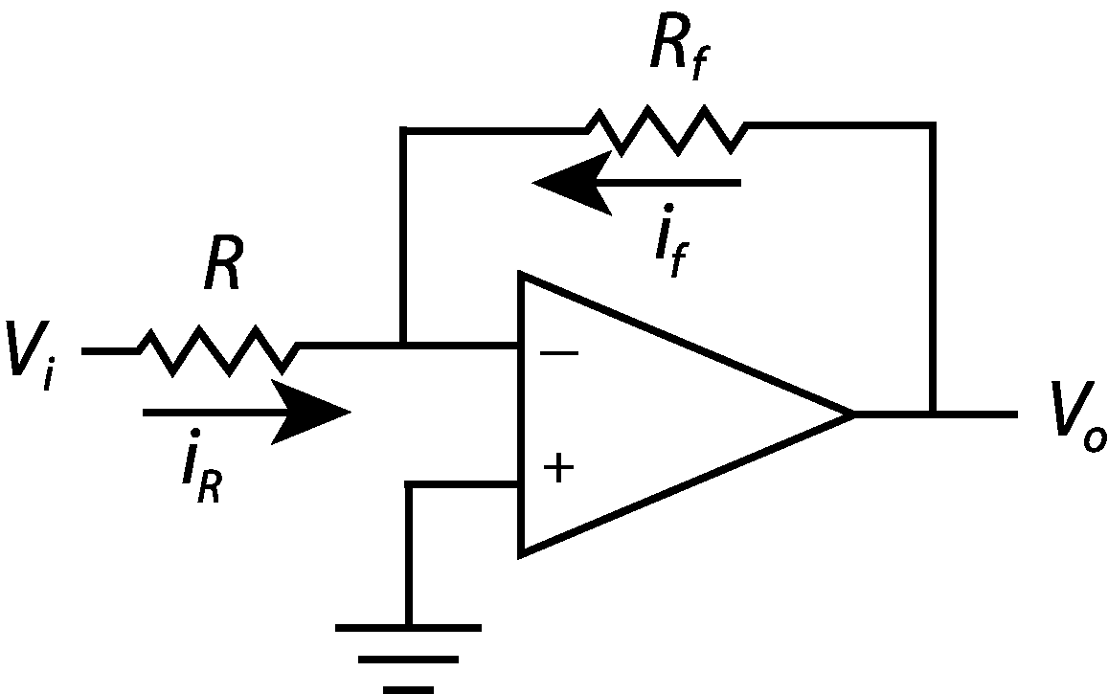
Figure 4. An inverting amplifier circuit.
Since the non-inverting input is connected to ground, v⁺ = 0. Equation (7) states that v⁻ = 0 as well. This is known as virtual ground. The directions of the currents assume that the currents run toward ground. Applying Ohm’s law results in the following equations:

$i_{R}=\frac{V_{i}}{R}$ (11)
$i_{f}=\frac{V_{o}}{R_{f}}$ (12)
Keeping in mind that the current from the inverting terminal i⁻ = 0 from Equation (4), KCL can be applied.
$i_{R}+i_{f}=0$ (13)
Substituting these currents yields
$\frac{V_{i}}{R}+\frac{V_{o}}{R_{f}}=0$ (14)
Finally, solving for V_{o} yields
$V_{o}=−\frac{R_{f}}{R}V_{i}$ (15)
The mathematical operation performed by the op-amp in this configuration is multiplication or amplification. Notice that the sign of the output is opposite the sign of the input. This is why it is called an inverting amplifier.
A simple modification can be made to the inverting amplifier to cause it to filter out high frequency noise. No electronic component is free of noise. Noise is sporadic variations in the voltage signal, commonly caused by external voltage or magnetic sources or from natural impurities in the devices or components. The low pass filter can effectively exclude input frequencies higher than a chosen amount. Simply connecting a capacitor in parallel with the feedback resistor as in Figure 5 creates the active low-pass filter.
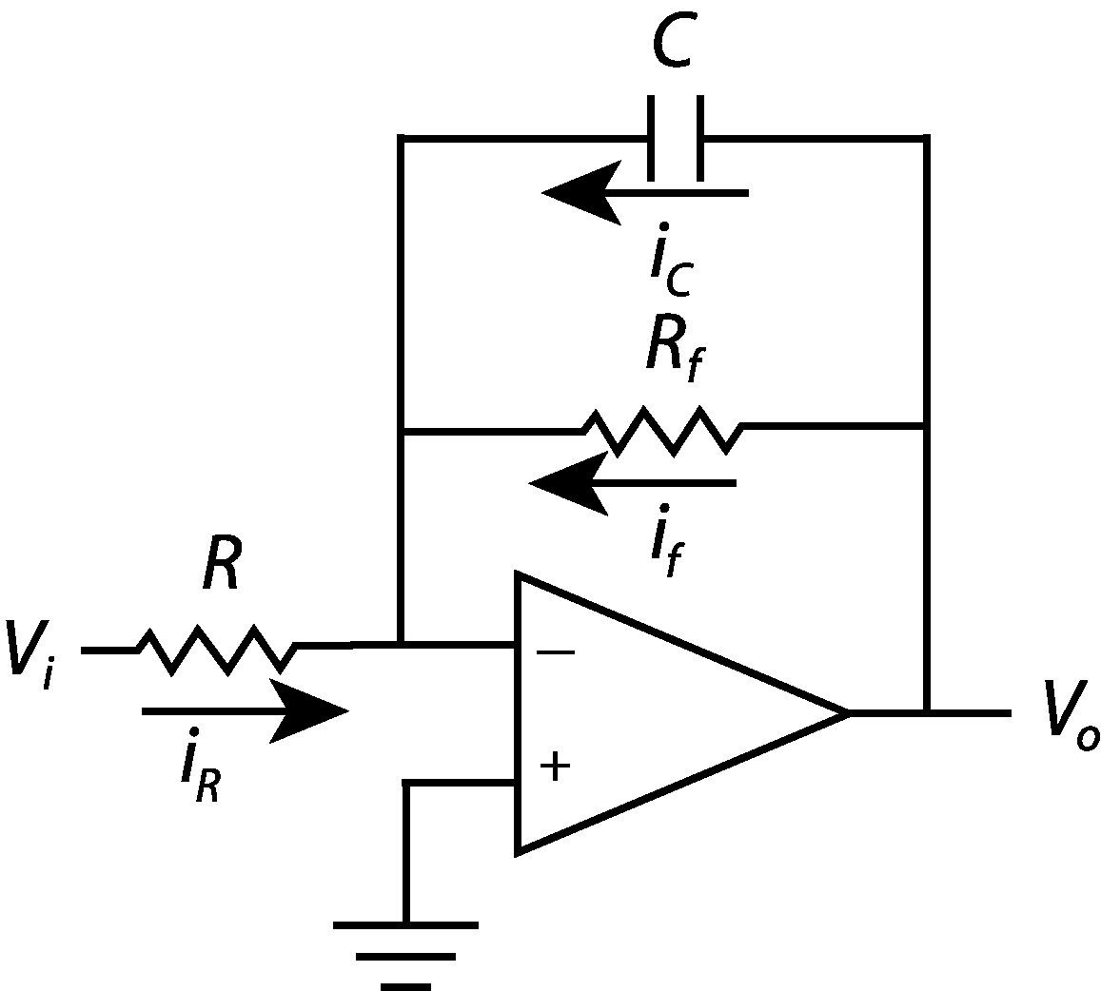
Figure 5. An active low pass filter.
This circuit does two jobs. Firstly, it amplifies the input voltage according to Equation (15) (which is valid for low frequencies), and secondly, it suppresses frequencies higher than its cutoff frequency, which is given in Equation (16) below:
$ω_{0}=\frac{1}{R_{f}C}$ (16)
where ω₀ is the cutoff frequency in rad/sec. To be exact, the output amplitude as a function of input frequency for this circuit is described by:
(17)

Figure 6 below gives a visual representation of the frequency response of an active low pass filter. The x-axis is the normalized frequency, and the y-axis is the absolute value of the system gain with the resistors chosen to give unity gain.
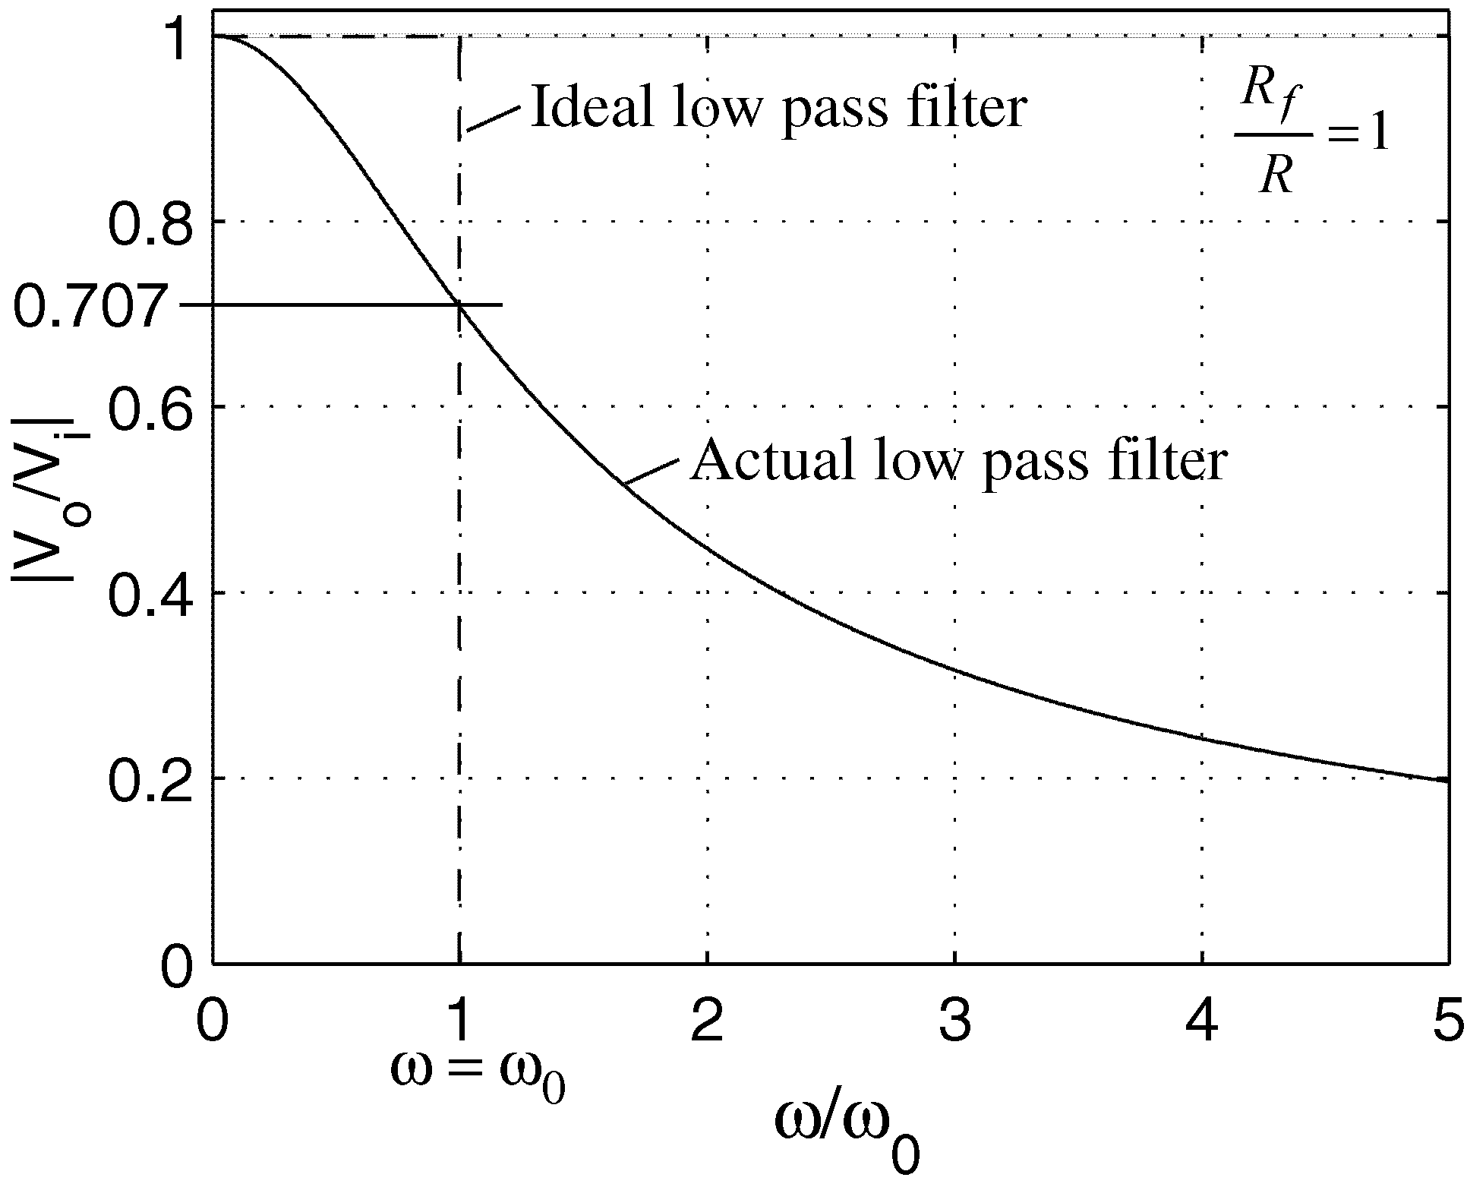
Figure 6. Low pass filter frequency response.
As indicated by Figure 6, at ω = 0 (DC voltage input), the output voltage is
(18)
As input frequency increases, amplitude decreases. At the cutoff frequency, ω = ω₀,
. (19)
Thus, in order to decrease the impact of the low pass filter on output amplitude, we set the cut-off frequency as high as possible. The trade-off of using a high cutoff frequency is that more noise is permitted to pass the filter. Thus, as a rule of thumb, set the cutoff frequency to at least twice the maximum expected input frequency and at less than one tenth of the expected noise frequency. A dominant source of noise in the lab is AC line noise at 60Hz. More sophisticated high order filters can be used to allow certain bands to pass or to create a more ideal filter.
Op-amps are readily available as inexpensive integrated circuits (ICs). The op-amp IC we have in the Mechtronics lab is the LM324 quad. This is a 14-pin DIP chip with four op-amps on it. When plugged into an electrical breadboard, each of the circuits can be built with one chip. A schematic of the LM324 is included in Figure 7. This type of schematic is known as a pinout. The data sheet for the LM324 is available on the class web page.
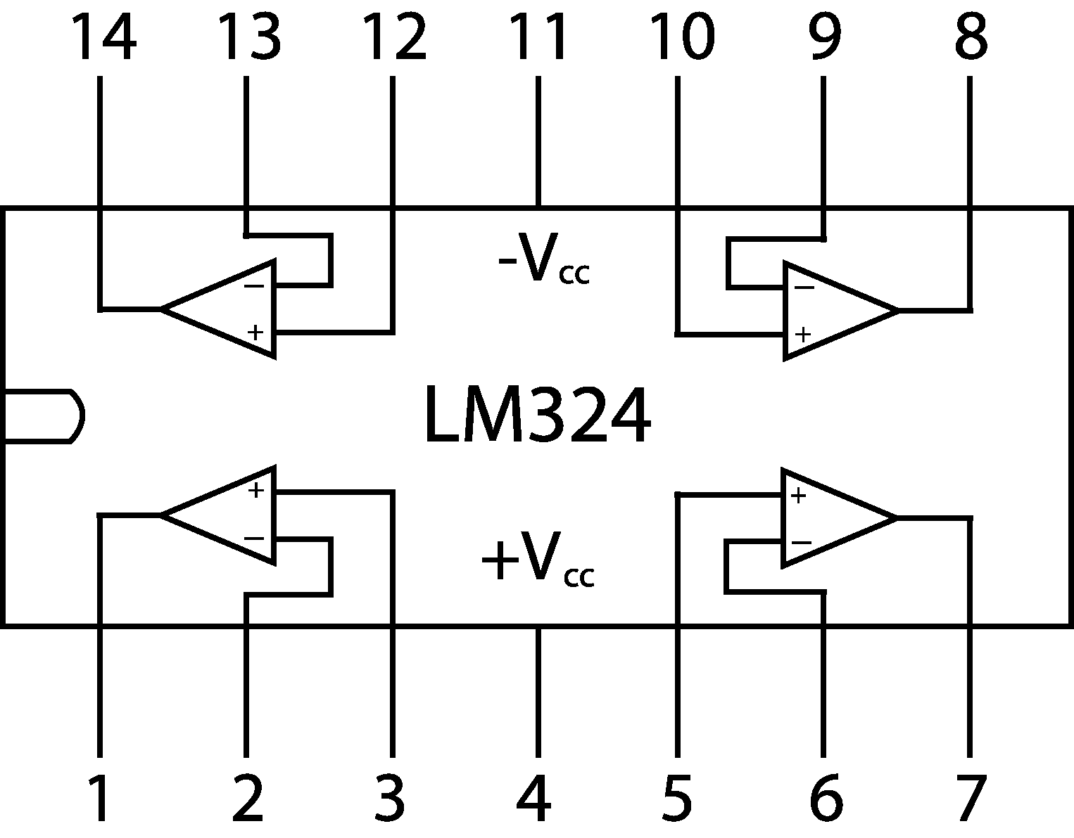
Figure 7. Schematic of the LM324 quad op-amp.
Aside from the applications discussed in this handout, the op-amp has many other uses in analog electronics. You are encouraged to further explore the abilities of this useful device.
Laboratory Exercise
- Locate an electronic breadboard and an LM324 quad op-amp IC. Press the chip into the breadboard straddling the center divider taking care not to bend any of the pins. Power the chip by connecting the bench power supply –12 volts to the –V_{cc} pin and +12 volts to the +V_{cc} pin. Do not turn on the bench power supply until your circuit is complete. In addition, whenever any changes are made on your circuits turn off or unplug the power supply from the circuit. This protects the circuitry and eliminates potential headaches from burned out op-amps.
- Turn on the function generator and oscilloscope. Connect the function generator output to the oscilloscope to verify that you have a 2 Hz, ±2-volt (4-volt peak-to-peak) sine wave.
- Design a low-pass filter and differentiator circuit that will differentiate the sine wave and amplify it to a ±4.5-volt (9-volt peak-to-volt) sinusoid. Refer to the pre-lab and the information provided on the active low pass filter to help with the necessary methods. The completed circuit should conceptually look like Figure 8 below.
(Hints: Design the filter first. Choose a reasonable output voltage from the filter, recalling that there are saturation limits. Choose a value for C_{f}. Choose ω₀ using the rule of thumb, recalling that the input frequency is in Hertz, but the output frequency must be in rad/sec. Design the differentiator next by choosing C. Following these hints and recalling the prescribed input and output voltage amplitudes, the resistance values should be defined by the equations.)
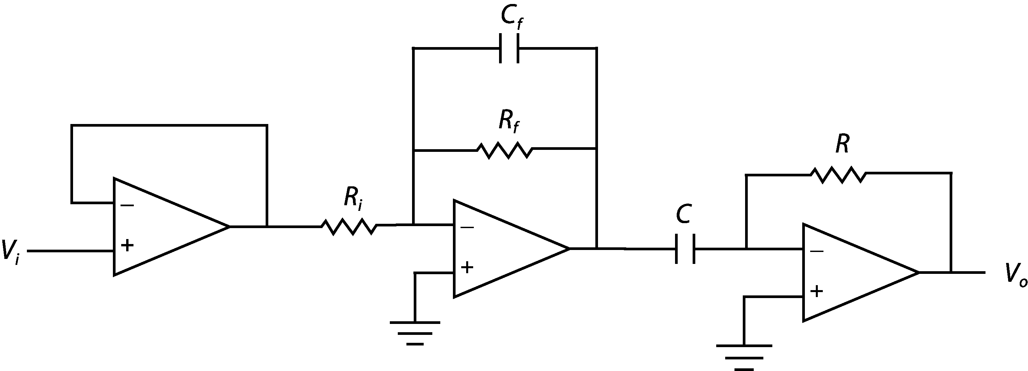
Figure 8. Buffer-filter-amplifier-differentiator circuit.
- Build the circuit you just designed. Refer to Figures 7 and 8 to help with wiring the circuit and to help pay attention to the pin out. Use the ground from the bench power supply for the appropriate non-inverting inputs. You will use the bench ground as your common ground. All equipment and circuits should be connected to that one ground point (i.e., AI_GND and the function generator output).
- Send the output of your circuit to AI_CH0 on the DAQ terminal block. Send the output of the function generator to AI_CH1 and to the input of your circuit.
- Start CVI and find “C\CVI\PROGRAMS\LABS\OP_AMP”. Open and run the project. Turn on the bench power supply, choose the appropriate number of samples and sampling rate, and push the START button on the screen.
- There should be two waveforms captured by CVI. One is the output signal from your circuit; the other is the input signal from the function generator. Save the data to disk. The data file contains three columns. The first column is time in seconds, the second is the output signal in volts, and the third is the input signal in volts. Use a data-plotting program such as MATLAB or EXCEL to plot the data. Notice the appearance of the data. What are the wave amplitudes and what is the phase difference?

- Increase the frequency of the input signal to 5Hz, choose the appropriate number of samples and sampling rate, and push the START button on the screen. Save the data to disk and plot the data. How has the appearance of the waves changed? What are the wave amplitudes and what is the phase difference? Why have the peaks been cut off of the sinusoids? (Hint: think back to the Data Collection experiment.)
- Increase the frequency of the input signal to 100Hz, choose the appropriate number of samples and sampling rate, and push the START button on the screen. Save the data to disk and plot the data. How has the appearance of the waves changed? Explain why the appearance of the output wave is changing.

