In this exercise you will explore the use of the potentiometer and the tachometer as angular position and velocity sensors. In addition, you will have the opportunity to implement the skills gained in the experiment on operational amplifiers.

Potentiometers

In previous exercises you have used the bench potentiometer to create a controllable voltage supply. In this experiment, you will use a servo potentiometer to measure angular position of a DC motor. In either case the principle is the same: the potentiometer is used as a voltage divider that produces an output voltage linearly dependent on angular position (note that audio pots are logarithmic). Since the potentiometer mounted on the motor setup is a servo (continuous) potentiometer, its shaft can be rotated indefinitely, but there is a small “dead-zone” of about 5-10 degrees that will produce no output voltage. The bench potentiometer, in contrast, is a single-turn pot (which is a misnomer since it achieves much less than a full rotation) with physical stops at the extreme positions. Ultimately, for a servo-pot with a 5 degree dead-zone and 5 volts applied across the pot, we find voltage relationship similar to:

For the above relationship for V_{out} to be true, we must prevent current from flowing through the wiper. To assure this, the wiper signal must first be buffered, as shown in Figure 1. We do not need to buffer the signal connected to the data acquisition board since the board has a very high input resistance. Since pots often use wire windings, the wiper produces electrical noise as it travels across the winding, and hence it is especially important to use a low pass filter when differentiating the signal from a pot. The filter is placed after the buffer. The filtered signal can then be differentiated to determine angular velocity. A diagram of this circuit is shown in Figure 1. The most important thing to avoid when using a pot in this fashion is the possibility of connecting the 5 volt supply or Ground to the wiper, which will burn out the pot when the wiper approaches the Grounded or 5 volt supply terminals, respectively.

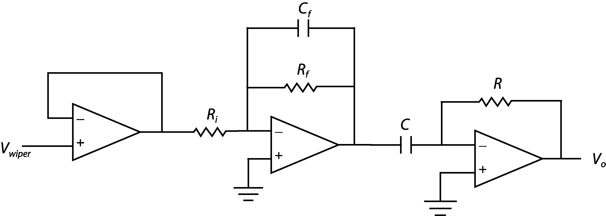
Figure 1. Buffer amplifier filter differentiator circuit.

Tachometers
A tachometer is essentially a generator; a DC motor run in reverse. The DC motor, or tachometer, consists of multiple loops of copper wire that can rotate through a magnetic field, typically provided by a fixed permanent magnet. These loops of wire are connected via brushes and a commutator ring to the external electrical leads. In the case of a generator, when the loops rotate through the field a nominal voltage is produced and can be measured at the electrical leads. The faster the generator rotates, the greater the voltage. Assuming that the electrical leads are connected to a device with high input resistance (such as an op-amp circuit or a measurement device such as a voltmeter or DAQ) this produces a linear relationship:
where k_{B} is the back-emf constant. Weaknesses of the tachometer include noise produced by the internal brushes, voltage fluctuations caused by the individual loops of wire moving through the field, and small output voltages at low speeds. Hence, it is wise to buffer, amplify, and filter the signal from a tachometer rotating at low speeds, as shown in Figure 2. Note that the last op-amp in this circuit inverts the inverted signal from the filter and uses equal resistors to provide unity gain.
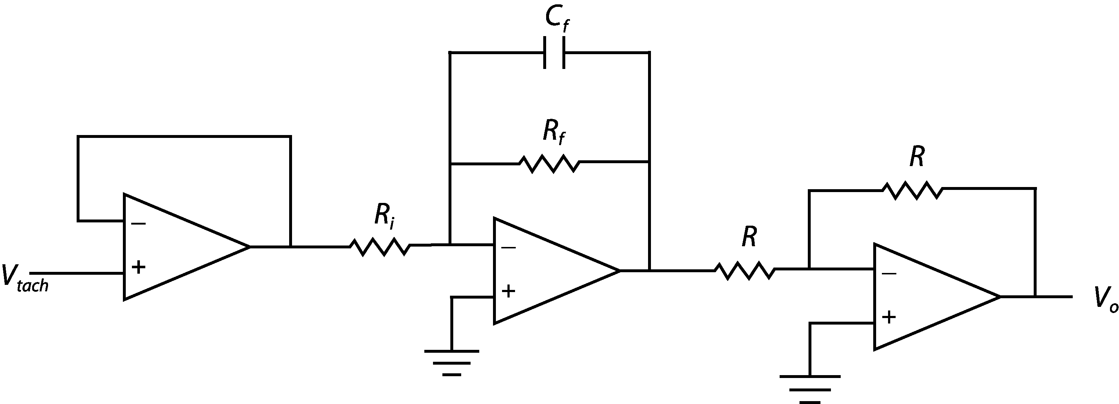
Figure 2. Buffer amplifier filter inverter circuit.

Measuring Phase
In this lab, you will be required to measure the phase between two different voltage signals. Given two signals with the same frequency, you can calculate the phase between them based upon the time between the peaks of the signals and the period, T, of the signals. An example calculation, refering to Figure 3, for phase φ based upon the peak time of the first signal, t_{p1}, and the second signal t_{p2} is:

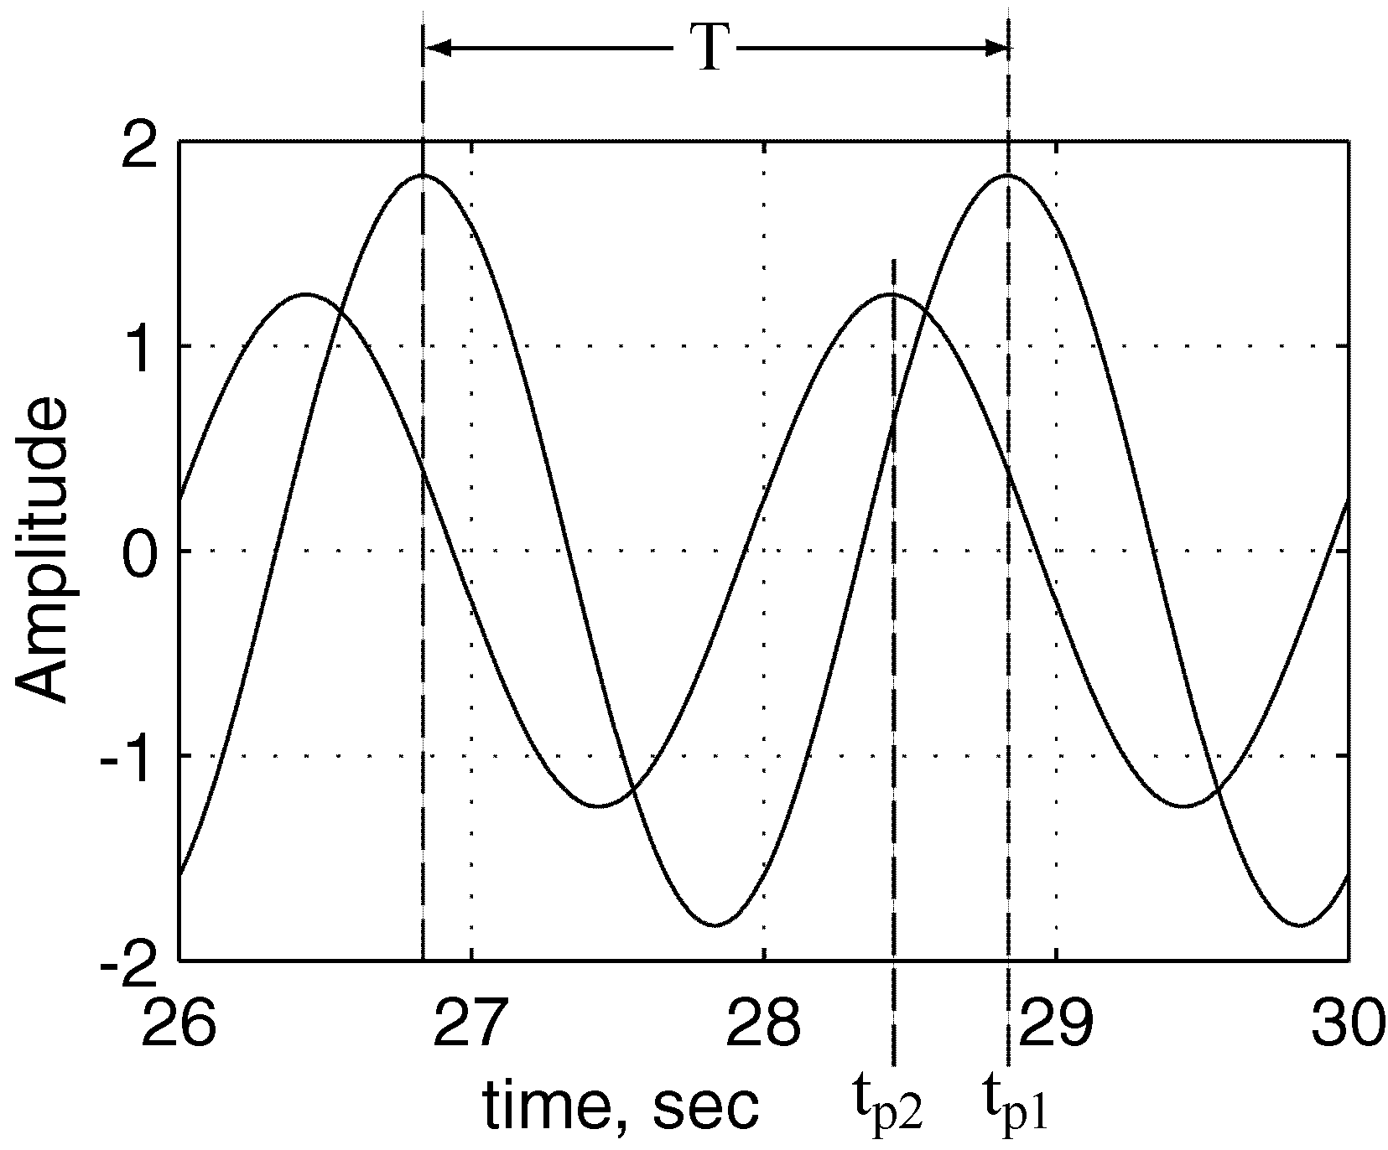
Figure 3. Measuring phase difference.
Laboratory Exercise
- WARNING! The pendulum makes an effective weapon! -
- Keep hands and heads clear! -
- Be sure the bench power supply is turned off!
- In order to measure the angular response of the pendulum, connect the wiper (YELLOW banana jack on setup) to AI_CH0 on the DAQ terminal block. To get a signal from the wiper, 5 volts is applied to one side of the potentiometer (the red banana jack) and the other side is tied to ground (the black banana jack).
- Connect the motor terminals to the amplifier power outputs (the + and – banana jacks) on the bench power supply.
- Apply a sinusoidal signal from the function generator to the power-amplifier that drives the motor (the coaxial BNC connection labeled V_{ref} on the bench power supply). Also connect the output from the function generator to AI_CH1. It is important that the DC offset of the signal is at or near zero, which can be checked via the oscilloscope or the CVI program that will be opened next.
- Turn the bench power supply on. The pendulum attached to the motor should oscillate. Try to get the largest (by adjusting the signal generator amplitude) and fastest (by adjusting the signal generator frequency) oscillation you can without the pendulum spinning around. Make sure that the pendulum is balanced on the shaft, so that it will oscillate through the same region throughout the experiment. Also try to avoid having the potentiometer oscillate through its dead zone.
- Start CVI and load and run the project "POT.PRJ" from the "C:\CVI\PROGRAMS\LABS\POT" folder. Set the appropriate sampling rate and number of samples and start the program. There should be two waveforms displayed by CVI, one is the output signal from the potentiometer and the other is function generator input signal. Depending on the quality of signal from your pot, you may choose to buffer, filter, and amplify the signal from the potentiometer according to Figure 2 (substituting v_{tach} with v_{wiper}) to get the best resolution from the data acquisition card and reduce the presence of noise.
- The CVI program will allow you to capture the signals from the pot and signal generator. Save the file to disk. The data file contains three columns. First column is time, second column is output signal, and third column is input signal. Use a data-plotting program such as MATLAB or EXCEL to plot your data.
What are the amplitudes of the signals and what is the phase difference between input applied to the motor and the resulting potentiometer signal?

- Buffer, amplify, filter, and differentiate your pot signal according to Figure 1 to obtain velocity information from the potentiometer output. Ensure that you have a low pass filter built into your differentiator with a cutoff frequency at least twice as high as the oscillating frequency of the pot. Connect the output from the differentiator to AI_CH0 and the function generator signal of AI_CH1. Set the appropriate sampling rate and number of samples and start the program. Save the file to disk. The data file contains three columns. First column is time, second column is differentiated potentiometer signal, and third column is input signal. Use a data-plotting program such as MATLAB or EXCEL to plot your data.
What is the amplitude of the velocity signal and the phase difference from the input to the output? Is this phase expected? Why or why not?

- With the differentiated signal from the potentiometer still connected to AI_CH0, connect the output voltage of the tachometer to AI_CH1 of the DAQ terminal block via the circuit in Figure 2 so that you can see the signal. Again, make educated decisions on the cutoff frequency and system gain for your circuit. Set the appropriate sampling rate and number of samples and start the program. Save the file to disk. The data file contains three columns. The first column is time, second column is differentiated potentiometer signal, and third column is tachometer voltage signal. Use a data-plotting program such as MATLAB or EXCEL to plot your data. Compare the signal from the tachometer with the information provided by differentiating the voltage from the potentiometer.
What is the phase difference between these signals?

Questions:
- Briefly describe at least two advantages of using a potentiometer for both position and velocity measurement.

- Briefly describe at least two disadvantages of using a potentiometer for both position and velocity measurement.

- Briefly describe at least two advantages of using a tachometer for velocity measurement.

- Briefly describe at least two disadvantages of using a tachometer for velocity measurement.

- How could you use a potentiometer or tachometer in your robotics project?

