Fall 2002

ME 3200 Mechatronics I Laboratory
Lab 3: Computer Data Collection

In this Laboratory exercise, you will be introduced to using a computer as a data measurement system. The computer will measure a series of data points, referred to as samples. There are two main concepts that you will explore in this lab: sample resolution and sampling rate. These concepts are now discussed.

Resolution
Analog-to-Digital Converters (ADCs) convert a voltage to a digital word for the computer to read. ADCs are specified by their resolution, voltage range, and sampling rate. The resolution is finite and is given as a number of bits such as 8-bit or 12-bit or 16-bit. This specifies the number of discrete divisions of voltage that the ADC can read over
its range. The number of divisions is 2 to the power of the number of bits. For example,
an 8-bit ADC has 2 8 or 256 divisions; a 12-bit ADC has 2 12 or 4096 divisions. The range of the ADC is the maximum and minimum voltage that it can read. For example, the
range of an ADC might be -10 volts to +10 volts. This means that the range is 20 volts.
The resolution is the range divided by the number of divisions. An 8-bit ADC with a
range of ±10 volts would have a resolution of 78 millivolts (mV). What this means is that
this ADC can discriminate a difference of 78 mV.

Pre-Lab Exercise

The laboratory ADCs are 12 bit with an input range between -5 to +5 volts. What is the
resolution of the ADCs in the laboratory computers in mV?

Sampling Rate
The sampling rate or speed of the ADC is another important factor. ADCs do not convert
the voltages to numbers continuously at all instants of time. Conversions are typically
done at discrete times - the time between two measurements is called the sampling time.
Sampling rate is number of samples per second, which is the reciprocal of the sampling
time. The ADC does not perceive a change in the signal between any two sampling
instances. For example, if the sampling rate is 1000 samples/sec (or Hz), then the signal is
read every millisecond and the computer assumes that the signal is constant during that
period.

It is very important that the sampling rate is faster than the signals being monitored. A
general rule is that the sampling rate is at least twice as fast as the highest frequency that
will be measured. A sampling rate 10 times faster than the highest frequency is desired in
order to achieve a good approximation of the signal. If the sampling rate is too slow, a
phenomenon known as aliasing will occur. Aliasing misrepresents a signal as a slower
frequency according to the equation:
(1)

where . Equation (1) is valid for . Figure 1
provides an example of a 10 Hz signal sampled at various frequencies within the alias
range as a demonstration of this concept.

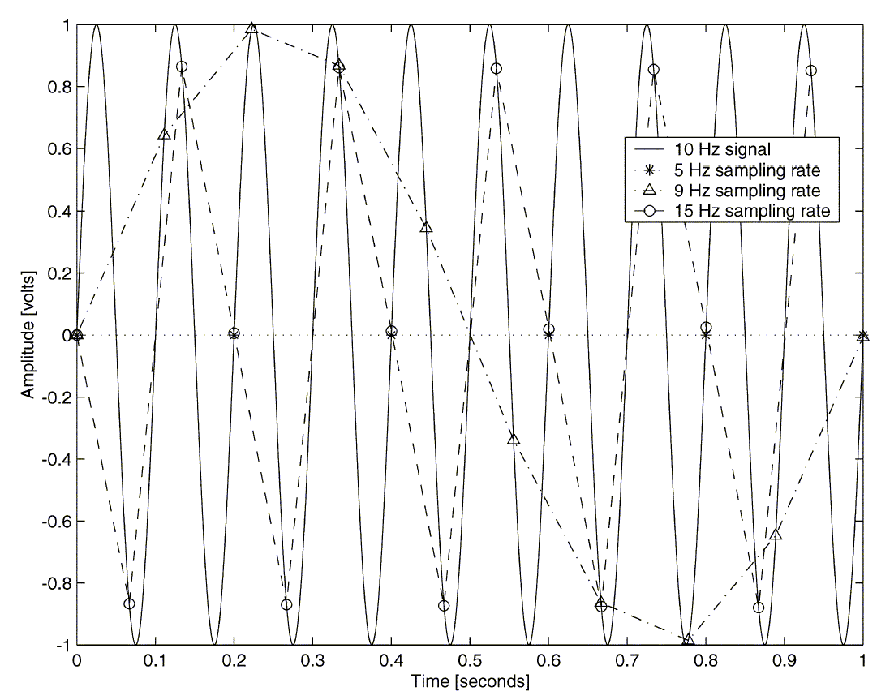

Figure 1. A 10 Hz signal sampled at various frequencies to demonstrate the aliasing phenomenon.

Voltage Divider
The formula that relates to in a voltage divider is as follows:

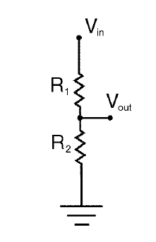
Figure 1: Voltage Divider
Where is the input voltage in volts,is the output voltage in volts, is the output resistance in ohms, and is the input resistance in ohms. The way that you will build a voltage divider is using the potentiometer on your bench. A potentiometer is a resistor that has voltage applied across it. A wiper (an electrical contact attached to a knob) is used to sweep along the resistor and create a voltage divider anywhere along its length.

Laboratory Exercise

Look for questions to be answered within the text of this handout along with the questions
at the end.

Equipment Needed: Function Generator and oscilloscope.

- Open Labview file you created in Lab 2. You should see your panel and the diagram files on the Labview console.
- Connect the output from the function generator (labeled Output 50Ω) to AI_CH0 of the DAQ terminal block. Also, using a BNC tee, connect this output to the oscilloscope-input channel 1. Ground the function generator to the left AI_GND on the DAQ terminal block and to the oscilloscope.
- Turn on the function generator and use the oscilloscope to verify that you have a 20 Hz, ±4.0 volt sine wave. Run the Labview project by selecting Run Continuously and click Start button on your panel. You should see the wave form in the Waveform Graph on your GUI".
- On the panel, set the sampling rate to 200 Hz and number of samples between 40-70. Press start to measure the sine wave. After a few seconds, you should see a plot of the input appear on the graph display. Save the data on your disk. The data is saved in two columns, the first column is the time and second column is the voltage data measured by the DAQ. Plot the signal with appropriate labeling of the axes. You may use any plotting routine that you have available (i.e., MATLAB or EXCEL) and find out how you can incorporate the plot directly into a word processing document. All of these applications are available to you in the lab but you may wish to try this on another computer.

What is the frequency of the data just measured? Is it consistent?

Why does the signal look “jagged”? How can you make the signal appear smoother?

- Record a 20 Hz, ±4-volt sine wave at a sampling rate of 20 Hz and number of samples set to 500. Save your data. What is the frequency of the measured signal? Why?

- Repeat exercise steps 1-4 using a 20 Hz, ±10 mV sine wave (sample rate of 200 Hz and number of samples between 40-50). The function generators are not capable of a 10mV signal, so a voltage divider circuit is required to properly scale down the sine wave. Turn the "Amplitude" knob on the function generator so that you get the smallest output. Connect the output from the function generator to the voltage divider circuit. Ask your TA for help if you have trouble. Run the program and save your data. What is the measured frequency?

Describe the difference in appearance of the sine wave and give a reason why.

QUESTIONS

1) What effect does the sampling rate have on measuring signals? You measured a
20 Hz signal at 200 Hz and at 20 Hz. Which one worked better? Why?

2) What should be the minimum sampling rate for a given signal? Why would slower sampling rate potentially fool the person collecting the data?

3) How does resolution affect the appearance of the sampled signal? What are two possibilities to improve the resolution of the ADC?

