ME 3200 Mechatronics I Laboratory
Lab 3: Computer Data Collection

Introduction

In this Laboratory exercise, you will be introduced to using a computer as a data measurement system. The computer will measure a series of data points, referred to as samples. There are two main concepts of computer data collection that you will explore in this lab: sample resolution and sampling rate. The following paragraphs describe the theory of these concepts as they apply to computer data collection. The pre-lab question and laboratory procedures are also outlined below.

Resolution

Analog-to-Digital Converters (ADCs) measure voltage and convert that measurement to a digital word for the computer to read. Two important factors that specify an ADC’s capabilities are its resolution and voltage range. The resolution of an ADC is finite and is determined by the number of bits the ADC has (8-bit, 12-bit, 16-bit, etc.). This number of bits specifies the number of discrete divisions of voltage that the ADC can measure over its entire voltage range. The number of divisions, d, is described by the following equation:

(1)

where n is the number of bits. For example, an 8-bit ADC has 2⁸ or 256 divisions; a 12-bit ADC has 2¹² or 4,096 divisions. The voltage range of an ADC is determined by the following equation.

(2)

where R is the range of the ADC and V_{max} and V_{min} are the maximum and minimum voltages of the ADC. For example, the range of an ADC might be ±10 volts: or a voltage range, R, of 20 volts. The resolution of an ADC is specified by the following equation:

(3)

where r is the resolution of the ADC. An 8-bit ADC with a range of ±10 volts would have a resolution of 78 millivolts (mV). A resolution of 78 mV means that the ADC will only return voltage measurements in increments of 78 mV (i.e. a 100 mV signal will be measured as 78 mV signal). The smaller the resolution of the ADC the more accurate the ADC’s voltage measurements will be.

Sampling Rate

Another important characteristic of ADCs is the sampling rate or speed of the ADC. ADCs do not convert voltages to numbers continuously at every instant in time. These conversions produce data "samples" at discrete periods that are typically specified by a sampling rate. The sampling rate determines the number of samples the ADC measures per second and the sampling period depends on the sampling rate. The sampling rate and sampling period are defined by the following equations:
(4)
(5)

While the ADC is sampling, it does not perceive a change in the signal voltage between any two sampling instances. For example, if the sampling rate is 1000 samples/sec (or Hz), then the signal is read by the ADC every millisecond and the computer assumes that the signal is constant until the next sample is taken.

It is very important that the sampling rate is faster than those of the signals being monitored by the ADC. As a general rule, the sampling rate should be at least twice as fast as the highest expected frequency (). However, a sampling rate that meets or exceeds ten times the highest frequency will improve the accuracy of the waveform measurement substantially. If the sampling rate is too slow, a phenomenon known as aliasing will occur. Aliasing misrepresents the actual signal as a slower frequency signal according to the equation:

when (6)

where f_{sampling} is the sampling frequency or sample rate, f_{actual} is the actual signal frequency, and f_{alias} is the aliased signal frequency. Equation 6 is only valid for the interval shown above and describes how the alias frequency can change depending on the difference between the actual and sampling frequencies. The aliasing phenomenon is sometimes a difficult concept to visualize so the laboratory procedure that follows will include an exercise to show how aliasing can alter the measurement of a signal of known frequency. Figure 1 provides an example of a 10 Hz signal sampled at a frequency within the alias range as a demonstration of this concept; notice that the signal is sampled at 9Hz, and as such, the aliased frequency that the computer detects is 1Hz.

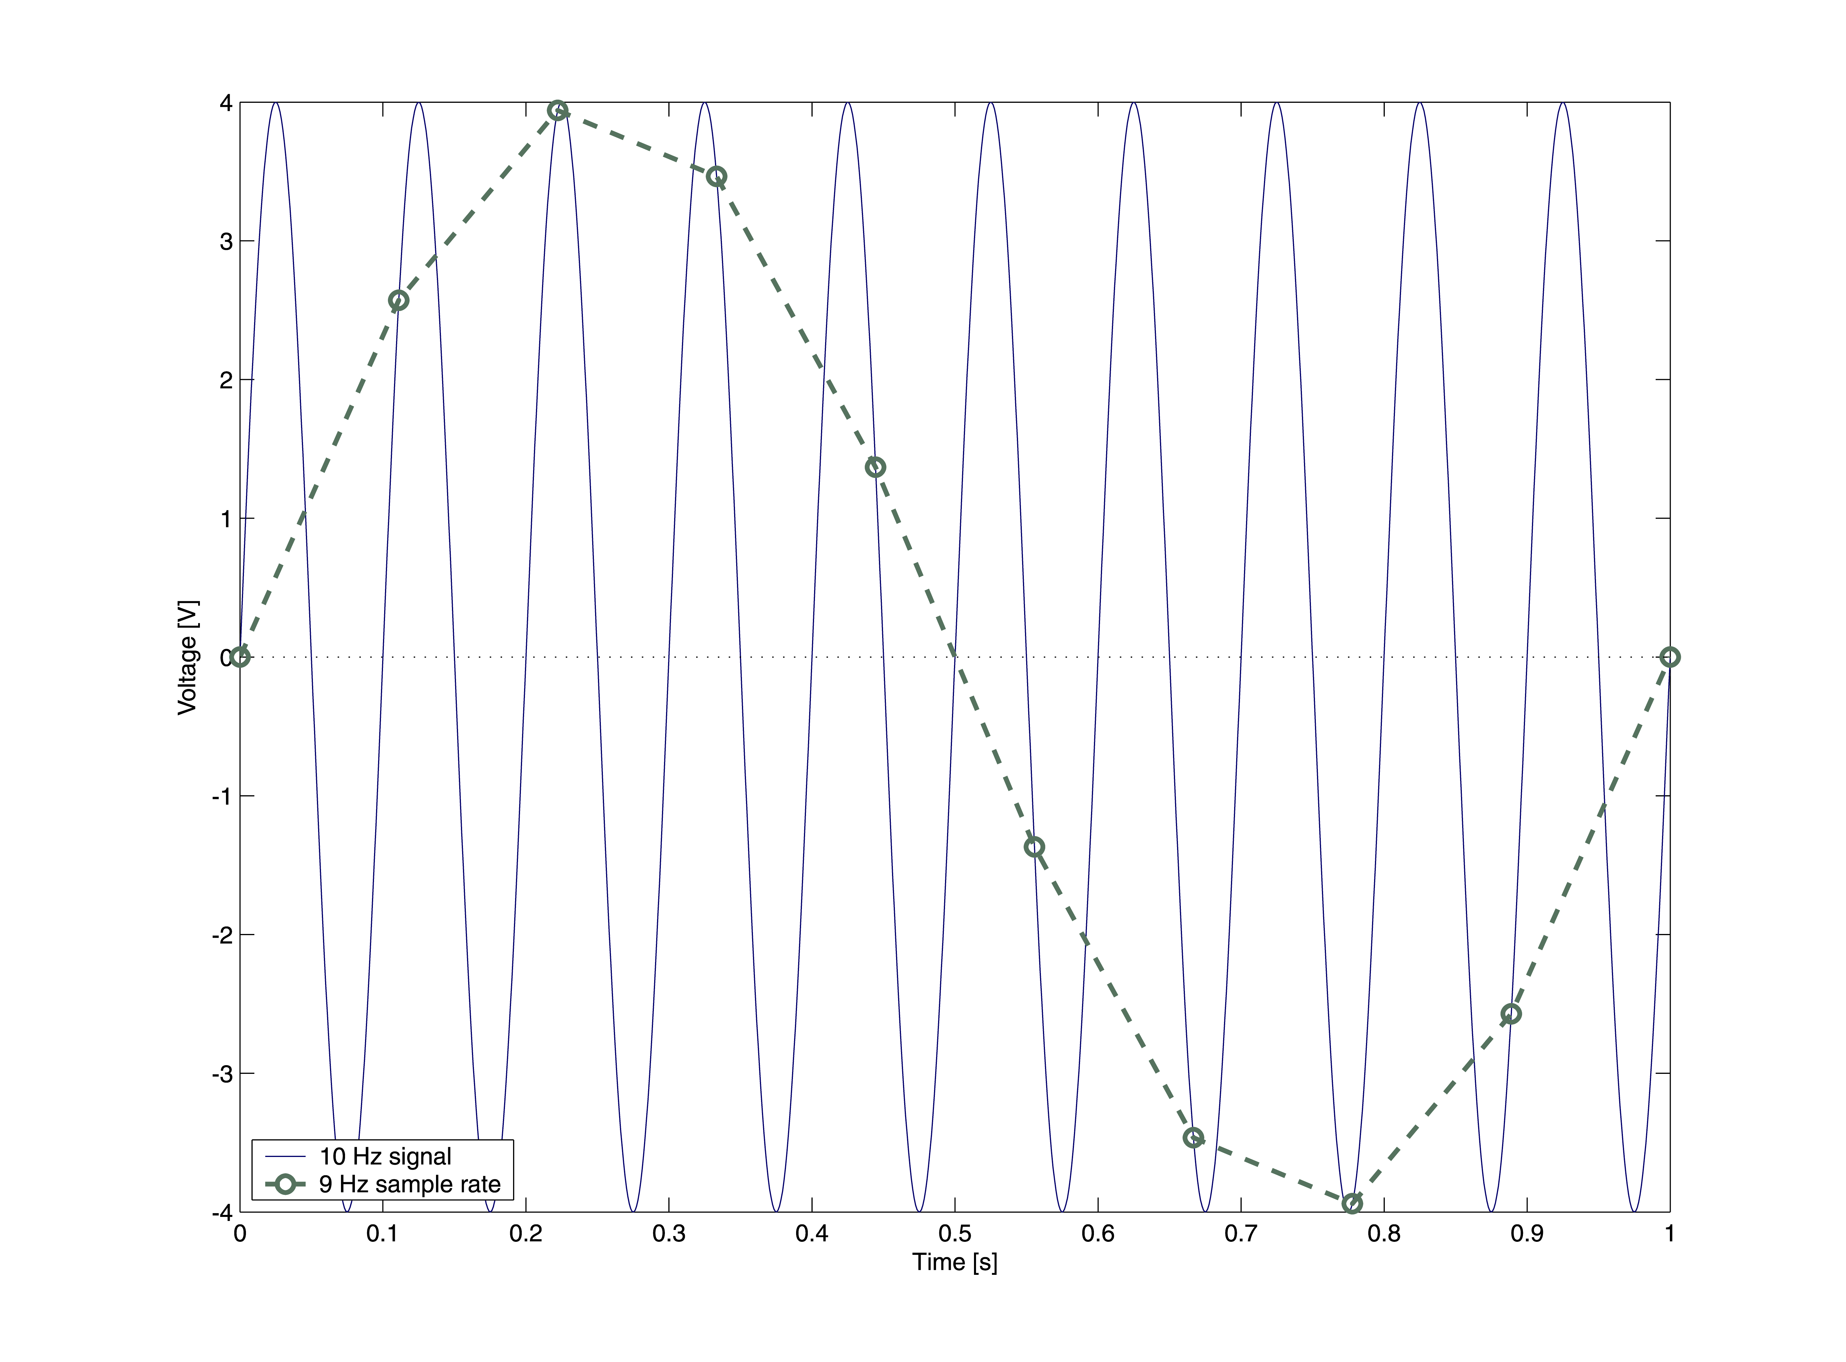
Figure 1: A 10 Hz signal and its 1 Hz alias when samples are taken at a 9 Hz sample rate.

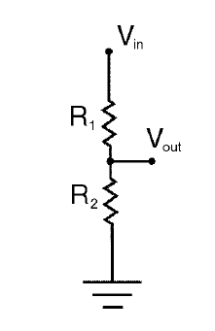
Figure 2: Circuit diagram of a voltage divider.

Voltage Divider

Sometimes during lab experiments we have a power supply that provides one voltage but we want a smaller voltage for our chosen application. In such cases a voltage divider can be a very useful electronic circuit if V_{out} in Figure 2 above is connected to a circuit with high impedance—such as a DAQ or multimeter. A voltage divider is a combination of resistors that reduces the voltage from a voltage source according to the following formula:
(2)
where V_{in} is the input voltage in volts, V_{out} is the output voltage in volts, and R₁ and R₂ are dividing resistors measured in ohms. The principle of a voltage divider can be applied to both alternating and direct current sources. A convenient voltage divider that is often used in the laboratory is a potentiometer; and one is located at your lab station just below the shelf that supports the computer monitor (it’s the rotary knob located next to three banana jack ports labeled one through three). This potentiometer is constructed of a disk of resistive material with a contact point called a wiper that can move back and forth between the two ends of the resistive disk. When a voltage is applied to the input (port 1) of the potentiometer and the output (port 3) is connected to ground a voltage develops on the wiper (port 2). The wiper voltage changes as the user adjusts the location of the wiper with the knob between the minimum and maximum positions of the potentiometer—the knob movement is essentially changing the resistances of R₁ and R₂ in Figure 2 above. This experimental setup is useful to scale-down a source voltage to a desired value.

Pre-Lab Exercise

The ADC of the data acquisition cards installed in the laboratory computers are 12-bit with an input range of ±5 volts. What is the resolution of this ADC in millivolts?

Laboratory Procedures

Equipment Needed: Function Generator, Oscilloscope, LabView, and the LabView file created in Lab 2.

- Open LabView file that you created in Lab 2.

- Using a BNC tee and BNC cables, connect the output from the function generator (labeled Output 50 Ω) to AI_CH0 of the DAQ terminal block and Channel 1 of the oscilloscope.

- Turn on the function generator and adjust its output to a 20 Hz, ±4.0 volt sine wave—use the oscilloscope and your LabView program to verify the signal.

- In the Panel Window of your program, set the sampling rate to 200 Hz and number of samples between 50-100, move the toggle switch to ‘Save’, and press start to measure the sine wave. After a few seconds, you should see a plot of the input appear in the Waveform Graph and you will be prompted to name the data file; save it with a .dat file extension to your floppy disk so it can be opened in either Excel or Matlab. The data is saved in two columns, the first column is the time and second column is the voltage data measured by the DAQ.

- Plot the signal and appropriately label the axes; you may use any plotting routine that you have available (i.e., MATLAB or EXCEL). What is the frequency of the data just measured? Is the measured frequency correct?
Why does the signal look “jagged”? How could you make the signal appear smoother?
- Using the table below, take sample data at each of the listed sample frequencies, record the observed alias frequency, and make a comment or two describing its shape in the spaces provided. Save each data set for your records.

- Determine minimum sampling frequency that will produce a nice, smooth signal that closely describes the actual source signal; make note of the sampling frequency in the space below.
f_{sampling} [Hz] | f_{alias} [Hz] | Description
10
12.5
15
17.5
20
22.5
25
27.5
30

- Using the function generator and the voltage divider on your bench top, create a 20 Hz, ±10 mV signal.

Note: The function generators are not capable of providing a 10mV signal, so feed the output of the signal generator to the input of the potentiometer, adjust the ‘Amplitude’ knob on the function generator so that you get the smallest output, connect the wiper output to the oscilloscope, and adjust the potentiometer knob until you create the specified amplitude. Check the waveform with the oscilloscope before you proceed to the next step.

- Set the sampling rate of your LabView VI to 200 Hz and the number of samples between 50-100 samples; run the program and save the data. What is the measured frequency?
Describe the difference in appearance of the measured signal and give a reason for its appearance. Can you do anything to improve the appearance of this signal with the equipment provided?

Questions

  - What effect does the sampling rate have on measuring signals with an ADC? Based on your experiments, how many times faster than the known frequency should you sample a signal to produce a nice, smooth curve?
  - What should be the minimum sampling rate for a given signal? Why may a slower sampling rate fool the person collecting the data?

  - In this laboratory you knew the actual signal frequency. Describe how you would determine the appropriate sampling rate needed for a signal of unknown frequency so as to prevent aliasing.
  - What type of signal conditioning would you recommend in order to prevent aliasing?

  - How will the resolution of an ADC affect the appearance of a measured signal whose amplitude is not much larger than the ADC resolution (you may want to draw a picture)? How could you improve the resolution of an ADC?

