Introduction

In mechanical design, the designer often has need of a linkage that provides a certain type of motion for the application he/she is designing. Since linkages are the basic building blocks of almost all mechanisms it is very important to understand how to design linkages for specific design characteristics. Therefore, the purpose of this lab is to offer practical experience in designing and building three and four-bar quick-return mechanisms that convert rotational to translational motion. To that end, a description of how to design these linkages, a laboratory activity, a pre-lab exercise, and follow-up questions are included in the following paragraphs.

Quick-Return Linkage Design

The following steps describe a graphical method of designing three and four-bar quick return mechanisms. You will need a pencil, ruler, compass, and protractor for this design; refer to Figure 1 below during this process.
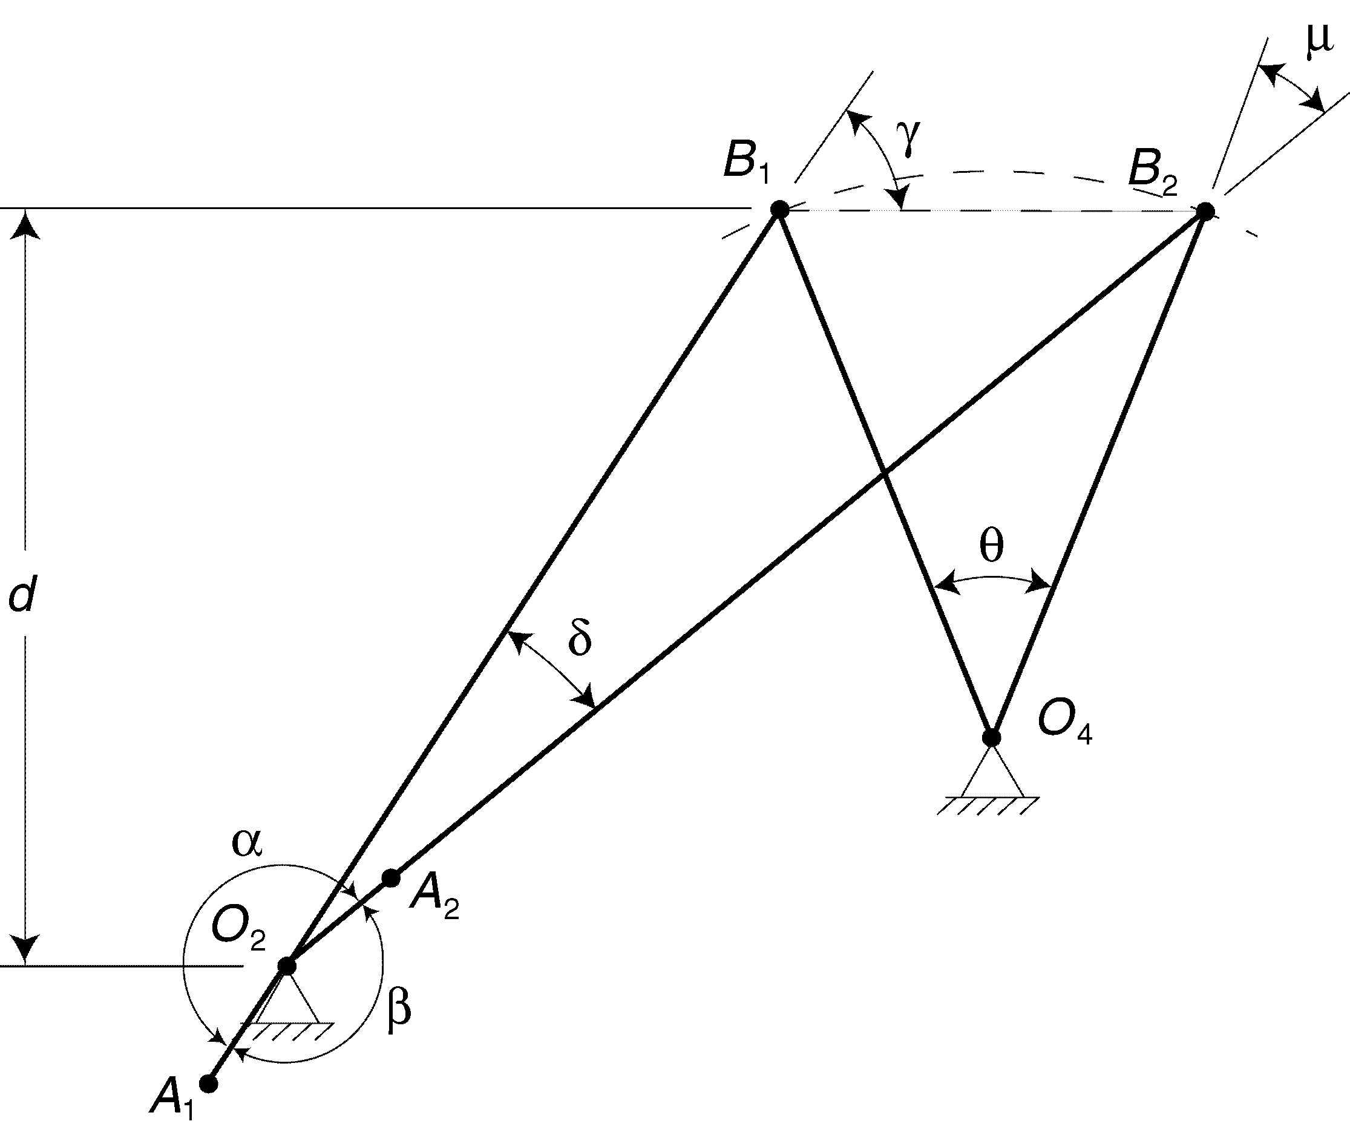
Figure 1. The graphical design of a crank-rocker quick-return mechanism.
- Locate points B₁ and B₂ on your paper. These are the extreme points of the slider or the pin joint connecting the coupler and rocker, which will be termed B for this exercise.

- Draw a line through B₁ at an angle γ ≠ 0 from the line connecting B₁ and B₂.

- Draw a line through B₂ at the construction angle δ with respect to the first line as described in this step. The angle δ is determined using Equation 3 below. The position of the crank when B is at the two extreme positions, B₁ and B₂, forms the obtuse angles α and β. Assume for this exercise that α > β and that the prescribed time ratio is determined by the ratio of α to β, where the sum of α and β is 360°. The following simultaneous equations are thus created:
(1)
(2)
where TR is the desired time ratio. The solution to these equations gives α and β. Once these angles are calculated, the construction angle δ is determined from the supplement of either angle according to the following relationship:
(3)
The intersection of the line drawn in step 2 and the line through B₂ at angle δ is the crank pivot O₂ (refer to Figure 1 above).

- With a ruler, measure the distance between O₂ and B₁ and O₂ and B₂. Keep in mind that B₂ is reached when the crank and coupler are fully extended and collinear, and B₁ is reached when they are fully retracted and collinear (the crank is right on top of the rocker). The following set of equations can then be used to find the lengths of the crank and coupler:
(4)
where _{CPL} is the length of the coupler, _{CR} is the length of the crank, and is the distance between O₂ and B₁ , and is the distance between O₂ and B₂ in Figure 1 above.

- Check the rotatability criteria for your crank-slider, using the following inequalities:
(5)
where d is the perpendicular distance between O₂ and the line passing through B₁B₂, as indicated in Figure 1. Both of these criteria must be satisfied for the crank to rotate a full revolution. At this point the design for your crank-slider linkage is complete.

- To extend your crank-slider design to a crank-rocker, determine the location of the rocker pivot point O₄ by drawing a perpendicular bisector from the line connecting B₁ and B₂, and then placing the point O₄ on that line to creates a desired angle θ. The length of the line that connects O₄ to either B₁ or B₂ is the length of the rocker and the radius of curvature of the rocker path. The distance between the pivots O₂ and O₄ is the length of the ground link of the four-bar mechanism.

- Check the Grashof condition in the case of the crank-rocker, using the following inequality:
(6)
where s is the length of the shortest link (which must be the crank for crank-rocker inversion), l is the length of the longest link, and p and q are the lengths of the other two links.

- The transmission angle μ is the angle between the coupler and rocker. In the case of the crank-slider, the rocker is a link of infinite length, so the transmission angle is measured between the coupler and a line perpendicular to the slider path. When you have completed your designs, they should look something like Figure 1 above.

Pre-lab Exercise
1. Crank-Slider
On a separate piece of paper, design a crank-slider with a stroke of 1 inch and a time ratio of 1.40.
2. Crank-Rocker
On a separate piece of paper, design a crank-rocker with an output angle of θ =30° and a time ratio of 1.40, where the rocker is 1.93” long (which corresponds to a distance of 1” between extreme positions).

NOTE: Both these mechanisms (for all configurations) must fit within an 8”X8” area. Also, because of a physical limitation of the hardware used in this lab, the minimum link length is approximately 1.5”. If you derive a design that does not satisfy this minimum link length, you may scale the entire system appropriately as long as it fits within the 8”x8” area.
Laboratory Exercise
Equipment Needed: Mechanical breadboard, ruler, protractor, and linkage parts kit.

1. Crank-Slider
Build the mechanism you designed in your pre-lab and show the TA how it works. It may be necessary to scale the links if you have not designed the system to fit within the 8” x 8” area on the mechanical breadboard. What are the minimum and maximum transmission angles of your mechanism?

2. Crank-Rocker
Build your crank-rocker mechanism and show your TA how it works. It may be necessary to scale the links. What are the minimum and maximum transmission angles of your mechanism?
Questions

- Draw a diagram that represents the components of Equation 4 graphically.
- What are the consequences of not satisfying Equations 5 or 6 above?
- What does the transmission angle indicate? What are the minimum and maximum transmission angles of your mechanisms? Based on these measurements, critique your designs; list their advantages and disadvantages.
- Briefly describe two real-world applications for both the crank-slider and crank-rocker quick return mechanisms (i.e. two each).
- How might you use these types of linkages for your robot project?

