ME 3200 Mechatronics Laboratory
Lab Exercise 8: Operational Amplifiers

Introduction
In this experiment you will explore some of the basic properties of operational amplifiers, better known as op-amps. These electronic devices are very useful in analog circuitry. As their name implies, they can perform mathematical operations on voltage signals: including algebraic and calculus operations.

The Ideal Op-Amp
An op-amp is a device with two inputs and one output. The two inputs are known as the non-inverting input, v⁺, and the inverting input, v–. The output of the op-amp is dependent upon the potential difference between the inverting and non-inverting inputs. Op-amps require an external power source denoted ±V_{cc}. The op-amps used in the Mechatronics lab use a ±V_{cc} of ±12 V provided by the bench power supply at each station. A simplified schematic of an ideal op-amp is shown in Figure 1 (a) below. It is common to omit the power connection in most op-amp diagrams; therefore, Figure 1 does not include these connections.

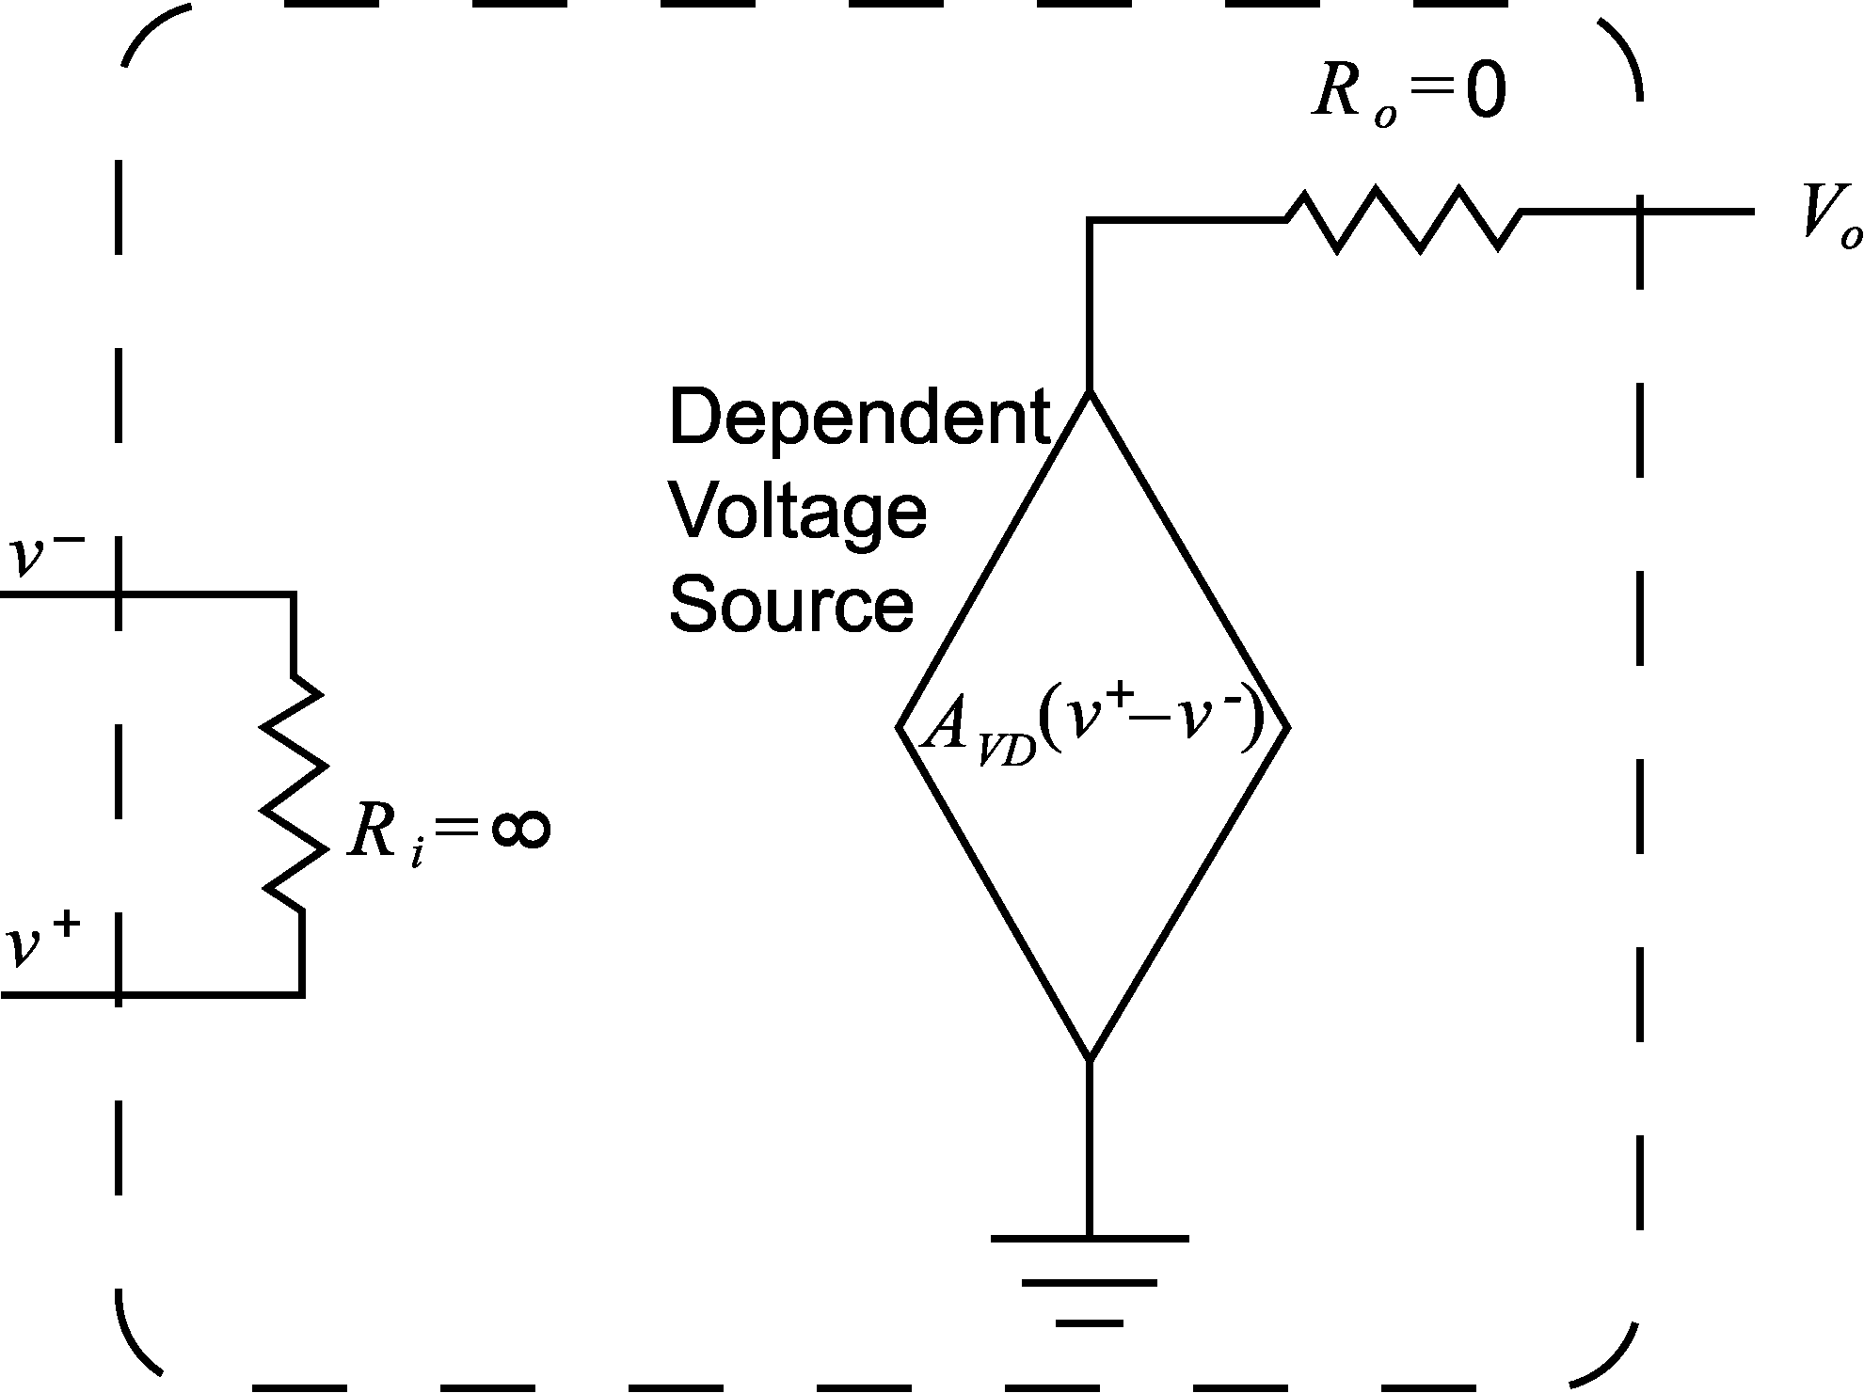
(a)
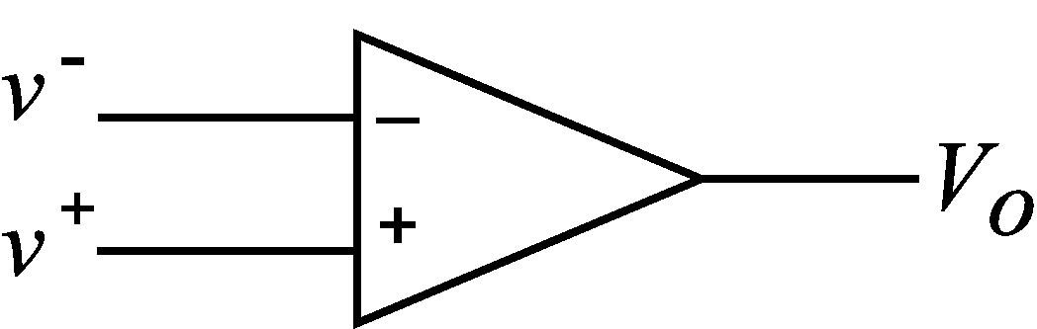
(b)
Figure 1: (a) Simplified op-amp schematic. (b) Op-amp circuit diagram.
The basic features of ideal op-amps and their representation in circuit diagrams are shown in Figure 1 (a) and (b) respectively. The two inputs of the op-amp are connected through a resistor with infinite resistance that restricts current from flowing into the op-amp at either terminal. The output lead is connected to a dependent voltage source through a resistor of zero value, thus causing the output voltage V_{o} to be equal to the voltage provided by the dependent voltage source. The voltage of the dependent source is proportional to the voltage difference between v⁺ and v– and can be expressed as follows:
where A_{VD} is the open-loop gain of the amplifier, which, ideally, is infinite.

Real Op-amps
Reality, however, dictates that infinitely large resistors, infinite open-loop gains, and zero-valued resistors do not exist. Fortunately, the characteristics typical of most op-amps generally allow the use of the equations and assumptions that define the ideal op-amp. This fact is very useful when designing and analyzing op-amp circuits. The typical input resistance R_{i} of an op-amp is on the order of 100 MΩ; a resistance that allows very little current into the input leads. The typical output resistance R_{o} of an op-amp is on the order of 10 Ω. An output resistance this low means that a non-ideal op-amp can provide a substantial, albeit finite, current and that Equation adequately approximates its voltage output. Equation , however, is only a good approximation if the nominal voltage difference between the inputs is small. If becomes too large the op-amp saturates at a voltage known as V_{sat}. Saturation occurs because the voltage difference between the inputs dictates that V_{o} must be larger than the supply voltage V_{cc} according to Equation . Since the op-amp cannot provide more voltage than it is given the output reaches an upper or lower limit (±V_{sat}). The saturation voltage of an op-amp is always a little lower than its supply voltage, V_{cc}. The op-amps used in this lab have a saturation voltage of about ±10 V.

The open loop gain, A_{VD}, of the op-amp is closely related to the saturation characteristics of a given op-amp; it defines how large the difference between v⁺ and v– can be before the op-amp saturates. The typical open loop, low-frequency gain of an op-amp is usually about 10⁵. The open-loop gain of most op-amps is frequency dependent and will become smaller and smaller depending on the frequency of the input signal(s). A large open-loop gain drastically restricts the size of the potential difference between v⁺ and v–, but it also means that the op-amp is very sensitive to small changes between v⁺ and v–. So, how does one avoid saturation and take advantage of the op-amps sensitivity? Saturation is avoided by diverting a portion of the op-amp’s output to its inverting terminal by physically connecting the output through a passive electronic device to the inverting input. This technique is called negative feedback and is very common in almost all useful op-amp circuits. Negative feedback ensures that the difference between v⁺ and v– will always be very nearly zero, but that the op-amp is still sensitive to small changes between v⁺ and v–.

The preceding characteristics of real op-amps allow the use of the following assumptions in circuit analysis of op-amps with negative feedback:
where i⁺ and i– are the currents flowing into the non-inverting and inverting inputs, respectively. It is important to note that Equation is valid if and only if negative feedback is used in the op-amp circuit and is sometimes referred to as virtual equality. With these assumptions, the circuit can then be analyzed using Kirchoff’s current or voltage laws (KCL and KVL respectively) and Ohm’s law. Consider the example below that illustrates how these assumptions are validated in the case of the simple voltage follower circuit.

Example 1
Determine the output voltage V_{o} of the op-amp in Figure 2 as a function of the input voltage V_{i}, given that the open-loop gain A_{VD} = 10⁵.
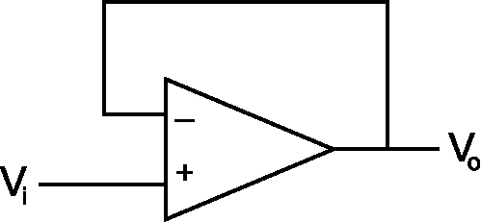
Figure 2: A voltage follower circuit.
The first step is to identify the voltage values at the input leads. The inverting input is tied to the output, and the non-inverting input is tied to the input voltage.
The next step is to substitute these values and the given value for the open-loop gain into Equation :
After some algebra, Equation becomes
This op-amp circuit is known as a voltage follower, or buffer, because the output voltage is essentially equal to the input voltage. The American Heritage Dictionary [www.dictionary.com] defines a buffer as “Something that lessens or absorbs the shock of an impact.” Based on the characteristics of a real op-amp, we see that this op-amp circuit reduces the “impact” of the current provided by the voltage input V_{i} so that it cannot propagate to the output. Since the input voltage is applied to the non-inverting input, any current coming from that input is blocked from the output (Equation ). The output is tied to the inverting input, and since there is no current between the input leads, there is no current in the wire connecting the output to the inverting input (this connection is known as the feedback path). Any current that is required for the device connected to the output of the buffer will be provided from the op-amp itself. This effectively separates the input device from the output device, but still provides an output voltage that is essentially identical to the input voltage.

Useful Op-amp Circuits
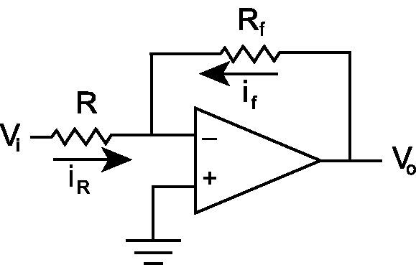
Figure 3: An inverting amplifier circuit.

The Inverting Amplifier
Consider the inverting amplifier circuit in Figure 3. The following analysis shows how to determine the output voltage V_{o} as a function of V_{i}. With the non-inverting input connected to ground, v⁺ = 0, implying that v– = 0 as well since the circuit has a negative feedback loop (through R_{f}) (see Equation ). The voltage at the inverting input is known as virtual ground. The directions of the currents assume that they run toward virtual ground. Applying Ohm’s law results in the following equations:
Keeping in mind that the current from the inverting terminal i– = 0 from Equation , KCL can be applied at the node containing the inverting input.
Substituting Equations and into Equation yields:
Finally, solving Equation for V_{o} yields
The mathematical operation performed by this op-amp circuit is multiplication (i.e. amplification of the input). Notice that the sign of the output is opposite the sign of the input. This sign inversion is why the circuit is called an inverting amplifier.

The Active Low-Pass Filter
A simple modification can be made to the inverting amplifier so that it can filter out high frequency noise—a common element found in most electronic signals. A dominant source of noise in the lab is AC line noise at 60Hz. High frequency noise is commonly caused by external voltage or magnetic sources or from natural impurities in circuit devices or components and is generally characterized by sporadic, high frequency variations in the voltage signal. The low pass filter effectively excludes input frequencies higher than a specified frequency called the cutoff frequency. To create an active low pass filter, simply connect a capacitor in parallel with the feedback resistor of the inverting amplifier as shown in Figure 5.
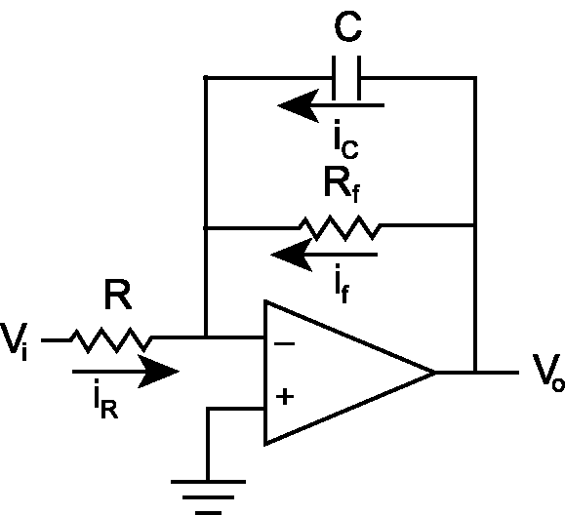
Figure 4: An active low pass filter
This circuit performs two operations. First, it amplifies the input voltage according to Equation (which is valid for low frequencies), and second, it suppresses frequencies higher than its cutoff frequency, where the cutoff frequency, ω₀ in rad/sec, is defined as:
To be exact, the output amplitude as a function of input frequency for this circuit is described by:
where ω is the frequency of the input signal V_{o}. Figure 5 shows the frequency response of an active low pass filter whose resistors have been chosen to provide a unity gain, and where the x-axis is the normalized frequency, and the y-axis is the absolute value of the system gain.
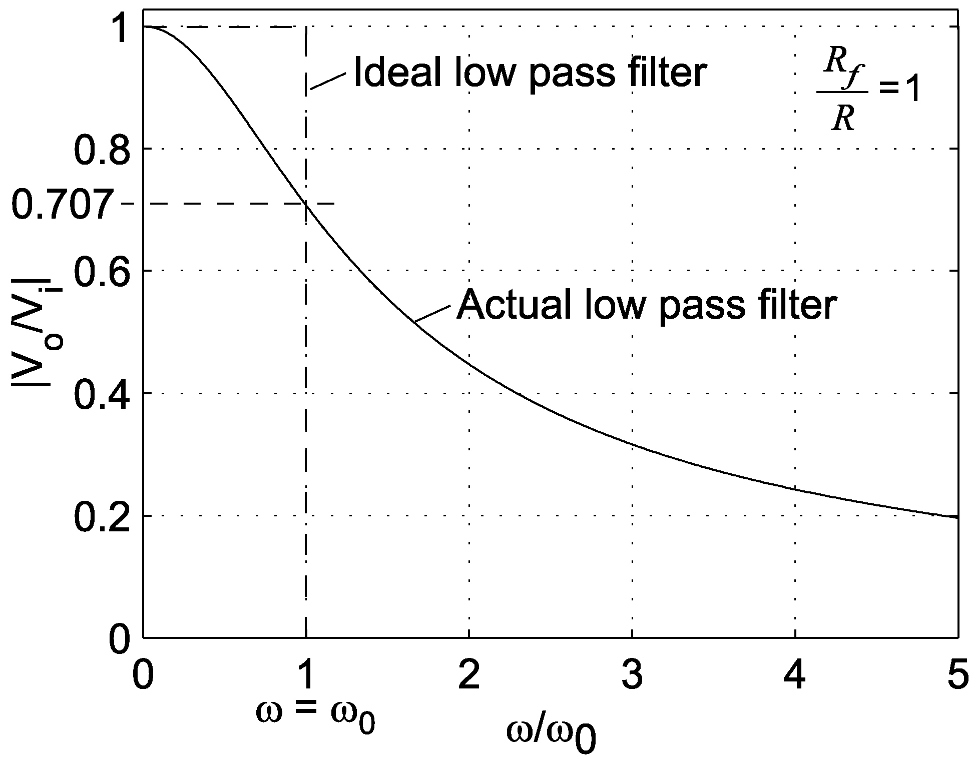
Figure 5: Low pass filter frequency response
As indicated in Figure 5, at ω = 0 (DC voltage input), the output voltage is
As input frequency increases, amplitude decreases. At the cutoff frequency, ω = ω₀, the magnitude of the output is defined by the following:
.
In order to decrease the impact of the low pass filter on the desired output signal, the cut-off frequency is set as high as possible. The trade-off of using a high cutoff frequency is that more noise is permitted to pass through the filter. As a rule of thumb, setting the cutoff frequency to at least twice the maximum expected input frequency and less than one tenth the expected noise frequency is best.

The LM324 Quad Op-Amp
Op-amps are readily available as inexpensive integrated circuits (ICs). The op-amp IC used in the Mechatronics lab is the LM324 quad op-amp. This is a 14-pin dual in-line package (DIP) chip that consists of four op-amps. When plugged into an electrical breadboard and provided the appropriate ±V_{cc}, the chip provides four independent op-amps that can be used to form a wide variety of useful circuits. A schematic of the LM324 is included in Figure 6. This type of schematic is known as a pin out, and it indicates how the pins of the DIP correspond to the inputs and outputs of the four op-amps. Whenever these types of IC devices are used, it is important to refer to the data sheet provided by the chip manufacturer that describes the device’s characteristics and limitations. The data sheet for the LM324 is available on the class web page on the lab handouts page.
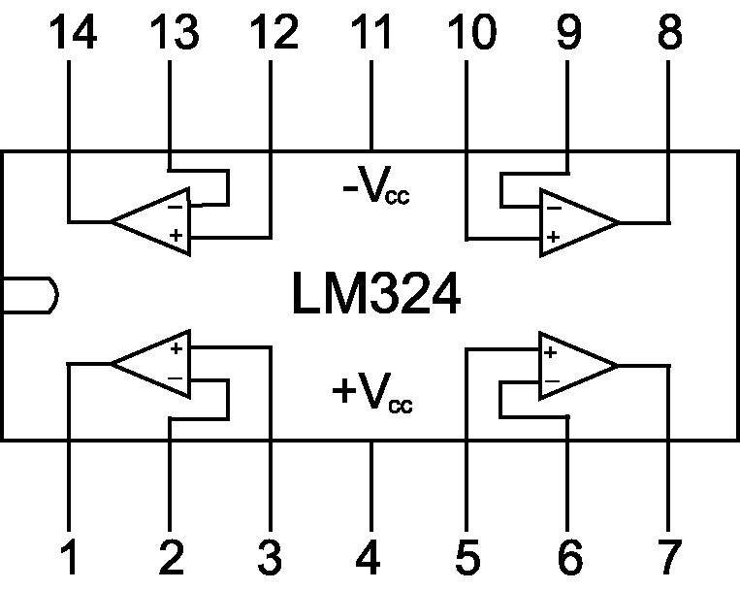
Figure 6: Schematic of the LM324 quad op-amp.
Aside from the applications discussed in this handout, the op-amp has many other uses in analog electronics. You are encouraged to explore other applications of this useful device.

Pre-lab Exercises

- Determine the output voltage V_{o} of the op-amp in Figure 1 as a function of the input voltage V_{i}, the resistance R, and the capacitance C. (Recall that the current through a capacitor is proportional to the time derivative of the voltage across it.)
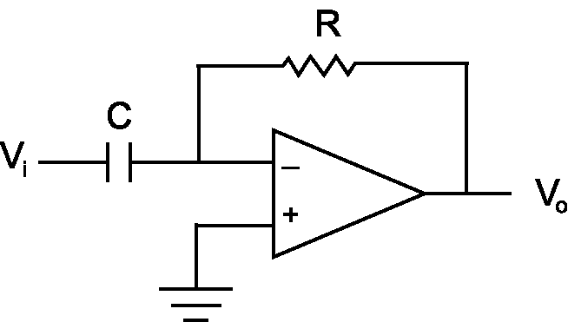
Figure 7: Differentiator circuit

- Calculate the ideal output voltage, V_{o}, of this circuit if the input voltage is equal to the following:
where A is the amplitude of the incoming signal in volts, ω is the frequency of the incoming signal in rad/sec, and t is time in seconds.

Laboratory Exercise

Required Materials/Equipment
- An Electronic Breadboard
- An LM324 Quad Op-amp Chip
- A Signal Generator
- Resistors
- Capacitors
- The Benchtop Power Supply
- The 2_channel_oscope.vi LabView VI used in Lab 2
- Solid Core Wire
- A Wire Cutter/Stripper
- Banana Cables
- BNC to Alligator Clip Cables
- Digital Multimeters
- Alligator Clips
- BNC to Banana Adapters
- BNC Cables
- BNC Tees

The circuits that you will build in this lab procedure are based on the ones described in the introductory sections of this lab handout. Not only are you expected to build the circuits described below, but you are also expected to debug them if they do not work appropriately the first time. Debugging circuits is a very useful skill and requires patience and attention to detail. The most common error in op-amp circuits is accidentally saturating the op-amp with too large a voltage difference at its inputs. One method of debugging this problem is to use the digital multimeters provided in the lab to check the voltages of the input and output pins to trace path of the circuit from beginning to end. Ask your TA for help if the circuit fails to function after your best efforts to debug the circuit.

Note: Do not turn on the bench power supply until your circuit is complete. In addition, whenever any changes are made on your circuits turn off or unplug the power supply from the circuit. This protects the circuitry and eliminates potential headaches from burned out op-amps.

- Locate an electronic breadboard and an LM324 quad op-amp IC and carefully press the chip’s pins into the holes of the breadboard so that it straddles the center divider without bending its pins.

- Provide power to the LM324 by connecting the bench power supply –12 volts to the –V_{cc} pin and +12 volts to the +V_{cc} pin.

- Using small lengths of solid core wire, build a voltage follower as shown in Figure 2.

- Design an inverting amplifier that doubles the amplitude of the input signal. Record the value of the resistors that you will use in the space provided.
R_{f} = _______________________ R =_______________________

- Build the inverting amplifier you designed in the step 3:

  - Use the ground lead of the benchtop power supply as your common ground.

  - Connect the output of the amplifier to the A_CH1 of the DAQ breakout box of your lab station using a BNC to Alligator cable (black is ground) and solid core wires.

  - Connect the ground of your circuit to the EXT_REF port of the DAQ breakout box using a BNC to Alligator cable.

- Open the 2_channel_oscope.vi from the LabView folder on your computer’s desktop, connect the signal generator’s output to A_CH0, select the run button from the toolbar, and adjust the output of the signal generator till you have a 2 Hz, ±2-volt sine wave.

- Attach a BNC tee to the output of the signal generator to split its output; connect one end of the tee to the A_CH0 input of the DAQ breakout box using a BNC cable. The other end of the tee is connected to the input of your circuit as described in the note below.

Note: You will need to use a BNC to Alligator cable and some solid core wires to connect the output of the signal generator to your circuit. Connect the black lead to the ground of the circuit; and the red lead to the input lead of the voltage follower.

- Under Oscilloscope Channel Selection in your LabView VI, type 0 and 1 in the boxes below the ON/OFF switches, and make sure that they are both turned “On” (toggle switches above the input boxes).

- Turn on your benchtop power supply using the illuminated toggle switch, select appropriate values for the sample rate and the number of samples on the LabView VI, and press the “Acquire Data” button.

- Examine the waveform in displayed in the LabView VI, save your data to a disk by pressing the OK button under “Save Data”, and determine the amplification factor of your inverting amplifier using the measurements of the LabView VI. Record this amplification factor below.
Amplification = ________________________

- Turn off your benchtop power supply.

- Design a buffer-filter-amplifier-differentiator circuit (Figure 8) that will differentiate a 2 Hz, ±2-volt sine wave and amplify its amplitude to a 2Hz, ±4.5-volt (9-volt peak-to-peak) sine wave. Refer to the pre-lab and the active low-pass filter section of this lab for the necessary methods. Be sure to use an appropriate cutoff frequency. Record the required values for your electronic components in the spaces provided.
R_{i} = _______________Ω R_{f} = _______________Ω C_{f} = _____________F
C = _______________F R = _______________Ω
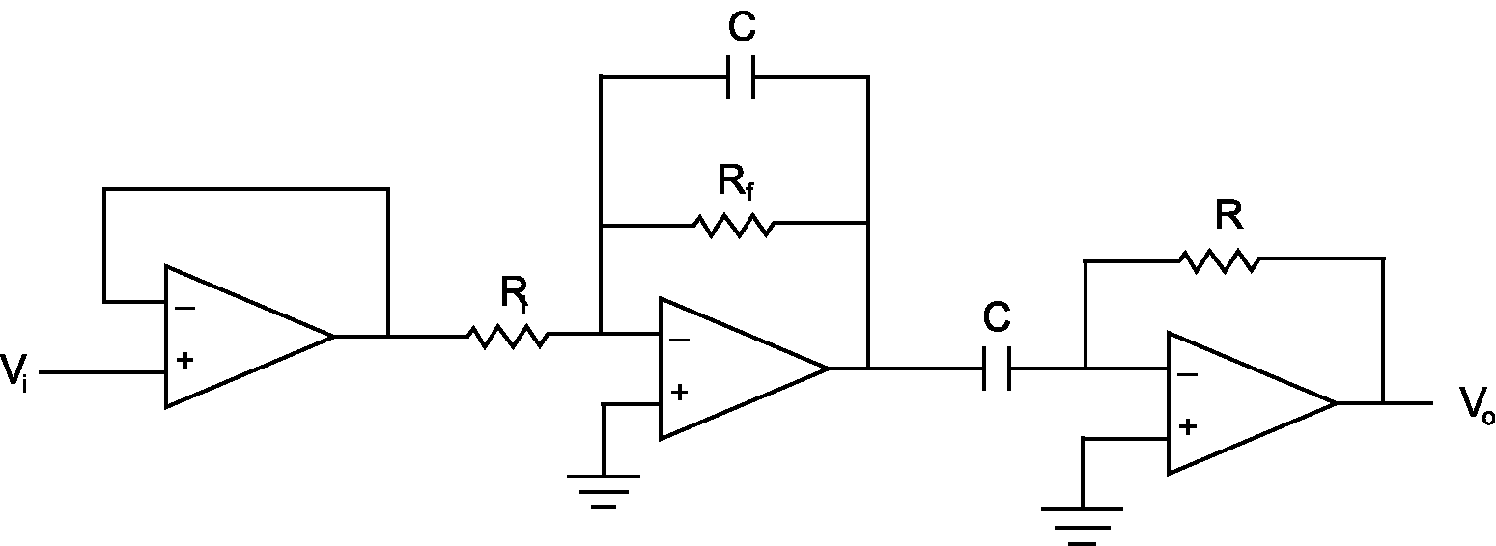
Figure 8: Buffer-filter-amplifier-differentiator circuit.
- Build the circuit you just designed. Refer to Figure 6 and Figure 8 to help with wiring the circuit—paying special attention to the pin out diagram of Figure 6. Use the ground from the bench power supply as the common ground for this circuit. As before, all equipment and circuits should be connected to that one ground point.

- Send the output of your circuit to A_CH1 on the DAQ terminal block and the output of the signal generator to A_CH0 and to the input of your circuit as done in step 6.

- Turn on the bench power supply, choose the appropriate number of samples and sampling rate in the LabView VI, and press the “Acquire Data” button to collect the waveform data. Save the data to disk and examine the waveforms.

- Determine the actual amplification achieved by your buffer-filter-amplifier-differentiator circuit using the same technique as in step 10. Also, determine the phase shift of the output of your circuit using the data traces in the waveform graph of the LabView VI. Record the amplification factor and phase shift below.
Amplification = ________________________ Phase Shift = ________________________rad
- Increase the frequency of the input signal to 5Hz, choose the appropriate number of samples and sampling rate, and push the “Acquire Data” button on the screen. Save the data to disk and plot the data.
How has the appearance of the output changed?
What is the amplitude and phase difference of the output this time?
A = ________________________V Phase Shift = ________________________rad
Why have the peaks been cut off of the sinusoids? (Hint: refer to the Pre-Lab and the Data Collection Laboratory.)

- Increase the frequency of the input signal to 100Hz, choose the appropriate number of samples and sampling rate, and push the “Acquire Data” button on the screen. Save the data to disk and plot the data.
How has the appearance of the output changed?
Why does the appearance of the output wave change as the input frequency increases?

Questions
- What is the most efficient way to implement a complex op-amp circuit that requires more than one op-amp?
- Describe at least two good ways of debugging an op-amp circuit.
- Draw the circuit diagram for an integrator-amplifier circuit that integrates the input voltage.
Solve for the output voltage as a function of time if the input voltage is equal to Equation above.
- Describe at least two practical applications for op-amps for your robot project.

