ME 3200 Mechatronics I Laboratory
Lab 9: Angular Position and Velocity Sensors

Introduction
In this exercise you will explore the use of a potentiometer and tachometer as angular position and velocity sensors. In addition, you will have the opportunity to implement the skills gained in the experiment on operational amplifiers.

Potentiometers
In previous exercises you have used the bench potentiometer to create a controllable voltage supply. In this experiment, you will use a servo potentiometer to measure the angular position of a DC motor. In either case the principle is the same: the potentiometer is used as a voltage divider that produces an output voltage that is linearly dependent on angular position of the wiper. The bench potentiometer is a “single-turn” potentiometer with physical stops at the extreme positions (“single-turn” is misleading because the physical stops are usually such that the angle the potentiometer can turn is less than 360°).

The potentiometer mounted on the motor setup, however, is a special potentiometer called a servo potentiometer. A servo potentiometer does not have a mechanical stop that limits the potentiometer’s rotation. Therefore, the shaft of a servo potentiometer can be rotated indefinitely. Unfortunately, there is a small “dead-zone” of about 5-10 degrees that produces an open circuit when the wiper moves across the dead zone. The equation that defines the output voltage, V_{out}, of a servo potentiometer with a dead zone can be expressed as:
where V_{in} is the input voltage in volts, θ is the angular position of the wiper in degrees, and θ_{dz} is the angle of the dead zone in degrees. For Equation to be true, we must prevent current from flowing through the wiper (i.e. the input impedance of the circuit the potentiometer is connected to must be very large). One effective way of ensuring that no current is drawn from the wiper is to use an op-amp as a buffer (see the first op-amp in the circuit of Figure 1). As you may recall, one of the properties of an op-amp is that its inputs have high input impedances. Therefore, the buffer circuit uses the op-amp to provide the voltage and current necessary to drive the remainder of the circuit while it matches the voltage of the wiper connected to its non-inverting input. A buffer is not required if the data acquisition card of the computer or a digital multimeter is used to measure the wiper voltage since these devices are designed to have very high input impedances.

The resistive materials used in most potentiometers are wire windings. As the wiper moves across these windings high-frequency electrical noise is produced. Therefore, it is especially important to filter the signal from the wiper using a low pass filter (see second op-amp in Figure 1) if the circuit accepting the signal is sensitive to high-frequency noise. However, apart from the noise produced during motion, a potentiometer is a very useful tool to measure angular position.
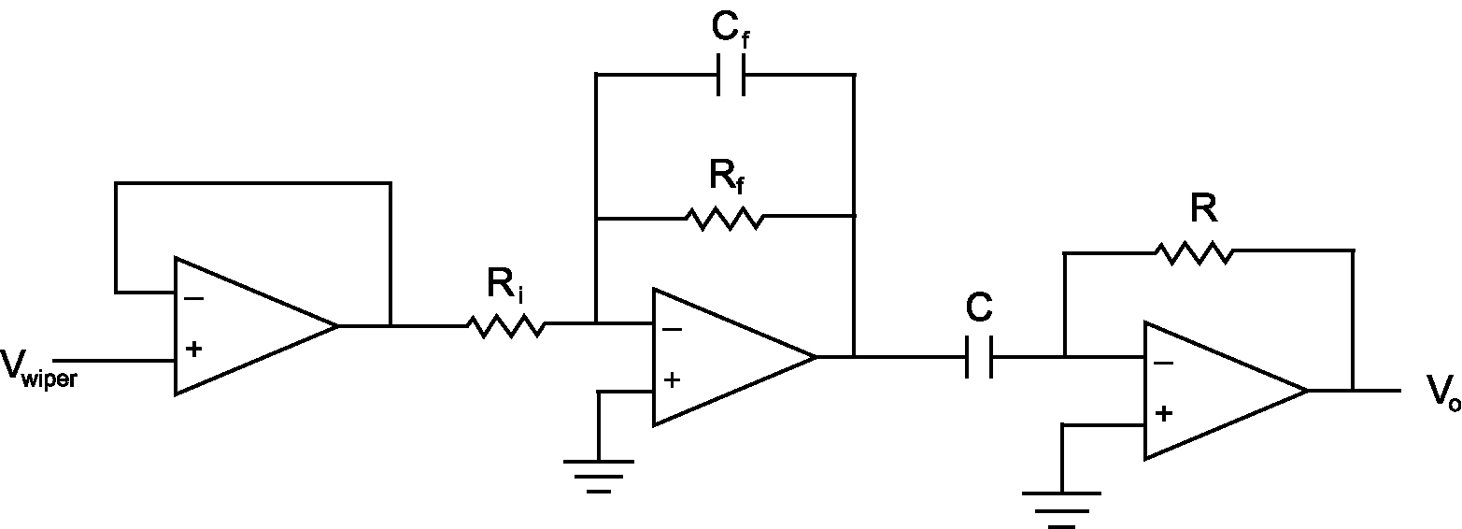
Figure 1: Buffer amplifier filter differentiator circuit.

In addition to providing angular position, potentiometers can be used to measure angular velocity using an external op-amp circuit like the one shown in Figure 1. The first stage of the circuit buffers the output of the potentiometer so as not to draw current from the wiper of the potentiometer. The second stage is a low pass filter designed so that the high frequency noise generated by the motion of the wiper will not be transmitted to the third stage. The third stage is a differentiator circuit that differentiates the angular position given by the potentiometer and outputs angular velocity. If the signal from the potentiometer were sent to this last stage directly, without the low-pass filter, the high-frequency noise produced by the wiper motion would be amplified much more than the desired signal from the potentiometer and erratic velocity measurements would result.

The most important thing to avoid when using a pot in this fashion is the possibility of connecting the supply voltage or ground connection to the wiper. These connections will burn out the potentiometer when the wiper approaches the grounded or supply terminals when it rotates through the dead zone of the potentiometer.

Tachometers
A tachometer is essentially a generator—a DC motor run in reverse. A tachometer consists of an armature that is wrapped with multiple loops of copper wire. These loops of wire are connected via brushes and a commutator ring to the external electrical leads. When the shaft of the tachometer is turned, the wire wrappings rotate through a magnetic field, typically provided by a fixed permanent magnet, and this movement produces a voltage according to the Faraday effect. The voltage produced is proportional to the rate, or angular speed, of the input shaft. Assuming that the electrical leads are connected to a device with high input impedance, the output voltage as a function of angular velocity is described by the following equation.
where V_{out} is the output voltage, ω is the angular velocity in radians per second, and k_{B} is a positive constant, called the back-emf constant, related to the armature’s winding geometry. Equation suggests that the output voltage will be positive or negative depending on the direction of the angular velocity; in other words, every tachometer has a positive and negative direction.

Although the tachometer is a convenient way to measure angular velocity, it does have drawbacks. First of all, the voltage produced by the tachometer must be read by a device with a high input impedance so that the tachometer’s output is not altered by the circuit the tachometer is connected to. In addition, the internal brushes of the tachometer create high-frequency noise as they run along the commutator ring. Finally, the voltage produced by the tachometer is very small at slow speeds and, therefore, usually needs an external amplifier circuit. In light of these facts, it is often wise to buffer, filter, and amplify the signal from a tachometer rotating at low speeds using a circuit like the one shown in Figure 2. Note that the last op-amp in this circuit rectifies the inverted signal from the filter.
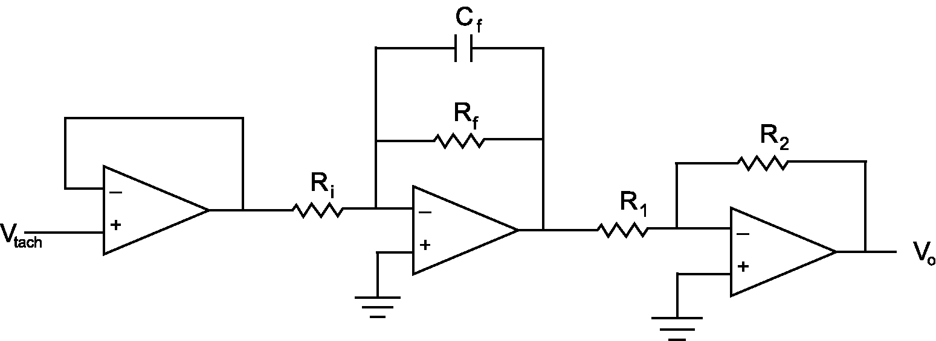
Figure 2: Buffer amplifier filter inverter circuit.

Measuring Phase
In this lab you will be required to measure the phase difference between two different sinusoidal voltage signals because the op-amp circuits used will cause the phase of the output signal to be shifted either forward or backward in time relative to the input signal. The phase difference between two sinusoidal signals of the same frequency is calculated from the time between the peaks of the signals and the period, T, of the signals in seconds (see Figure 3).

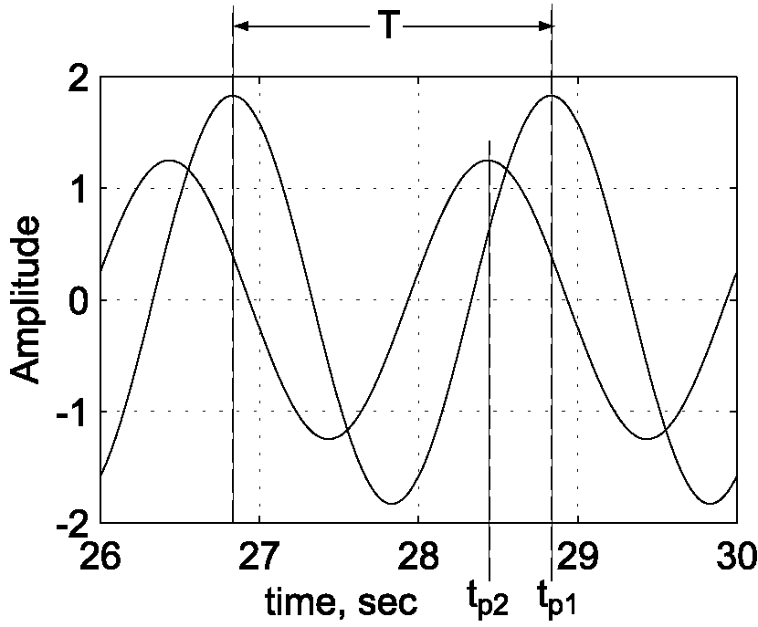
Figure 3: Measuring the phase difference between signals.
The phase difference, φ, is defined by the following equation:
where t_{p1} is the time associated with the peak of the first signal, t_{p2} is the time associated with the peak of the second signal. Note that φ > 0 corresponds to signal one “lagging” signal two (as shown in Figure 3), while φ < 0 corresponds to signal one “leading” signal two.

Pre-lab Exercise
In the following lab you will be required to design and build the circuits of Figure 1 and Figure 2 above. This pre-lab is designed to help you design the circuits in the least amount of time possible. To that end, solve the following problems on a separate piece of paper:

- Low-pass Filter:
  - Refer to Lab 8: Operational Amplifiers and, using Equations 13 and 14, solve for the resistor values of the circuit assuming that ω, ω₀, C, and V₀/V_{i} are known quantities.
  - Calculate the resistor values R and R_{f} if ω = 60 rad/s, ω₀ = 160 rad/s, C = 0.1μF, and V₀/V_{i} = 1.

- Differentiator:
  - Refer to the Pre-lab Exercise from Lab 8. Solve for R assuming that ω, A, C, V₀, and V_{i} are known.
  - Calculate the resistor value R if ω = 60 rad/s, C = 1μF, A = 2, and V₀ = 4 V.

- Inverting Amplifier:
  - Refer to Lab 8 and, using Equation 12, solve for R in terms of R_{f}, V₀, and V_{i}.
  - Calculate the resistor value R if R_{f} = 2 kΩ, and V₀/V_{i} = -2.

Laboratory Exercise
WARNING! The pendulum makes an effective weapon! Keep hands and heads clear!

- If on, turn off the bench power supply.

- Connect the wiper of the potentiometer (YELLOW banana jack on setup) to A_CH0 on the DAQ terminal block, the 5 volts source from the bench power supply to the red banana jack and the black banana jack to ground.

- Connect the motor terminals to the bench amplifier power outputs (the + and – banana jacks) on the bench power supply.

- Turn on your function generator; set the frequency of the output to 2 Hz, and make sure that the offset knob is pushed in.

- Connect a BNC tee to the output of the function generator and connect one output of the tee to the BNC port on the bench power supply labeled V_{ref} and the other to the A_CH1 of the DAQ terminal block.

- Turn on the bench power supply and the 24 Volt power supply for the motor amplifier (light switch at your lab station). The pendulum attached to the motor should oscillate.

- Adjust the amplitude of the function generator so that the pendulum oscillates back and forth with the largest amplitude without completing a full rotation. If the pendulum doesn’t oscillate about a single orientation adjust the weights on the pendulum to balance it on the shaft. Also try to avoid having the potentiometer oscillate through its dead zone.

- Open POT.exe from the CVI Projects folder on the Desktop. Make sure that the Output Signal is set to zero, the Input Signal is set to one, the Mode is set to RSE, and the Gain is set to 1.

- Choose appropriate settings for the sample rate and number of samples and press Start to collect a data set. There should be two waveforms displayed by CVI, one is the output signal from the potentiometer and the other is function generator input signal.
Note: You may notice that the output signal is offset from the input signal. This offset can be corrected by entering the amplitude of this offset in the Output Offset box of the CVI program. Update this value and take successive data sets until the offset is eliminated (record the value for future reference).

- Once the offset is properly adjusted, save the data set collected to disk; open the data set using Excel or Matlab to verify it was saved properly. The data file should contain three columns: the first column is the time vector, the second column is the output signal from the potentiometer, and third column is the input signal from the signal generator.

- Measure and record the amplitudes of the signals and the phase difference between input applied to the motor and the resulting potentiometer signal in the space below (these quantities may be easier to determine using Excel or Matlab).

Input Amplitude: ____________________Volts Phase Shift: ____________________°

Output Amplitude: ____________________Volts

- Design and build a circuit of the form depicted in Figure 1 above that will differentiate the potentiometer signal: resulting in an angular velocity measurement. Make sure that the low pass filter has a cutoff frequency that is at least twice the input frequency and that the overall gain of the circuit limits the output signal amplitude to less than five volts. Record the values of your circuit components below:
R_{i} = _______________Ω R_{f} = _______________Ω C_{f} = _____________F
C = _______________F R = _______________Ω Gain = _______________

- Connect the output from the potentiometer to the input of the differentiator circuit, and the differentiator output to A_CH0 (the function generator signal remains connected to A_CH1). Press Start on the CVI program and save the data to disk.

- Measure and record the amplitudes of the input and output signals and the phase difference between input applied to the motor and the resulting differentiated potentiometer signal in the space below.
Input Amplitude: ____________________Volts Phase Shift: ____________________°
Output Amplitude: ____________________Volts

- Disconnect the differentiator circuit from your setup, but save it for later.

- Connect the tachometer output to the A_CH0 input of the DAQ and collect a data set with the CVI program. Make note of the amplitude of the tachometer signal.

- Design and build a circuit of the form depicted in Figure 2 above that will filter and amplify the signal from the tachometer. Again, make sure that the low pass filter has an appropriate cutoff frequency and the overall gain of the circuit limits the tachometer output amplitude to less than five volts. Record the component values of the circuit below:
R_{i} = _______________Ω R_{f} = _______________Ω C_{f} = _____________F
R₁ = _______________F R₂ = _______________Ω Gain = _______________

- Connect the output of the tachometer to the filter-amplifier circuit input (make sure that one of the tachometer ports is grounded to your circuit) and connect the output of the filter-amplifier to the A_CH0 input of the DAQ. Collect a data set and verify that the circuit works properly. Save the best data set to disk.

- Measure and record the amplitudes of the input and output signals and the phase difference between input applied to the motor and the resulting conditioned tachometer signal in the space below.
Input Amplitude: ____________________Volts Phase Shift: ____________________°
Output Amplitude: ____________________Volts

- Reconnect the differentiated signal from the potentiometer A_CH0, connect the output voltage of the tachometer circuit to A_CH1 so that you can compare the two velocity measurements. Collect a data set and save it to disk.

- Measure and record the amplitudes of the input and output signals and the phase difference between the differentiated potentiometer signal and the conditioned tachometer signal in the space below.
Pot. Amplitude: ____________________Volts Phase Shift: ____________________°
Tach. Amplitude: ____________________Volts

Questions:
- Briefly describe at least two advantages of using a potentiometer for both position and velocity measurement.
- Briefly describe at least two disadvantages of using a potentiometer for both position and velocity measurement.
- Briefly describe at least two advantages of using a tachometer for velocity measurement.
- Briefly describe at least two disadvantages of using a tachometer for velocity measurement.
- How could you use a potentiometer or tachometer in your robotics project?

