The simplest dynamic system is a linear first order system. The time response of a first-order system is exponential. In this lab you will measure the parameters of a simple thermal system and use the measured parameters to estimate the parameters of a similar but unknown system. The thermal system will consist of a temperature source supplying heat to water in an Erlenmeyer flask.

Pre-Lab Exercise
Derive the transfer function and time response for the system. Symbolically solve for heat source, q_{S}. Derive the system using temperature differences with the ambient temperature as the reference. The transfer function should be in the form T_{C} / q_{S}.

Theoretical Background
The system under investigation for this experiment consists of an Erlenmeyer flask containing water. The flask sits upon an electric hotplate. Given sufficient preheating, the hotplate reaches a steady-state temperature that can be considered an ideal heat flux source q_{S}. A temperature transducer converts the temperature of the water to a proportional voltage signal, which is then measured by the bench DAQ system. Figure 1 presents a schematic of the experimental setup.
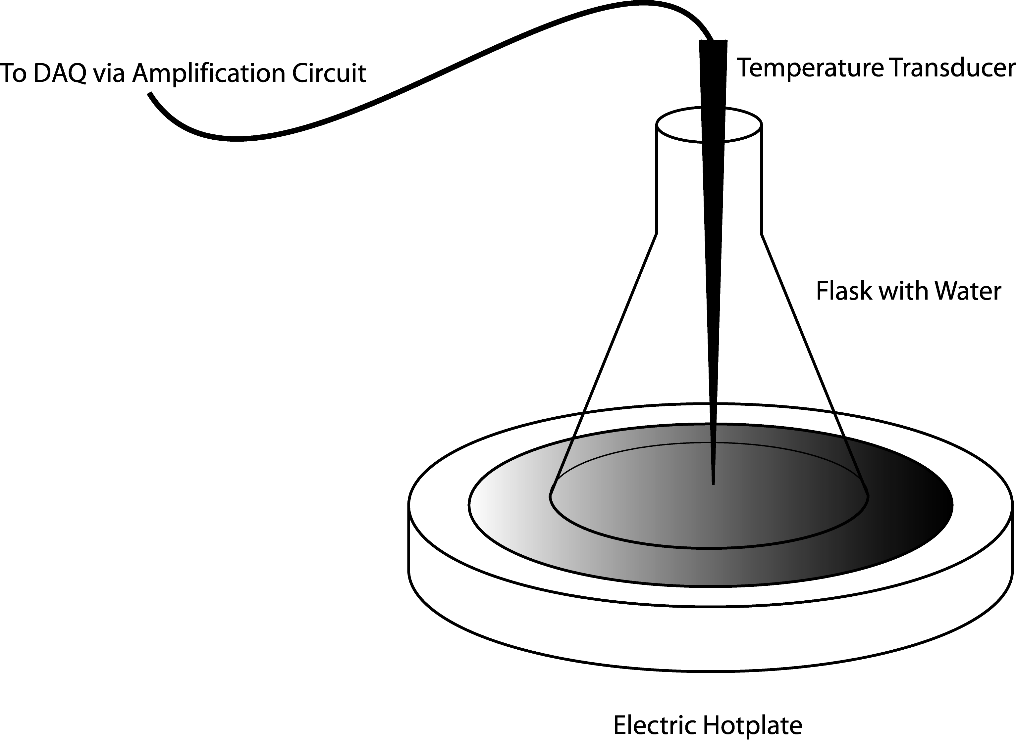
Figure 1. Schematic of the experimental setup for the first-order response exercise.
The water itself has a fluid capacitance C that allows it to store heat energy. The fluid capacitance of water is the product of its mass m and its specific heat C_{p}:
(1)
The mass of the water will be measured directly, and the specific heat of water can be approximated as 4.218 kJ/kg.K for the temperature range in this experiment. Due to imperfections in the surface of the flask, it is possible that there may be pockets of air between the surface of the hotplate and the water. Although the glass itself is a good thermal conductor, it does offer some resistance to the heat flowing into the water. These combine to form a conduction resistance R_{S} between the temperature source and the water. The heat leaving the water passes through the glass into the atmosphere. For simplicity, it is assumed that the conduction resistance of the glass and the convective heat loss into the atmosphere can be combined into an effective heat loss resistance, R_{L}. Closer inspection of the experimental setup shows the temperature nodes and thermal impedances elements associated with this experiment. This closer inspection is presented in Figure 2 below.
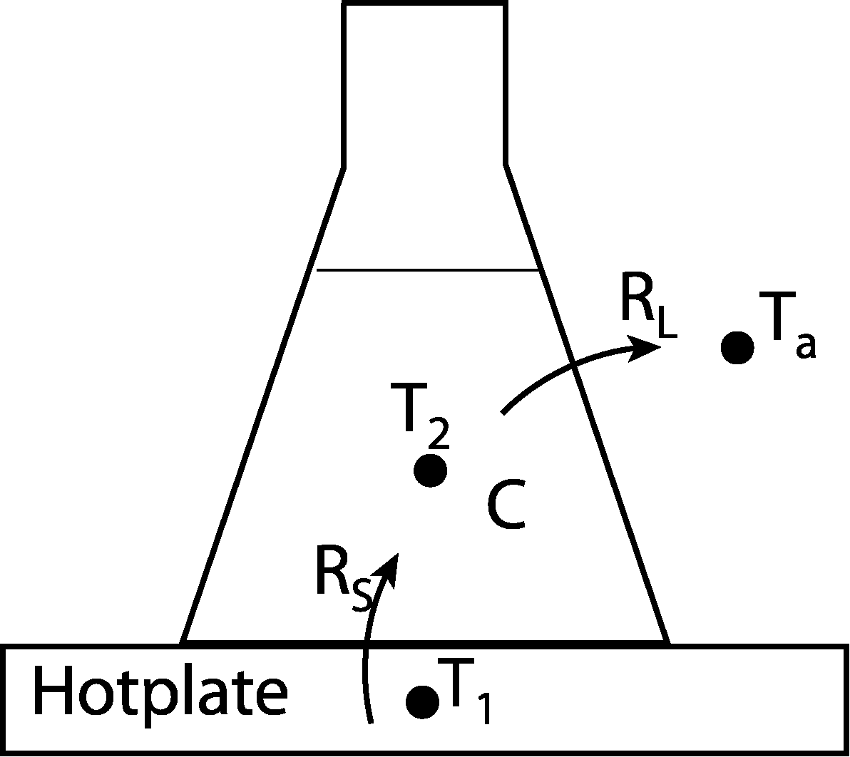
Figure 2. Schematic showing measured temperatures and thermal impedance elements.
The linear graph that describes the system is depicted in Figure 3 below:

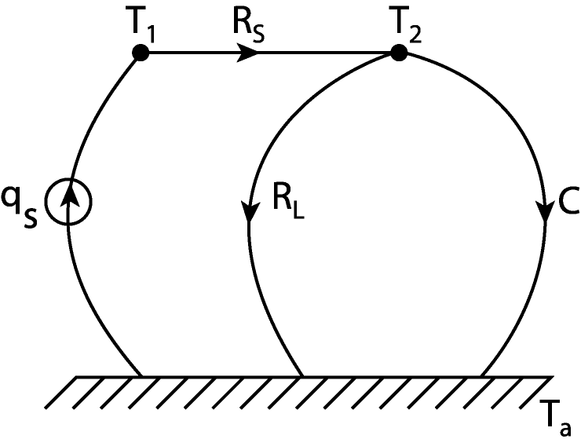
Figure 3. Linear graph of the thermal system.
The time response of a first-order system, such as the one examined in this experiment, shows that the output exponentially reaches its final value. One important parameter that describes the time response of a dynamic system is the time constant τ. The units for the time constant are seconds. After three time constants of time, the system reaches 95% of its final value. After four time constants, it reaches 98% of its final value. The time constant is measured by first finding the final value of the system. The time it takes for the system to reach 63% of the final value is the time constant.

Experimental Method:
- Locate a hotplate, plug it in, and switch it on
- Locate a Fluke 80T-150U Temperature Probe. This sensor converts the temperature experienced at its tip to an equivalent voltage signal at its output. The selector allows the choice between Celsius and Fahrenheit measurements. The output is in millivolts
- Go to the sink and acquire an Erlenmeyer flask. Use the scale to determine the mass of the flask. M_{flask} = . Fill the flask with less than 100-125 ml of water from the container next to the sink, which is at room temperature. Try to keep it close to 100-125 ml, but do not go over this level. Conversely, do not use an excessively small amount of water, either. Weigh the flask with the water on the scale. M_{flask+water} = . Subtract the mass of the flask to determine the mass of the water. M_{water} = .
- Set the run time to the 40 minutes. The approximate time constant for a 50 ml sample is 1000 seconds. Use a test tube clamp to hold the temperature probe in the middle of the water. Ensure that the probe is in the approximate center of mass of the water for best results. Place the flask on the hotplate and click the ACQUIRE button.
- Once the data set is completed, save the data file to disk. Make sure the data was saved properly by opening it in some software package such as Matlab or Excel.
- Dump the water into the sink. Fill the flask with less than 75-100 ml of room temperature water again and place it on the hotplate. Replace the temperature transducer and restart the CVI program with the appropriate time.
- While the second flask of water is heating , plot the data from the first run using Matlab or Excel. From the plot determine the time constant. τ =
- Use Equation (1) to determine the fluid capacitance of the water used in the first run.

C =

- Use the results of steps 9 and 10 as well as your pre-lab to determine the heat flux associated with the system.

q_{S} =
- Refer again to your pre-lab. Symbolically determine the time constant τ as a function of m, and q_{s}.

τ =
- Once the second experimental run has been completed, save the data. Again, ensure that the data has been saved by opening it in Matlab or Excel before closing Labveiw. Do not empty the flask yet.
- Plot the data. From the plot, determine the time constant τ. τ =
- Using the results from steps 10, 11, and 12, determine the mass of the water in the Erlenmeyer flask.

m =
- Measure the mass of the flask with the water in it to determine the mass of the water. m_{water} =
- Empty the flask in the sink and clean up the station.

Questions
- Compare the theoretical mass of the water determined in step 15 to the actual mass measured in step 16. Suggest at least two un-modeled components of the system that could explain this discrepancy.

- Is a first-order approximation valid for this system? Why or why not?

- Of the three parameters (q_{S}, R_{L}, and C), which does not affect the steady state temperature? Why is it only dependent on the other two parameters?

- How could you reduce the time constant of the system? Suggest at least two methods.

- Describe at least two other first-order systems.

