ME 3210 Mechatronics II Laboratory
Lab 1: Angular Position and Velocity Sensors

Introduction
In this exercise you will explore the use of a potentiometer and tachometer as angular position and velocity sensors. In addition, you will have the opportunity to implement the skills gained in the experiment on operational amplifiers.

Potentiometers
In previous exercises you have used the bench potentiometer to create a controllable voltage supply. In this experiment, you will use a servo potentiometer to measure the angular position of a DC motor in real time. In either case the principle is the same: the potentiometer is used as a voltage divider that produces an output voltage that is linearly dependent on angular position of the wiper. The bench potentiometer is a “single-turn” potentiometer with physical stops at the extreme positions (“single-turn” is misleading because the physical stops are usually such that the angle the potentiometer can turn is much less than 360°).

However, the potentiometer mounted on the motor setup is a special potentiometer called a servo potentiometer. A servo potentiometer does not have a mechanical stop that limits the potentiometer’s rotation. Therefore, the shaft of a servo potentiometer can be rotated indefinitely. Unfortunately, there is a small “dead-zone” of about 5-10 degrees that produces an open circuit when the wiper moves across the dead zone. The equation that defines the output voltage, V_{out}, of a servo potentiometer with a dead zone can be expressed as:
(1)
where V_{in} is the input voltage in volts, θ is the angular position of the wiper in degrees, and θ_{dz} is the angle of the dead zone in degrees. For Equation (1) to be true, we must prevent current from flowing through the wiper (i.e. the input resistance to the circuit the potentiometer is connected to must have a very large input resistance). One effective way of ensuring that no current is drawn from the wiper is to use an op-amp as a buffer (see the first op-amp in the circuit of Figure 1). As you may recall, one of the properties of an op-amp is that its inputs have high input impedances. Therefore, the buffer circuit uses the op-amp to provide the voltage and current necessary to drive the remainder of the circuit while it matches the voltage of the wiper connected to its non-inverting input. A buffer is not required if the data acquisition card of the computer or a digital multimeter is used to measure the wiper voltage since these devices have very high input resistances.

The resistive materials used in most potentiometers are wire windings. As the wiper moves across these windings high-frequency electrical noise is produced. Therefore, it is especially important to filter the signal from the wiper using a low pass filter if the circuit accepting the signal is sensitive to high-frequency noise. However, apart from the noise produced during motion, a potentiometer is a very useful tool to measure angular position.

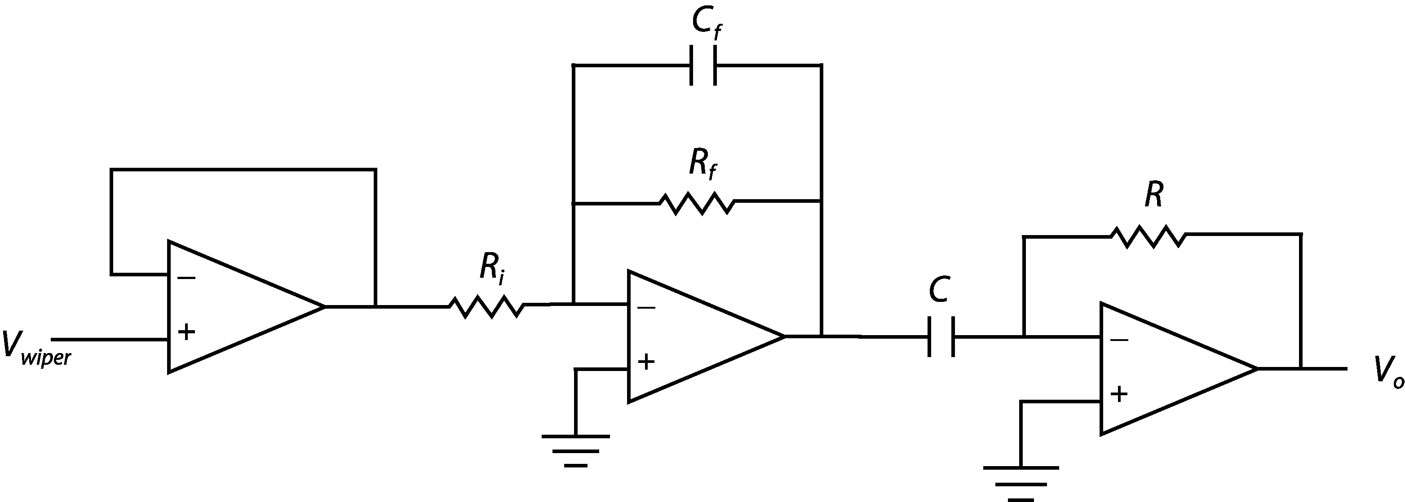
Figure 1: Buffer amplifier filter differentiator circuit.

In addition to providing angular position, potentiometers can be used to measure angular velocity using an external op-amp circuit like the one shown in Figure 1. The first stage of the circuit buffers the output of the potentiometer so as not to draw current from the wiper of the potentiometer. The second stage is a low pass filter designed so that the high frequency noise generated by the motion of the wiper will not be transmitted to the third stage. The third stage is a differentiator circuit that differentiates the angular position given by the potentiometer and outputs angular velocity. If the signal from the potentiometer were sent to this last stage directly, without the low-pass filter, the high-frequency noise produced by the wiper motion would be amplified much more than the desired signal from the potentiometer and erratic velocity measurements would result. The most important thing to avoid when using a pot in this fashion is the possibility of connecting the supply voltage or ground connection to the wiper. These connections will burn out the potentiometer when the wiper approaches the grounded or supply terminals when it rotates through the dead zone of the potentiometer.

Tachometers
A tachometer is essentially a generator—a DC motor ran in reverse. A tachometer consists of an armature that wrapped with multiple loops of copper wire. These loops of wire are connected via brushes and a commutator ring to the external electrical leads. When the shaft of the tachometer is turned, the wire wrappings rotate through a magnetic field, typically provided by a fixed permanent magnet, and this movement produces a voltage according to the Faraday effect. The voltage produced is proportional to the rate, or angular speed, of the input shaft. Assuming that the electrical leads are connected to a device with high input resistance, the output voltage as a function of angular velocity is described by the following equation.
(2)
where V_{out} is the output voltage, ω is the angular velocity in radians per second, and k_{B} is a positive constant related to the armature’s winding geometry called the back-emf constant. Equation 2 suggests that the output voltage will be positive or negative depending on the direction of the angular velocity; in other words, every tachometer has a positive and negative sense.

Although the tachometer is a convenient way to measure angular velocity, it does have drawbacks. First of all, the voltage produced by the tachometer must be read by a device with a high input resistance so that the tachometer’s output is not altered by an external resistance. In addition, the internal brushes of the tachometer create high-frequency noise as they run along the commutator ring. And the voltage produced by the tachometer is very small at slow speeds and, therefore, usually needs an external amplifier circuit. In light of these facts, it is often wise to buffer, filter, and amplify the signal from a tachometer rotating at low speeds using a circuit like the one shown in Figure 2. Note that the last op-amp in this circuit rectifies the inverted signal from the filter.
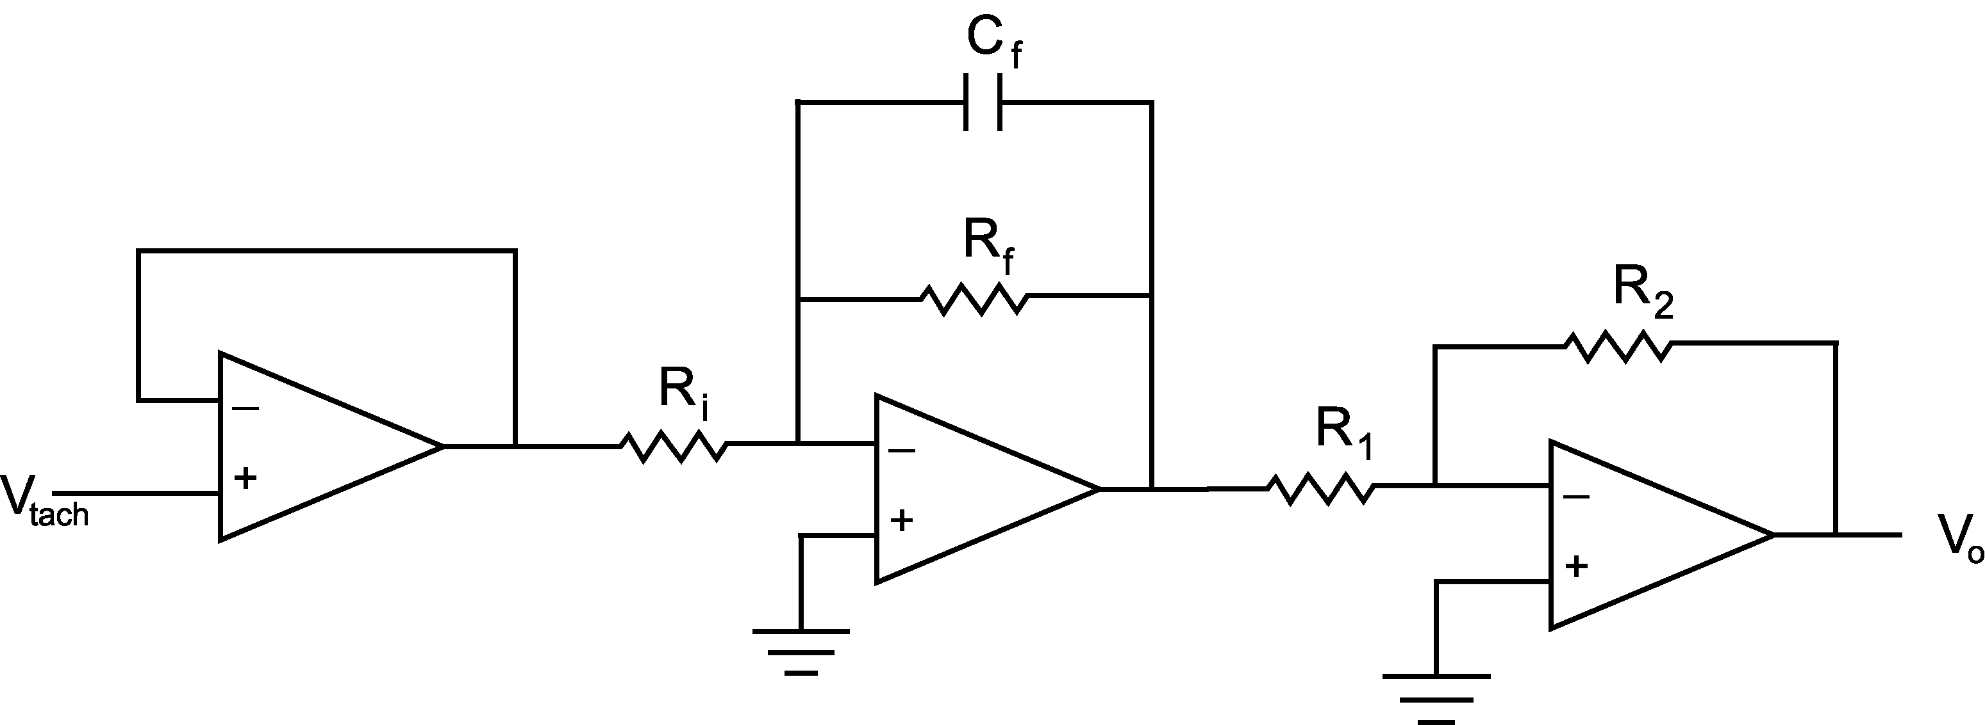
Figure 2: Buffer amplifier filter inverter circuit.

Measuring Phase
In this lab you will be required to measure the phase difference between two different sinusoidal voltage signals because the op-amp circuits used will either add or subtract phase from the input signal. The phase difference between two sinusoidal signals of the same frequency is based upon the time between the peaks of the signals and the period, T, of the signals in seconds (see Figure 3). The phase difference, φ, is defined by the following equation:
(3)
where t_{p1} is the time associated with the peak of the first signal, t_{p2} is the time associated with the peak of the second signal.
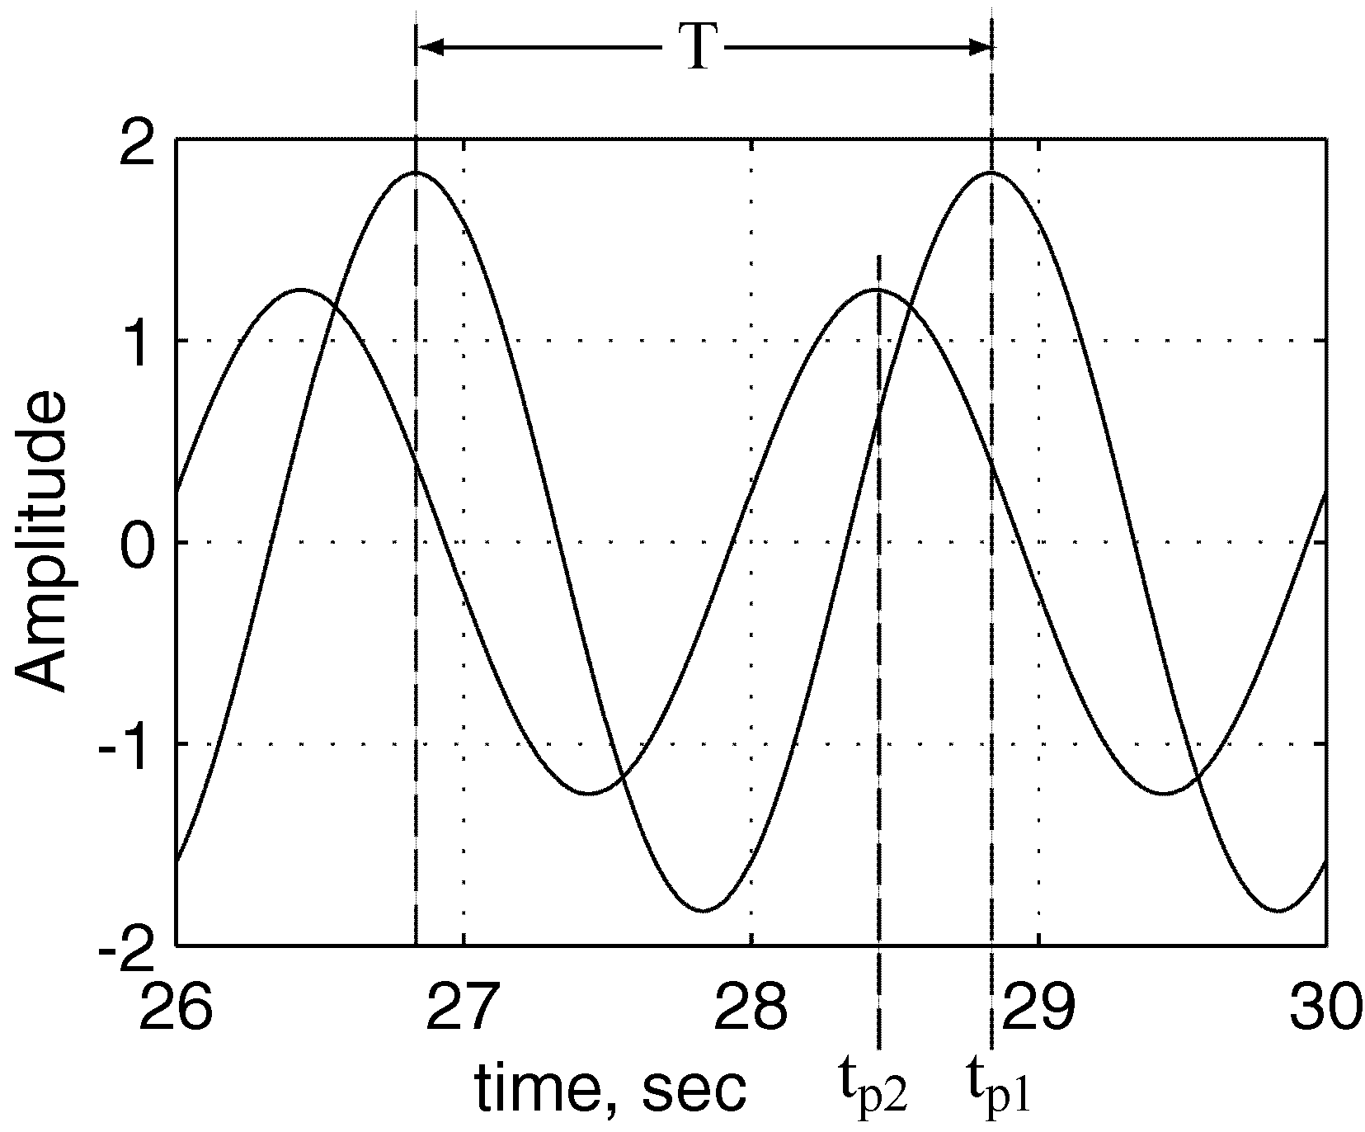
Figure 3: Measuring the phase difference between signals.

Pre-lab Exercise
In the following lab you will be required to design and build the circuits of Figure 1 and 2 above on the fly. This pre-lab is designed to help you design the circuits in the least amount of time possible. To that end, solve the following problems:

- Low-pass Filter:
  - Refer to Lab 8: Operational Amplifiers from last fall and, using Equations 13 and 14, solve resistor values of the circuit assuming that ω, ω₀, C, and V₀/V_{i} are known quantities.
  - Calculate the resistor values R and R_{f} if ω = 60 rad/s, ω₀ = 160 rad/s, C = 0.1μF, and V₀/V_{i} = 1.

- Differentiator:
  - Refer to the Pre-lab Exercise from last fall’s Lab 8. Solve for R assuming that ω, A, C, V₀, and V_{i} are known.
  - Calculate the resistor value R if ω = 60 rad/s, C = 1μF, A = 2, and V₀ = 4 V.

- Inverting Amplifier:
  - Refer to last fall’s Lab 8 and, using Equation 12, solve for R in terms of R_{f}, V₀, and V_{i}.
  - Calculate the resistor value R if R_{f} = 2 kΩ, and V₀/V_{i} = -2.

Laboratory Exercise
WARNING! The pendulum makes an effective weapon! Keep hands and heads clear!

- If on, turn off the bench power supply.

- Connect the wiper of the potentiometer (YELLOW banana jack on setup) to ACH0 on the DAQ terminal block, the 5 volts source from the bench power supply to the red banana jack and the black banana jack to ground.

- Connect the motor terminals to the bench amplifier power outputs (the + and – banana jacks) on the bench power supply.

- Turn on your function generator; set the frequency of the output to 2 Hz, and make sure that the offset knob is pushed in.

- Using a BNC tee connected to the output of the function generator, connect one output of the function generator to the BNC port on the bench power supply labeled V_{ref} and the other to the ACH1 of the DAQ terminal block.

- Turn on the bench power supply and the 24 Volt. The pendulum attached to the motor should oscillate. Adjust the amplitude and frequency of the function generator so that the pendulum oscillates back and forth without completing a full rotation. If the pendulum doesn’t oscillate about a single orientation adjust the weights on the pendulum to balance it on the shaft. Also try to avoid having the potentiometer oscillate through its dead zone.

- Open POT.exe from the CVI Projects folder on the Desktop. Make sure that the Output Signal is set to zero, the Input Signal is set to one, the Mode is set to RSE, and the Gain is set to 1.

- Choose appropriate settings for the sample rate and number of samples and press Start to collect a data set. There should be two waveforms displayed by CVI, one is the output signal from the potentiometer and the other is function generator input signal.
Note: You may notice that the output signal is offset from the input signal. This offset can be corrected by entering the amplitude of this offset in the Output Offset box of the CVI program. Update this value and take successive data sets until the offset is eliminated (record the value for future reference).

- Once the offset is properly adjusted, save a data set you collected to disk; open the data set using Excel or Matlab to verify it was saved properly. The data file contains three columns: the first column is time, the second are the output signal voltages, and third are input signal voltages.

- Measure and record the amplitudes of the signals and the phase difference between input applied to the motor and the resulting potentiometer signal in the space below (these quantities may be easier to measure using Excel or Matlab).

Input Amplitude: ____________________Volts Phase: ____________________°

Output Amplitude: ____________________Volts (rad)

- Design and build a circuit of the form depicted in Figure 1 above that will differentiate the potentiometer signal: resulting in an angular velocity measurement. Make sure that the low pass filter has a cutoff frequency that is at least twice the input frequency and that the overall gain of the circuit limits the output signal amplitude to less than five volts. Record the values of your circuit components below:
R_{i} = _______________Ω R_{f} = _______________Ω C_{f} = _____________F
C = _______________F R = _______________Ω Gain = _______________

- Connect the output from the potentiometer to the input of the differentiator circuit, and the differentiator output to ACH0 (the function generator signal remains connected to ACH1). Press Start on the CVI program and save the data to disk.

- Measure and record the amplitudes of the input and output signals and the phase difference between input applied to the motor and the resulting differentiated potentiometer signal in the space below.
Input Amplitude: ____________________Volts Phase: ____________________°
Output Amplitude: ____________________Volts (rad/s)

- Disconnect the differentiator circuit from your setup and set it aside (you will need it later).

- Connect the tachometer output to the ACH0 input of the DAQ and collect a data set with the CVI program. Make note of the amplitude of the tachometer signal.

- Design and build a circuit of the form depicted in Figure 2 above that will filter and amplify the signal from the tachometer. Again, make sure that the low pass filter has an appropriate cutoff frequency and the overall gain of the circuit limits the tachometer output amplitude to less than five volts. Record the component values of the circuit below:
R_{i} = _______________Ω R_{f} = _______________Ω C_{f} = _____________F
R₁ = _______________F R₂ = _______________Ω Gain = _______________

- Connect the output of the tachometer to the filter-amplifier circuit input (make sure that one of the tachometer ports is grounded to your circuit) and connect the output of the filter-amplifier to the ACH0 input of the DAQ. Collect a data set and verify that the circuit works properly. Save the best data set to disk.

- Measure and record the amplitudes of the input and output signals and the phase difference between input applied to the motor and the resulting conditioned tachometer signal in the space below.
Input Amplitude: ____________________Volts Phase: ____________________°
Output Amplitude: ____________________Volts (rad/s)

- Reconnect the differentiated signal from the potentiometer ACH0, connect the output voltage of the tachometer circuit to ACH1. Collect a data set and save it to disk.

- Measure and record the amplitudes of the input and output signals and the phase difference between the differentiated potentiometer signal and the conditioned tachometer signal in the space below.
Input Amplitude: ____________________Volts (rad/s) Phase: ____________________°
Output Amplitude: ____________________Volts (rad/s)

Questions:
- Briefly describe at least two advantages of using a potentiometer for both position and velocity measurement.
- Briefly describe at least two disadvantages of using a potentiometer for both position and velocity measurement.
- Briefly describe at least two advantages of using a tachometer for velocity measurement.
- Briefly describe at least two disadvantages of using a tachometer for velocity measurement.
- How could you use a potentiometer or tachometer in your robotics project?

