Force Sensors
Force and torque are not measured directly. Typically, the deformation or strain of some material is what is measured, and then the force or torque is inferred from that measurement. The deformation can be measured in many ways. If the displacement is large, as with a spring, the displacement can be read directly on a scale or linear potentiometer. If the displacement is smaller, an LVDT, encoder, or other sensitive displacement measuring transducer can be used. If the deformation is very small, strain gages can be applied.
In this laboratory experiment you will use strain gages to measure the strain of a cantilever beam that is undergoing transverse deflection as a result of force applied to tip of the beam. Your main objective will be to calibrate the system as a force sensor. The beam is clamped on one end, making it cantilevered, and strain gages are applied to this end in order to read the strain at this location. You will deform the beam by placing known weights on the free end, thus deflecting the beam and creating strain. The force exerted by the weights is proportional to the strain along the beam. This strain will be measured using strain gauges in a Wheatstone bridge configuration. You will calibrate the output of the strain gages as a function of the applied force. From this calibration, the measurements taken from the strain gages can be converted via a least-squares-fit to a linear approximation of the applied force.
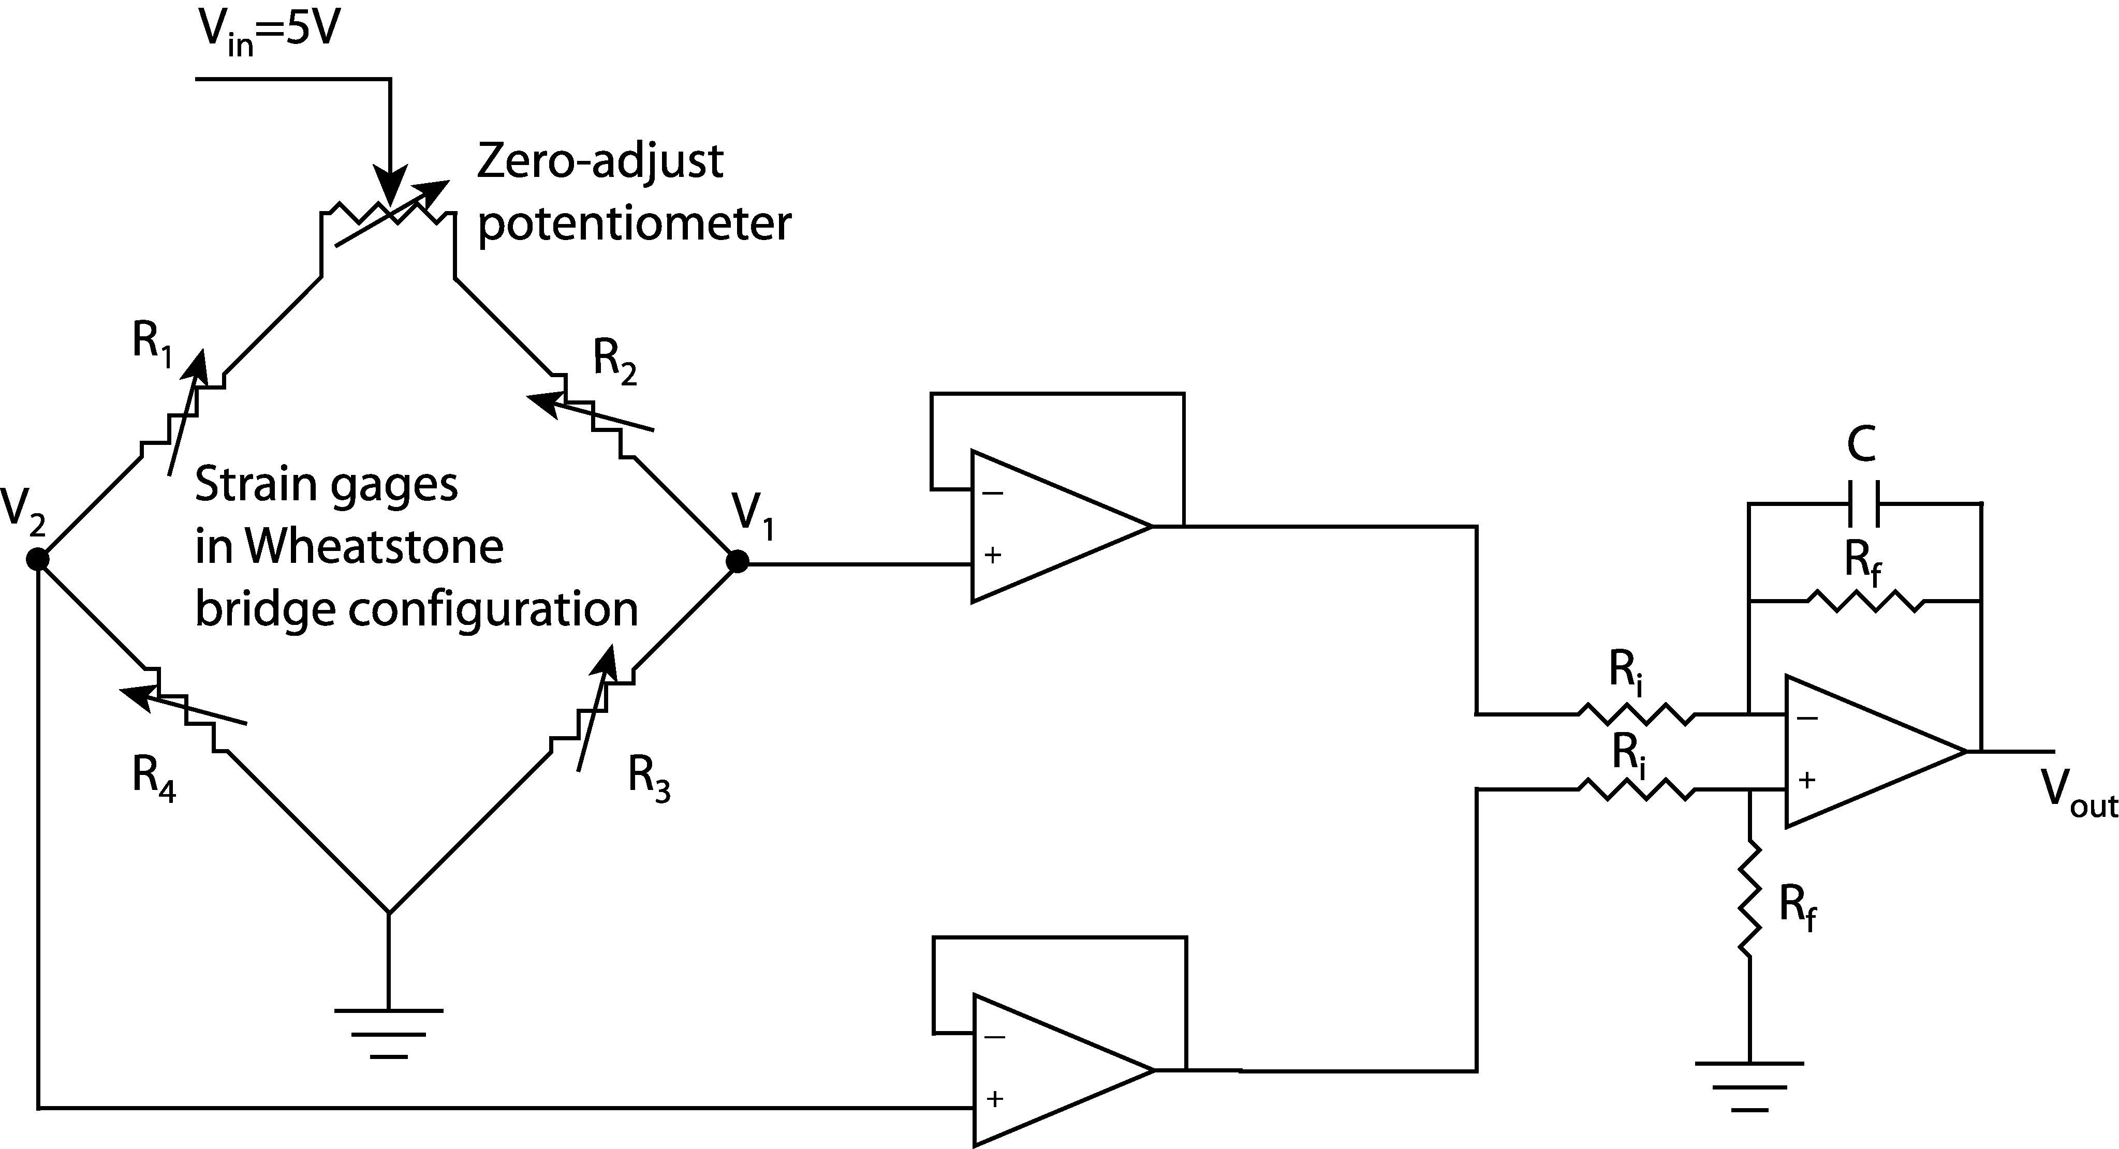
Strain Gages
Figure 1. Force measurement circuit.
A bonded metal-foil strain gage is a variable resistor whose change in resistance is proportional to the strain in the beam upon which it is mounted. It is important that the gage adheres well to the beam to obtain accurate results and that the grid from which the gage is constructed is properly aligned in the direction of the deformation. A common force sensor utilizes four gages. Two gages are mounted on the bottom of a beam, and two are mounted on the top. They are wired to form a Wheatstone bridge circuit as in Figure 1, which provides maximum sensitivity to the very slight changes in resistance. The zero-adjust knob is a potentiometer whose task is to manually ensure that V₁ and V₂ are equal under no load conditions (balance the bridge). Upon inspection of the rest of the Wheatstone bridge, it can be seen that each side is a voltage divider. The voltage V₁ can be determined using the voltage divider law as follows:
(1)
Similarly, the voltage V₂ is
(2)
The difference between V₂ and V₁ gives a highly sensitive and accurate measurement of the strain experienced by the beam at the location of the strain gages. The voltage that corresponds to this strain, V_{ε} is simply stated:
(3)
It is assumed that the strain gages are all uniformly similar. When the bridge is balanced and there is no load applied to the end of the beam, R₁ = R₂ = R₃ = R₄ = R. When a load is applied to the beam in the –y direction, strain gages 1 and 3 experience tension when a force is applied, and gages 2 and 4 experience compression. The resistance of any particular strain gage changes by an equal in magnitude value of ΔR as its surface area increases (+ΔR, tension) or decreases (-ΔR, compression), or ΔR₁ = -ΔR₂ =ΔR₃ = -ΔR₄ = ΔR. After the force is applied to the beam, equation (3) becomes
(4)
This shows a linear relationship between V_{ε} and ΔR.
The op-amp circuit on the right of Figure 1 consists of two buffers to protect the gages and a differential amplifier. The differential amplifier has two jobs: it subtracts one signal from another, and it multiplies this difference according to the relationship
(5)
Looking at Equation (3) reveals that this differential amplifier amplifies the signal coming from the Wheatstone bridge, V_{ε} according to the following relation:
(6)
where A is the gain of the differential amplifier.
Mechanical Strain
Figure 2 shows the beam with the gages attached. Note that gages 1 and 3 are mounted on the top of the beam, and that gages 2 and 4 are mounted on the bottom. The dimensions of the beam are labeled as width b, thickness h, and length . A point force of magnitude F is applied to the free end of the beam in the –y direction.
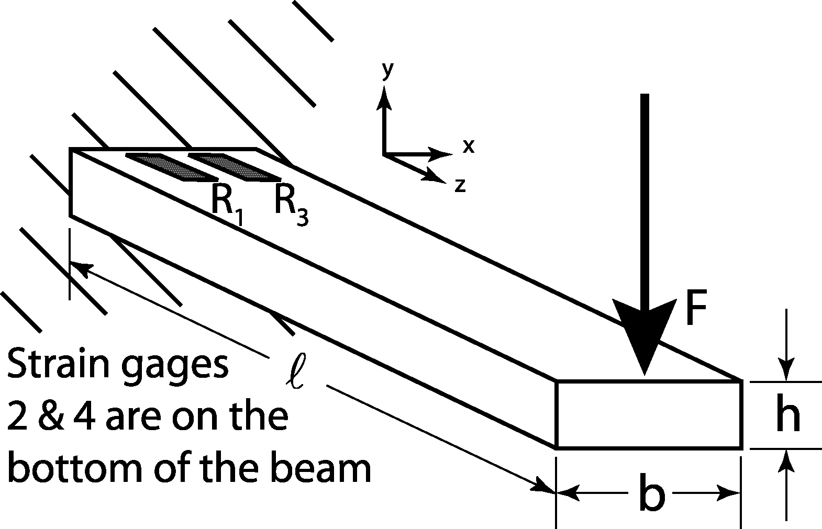
The strain gages are measuring strain, which is a mechanical parameter. Mechanical strain ε is defined as the change in length Δ per unit length  of a material under loading conditions. In mathematical terms, this last statement is
Figure 2. Cantilever beam with strain gages attached.
(7)
Note that strain is a unitless quantity, but units such as in/in are commonly used. Mechanical stress σ is defined as the amount of force per unit area experienced by the material at any given point within the material. Note that the stress in a loaded material generally varies throughout the material. Within a certain region, stress and strain are related through Hooke’s law for linear springs, where the spring constant is Young’s modulus, or the modulus of elasticity. The relationship is as follows:
(8)
The unit of Young’s modulus is the same as that for stress. Stress can be determined in a material by using Euler’s beam equation
(9)
where M is the moment experienced at the point in question (M=F), c is the distance to the midline of the material (c=h/2), and I is the area moment of inertia, which can be determined by the following relation:
(10)
Upon substitution and reduction, the strain can be determined theoretically by the following equation:
(11)
Of all the parameters on the right-hand side of equation (10), only F is a variable. This shows a linear relationship between the applied force and the resultant strain.
As discussed before, a strain gage is a variable resistor whose resistance changes as its surface area changes. Its surface area changes as a result of the strain experienced by the material upon which it is mounted. A parameter is defined for a strain gage relating its change in resistance to the strain of the material upon which it is mounted. This parameter is known as the gage factor GF. The gage factor takes into account the information known from equation (4) to determine the strain defined in equation (6) as follows:
(12)
In reality, the gage factor will be different for each strain gage, even those from the same batch. A certain model of strain gage is assigned an average gage factor from tests performed by the manufacturer. Since the manufacturer supplies an approximate value for the gage factor, and V_{out} and V_{in} can be measured directly, the strain can be determined as follows
(13)
Fortunately, "For such an application, the gage factor need not be accurately known since the overall system can be calibrated by applying known displacements to the end of the beam and measuring the resulting bridge output voltages." (Doebelin, Measurement Systems, 1990).

Laboratory Exercise
This is the first of a two-part lab. You will use your results from the force measurement setup from this lab to later construct a dynamometer. If you are careful and take your time with this part of the lab then your next lab will go much more smoothly. Be sure to make note of the element values used in your circuit for the next lab. Be sure also to bring your calibration constant with you next week and to use the same station, as each setup is slightly different.
- The strain gages will provide a very weak signal. You will want to boost this signal to obtain usable results. You will need to connect the bridge to the instrumentation amplifier shown in the right half of Figure 1. Additionally, you may need to apply one or two cascading amplifier stages after the stage shown below in order to boost the signal. Use a capacitor in the feedback path of your amplifier to filter the signal (recall the exercise on operational amplifiers). Make note of the resistor and capacitor values you used for the next lab.
- Use a voltmeter to measure the output voltage of the bridge for different masses placed on the end of the beam. Use the zero-adjust knob to balance the bridge circuit. If the output decreases with added load, swap the wires to V₁ and V₂. Convert the mass to force. Record several different readings for different applied masses.
Force | Voltage | Force | Voltage | Force | Voltage
- Use the grid provided to plot the data you just collected. Using a straight-edge and your best judgment, draw a straight line through the data. Measure the slope of the line - rise over run - and find the y-intercept. Write down the equation for the line.
The slope of the line is the calibration coefficient.

- Use the least squares method (also known as linear regression) to obtain the best first-order relationship between the data. The slope of this line will be the calibration coefficient. As you may recall, the least squares fit of two data sets to a line can be obtained by

Calibration coefficient
Compare with your results from step 3.
- Use a plotting application, such as Excel or Matlab, to plot of the output voltage versus load. Use the software to get the equation for the best fit line and compare it to your results from steps 3 and 4. Write the calibration coefficient here.
- Measure the length of the beam. What is the torque calibration coefficient?
- Explain any anomalies - differences from theory or what you thought should happen. Is a linear approximation sufficient to describe and predict the relationship between load and output voltage?

