ME 3210 Mechatronics II Laboratory

Lab 3: Dynamometer II: DC Motor Torque-Speed Curve

Introduction
The goal of this exercise is to measure and plot the torque-speed curve for a DC electric motor. The lab procedure builds on the concepts and data collected in the previous lab exercise. You will use the calibration coefficient you determined in the last lab with the lab setups to form a dynamometer. Using this dynamometer you will obtain a torque-speed curve for the DC motor of the lab setup.

Torque-Speed Curve
A permanent magnet DC motor can easily be characterized by its torque-speed curve. The torque T provided by the motor is proportional to the rotational velocity ω at which it is operated. The relationship between torque and rotational velocity can be stated as follows:
(1)
where K₁ is a coefficient of proportionality whose magnitude is the slope of the line described by the torque as a function of the speed and K₂ is the intercept of the torque axis, generally known as the stall torque. Note that the negative sign implies that the torque output will decrease as rotational speed increases. The linear relationship between the torque provided by a DC motor and the speed at which it operates is specific to the input voltage. This is demonstrated in Figure 1, which shows the relationship between torque and speed, as well as the fact that this relationship is actually a family of curves that depend on the input voltage. Note that the torque-speed curve moves up and to the right with increasing input voltage.
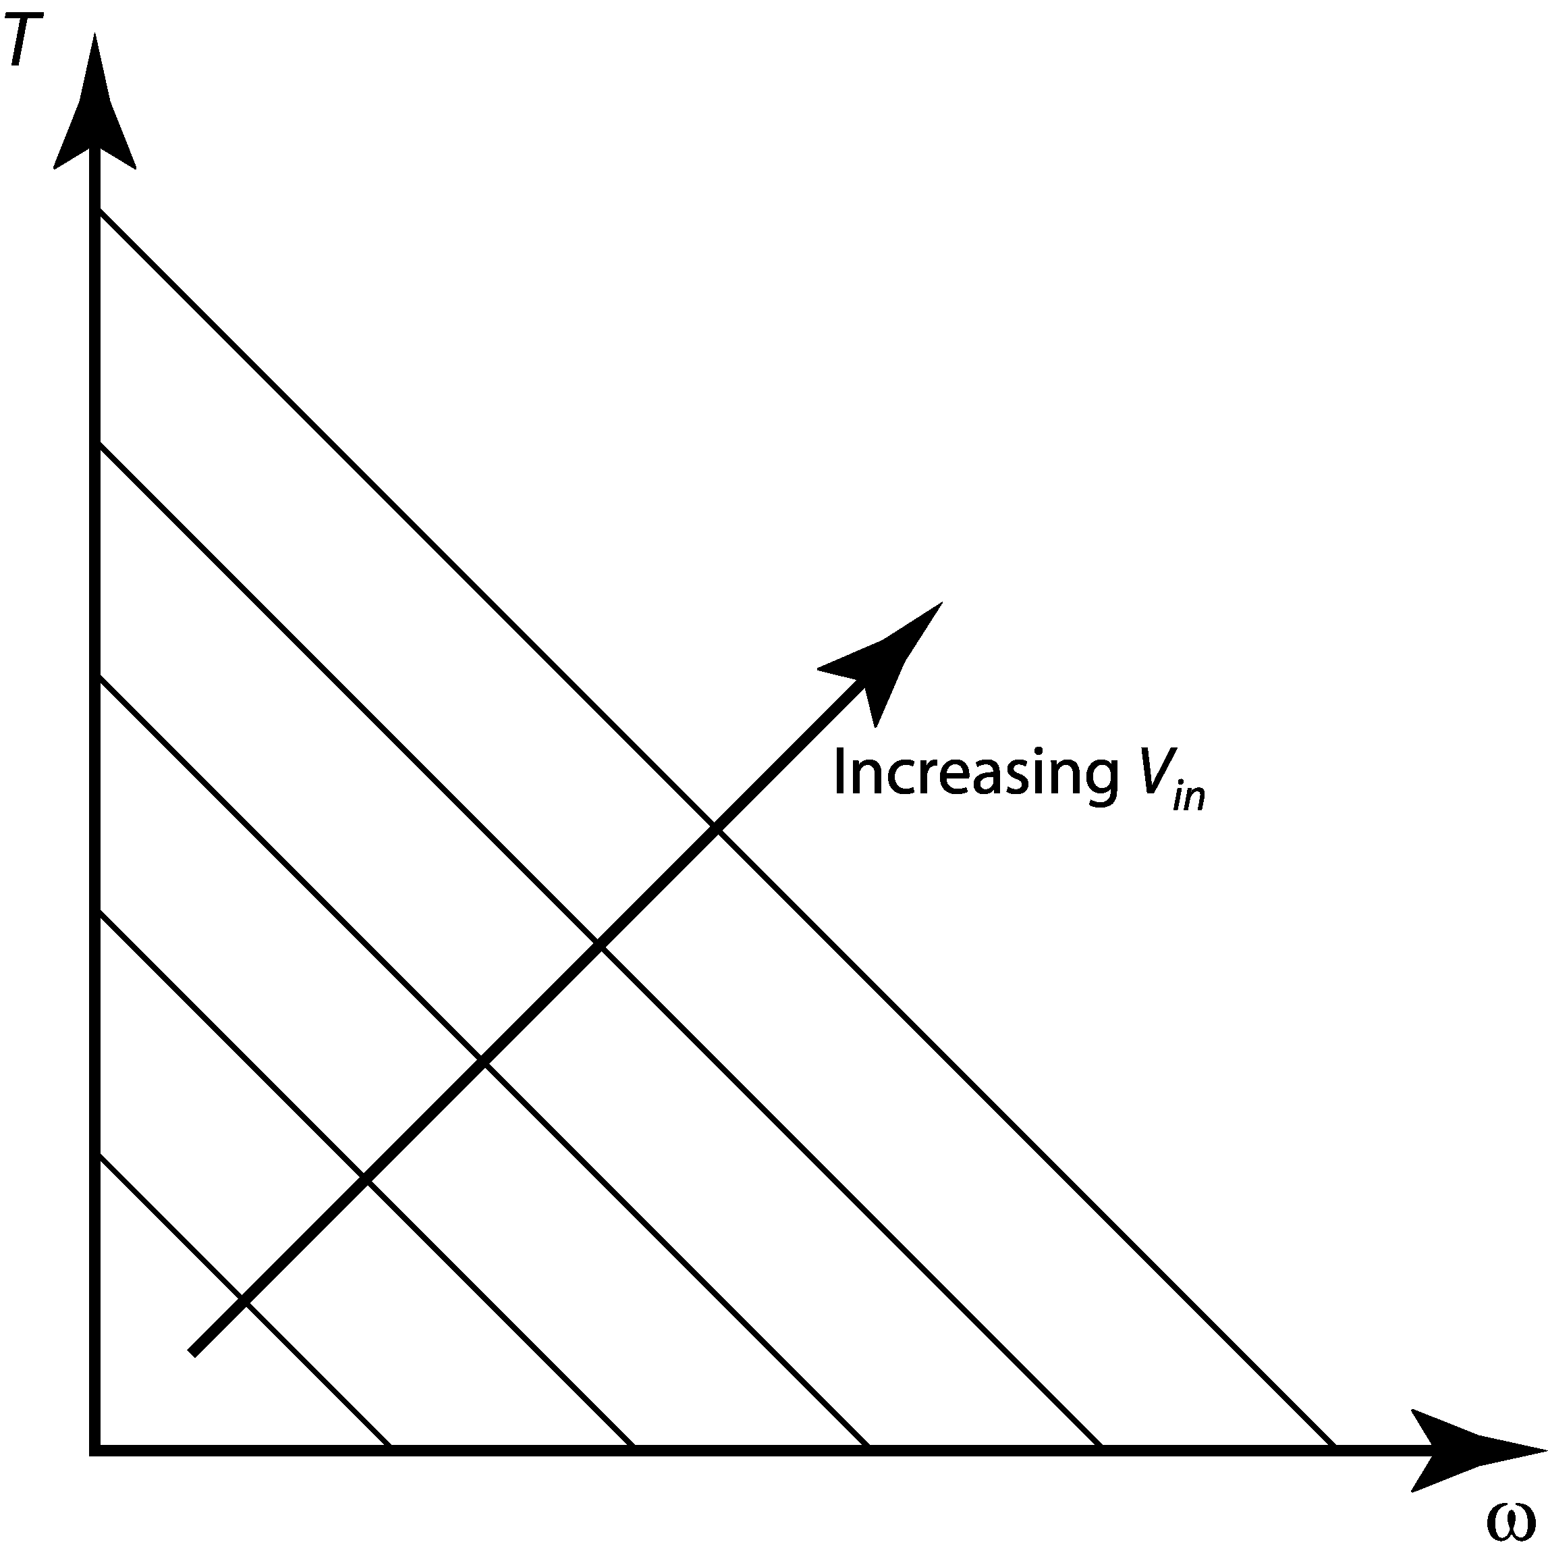
Figure 1: Family of torque-speed curves.
The torque provided by the motor when the rotor no longer turns is known as the stall torque, as introduced above. The stall torque for a particular motor at a specific input voltage is where the torque-speed curve intersects the torque axis. The speed at which the rotor turns when no torque is provided is known as the no-load speed. The no-load speed is called as such since it is the speed at which the rotor will turn when there is no load connected. Although it is assumed that at no-load speed no torque is provided, some torque is required to keep the inertia of the rotor turning and to overcome frictional torques.

The torque-speed curve of a DC motor indicates the total amount of power that the motor is capable of providing given a specific input voltage. For rotational motion, power P is defined as the product of the torque and the rotational velocity (see Equation 2).
(2)
Note that at stall torque and at the no-load speed, theoretically no power is expended at the motor output. Substituting Equation 1 into Equation 2 to get the power as a function of the speed reveals a quadratic:
(3)
Notice that the vertex of this parabola is a maximum, which implies the point of maximum power output.

Dynamometers
Dynamometers measure the torque and the speed of a motor. From these measurements engineers plot the torque speed curves for the motor and calculate its power output as a function of rotational speed. To create the torque speed curve it is necessary to obtain many torque-speed data points. Typically, a brake is used to load the motor at increasingly higher torques, a torque sensor is attached to the brake so that the torque produced by the motor is measured, and a tachometer is used to measure the rotational speed of the output shaft.

In this experiment, the dynamometer consists of a DC motor, a particle brake, a tachometer, a load cell, an op-amp circuit, and a data acquisition system. A simple schematic of the experimental setup is provided in Figure 2.
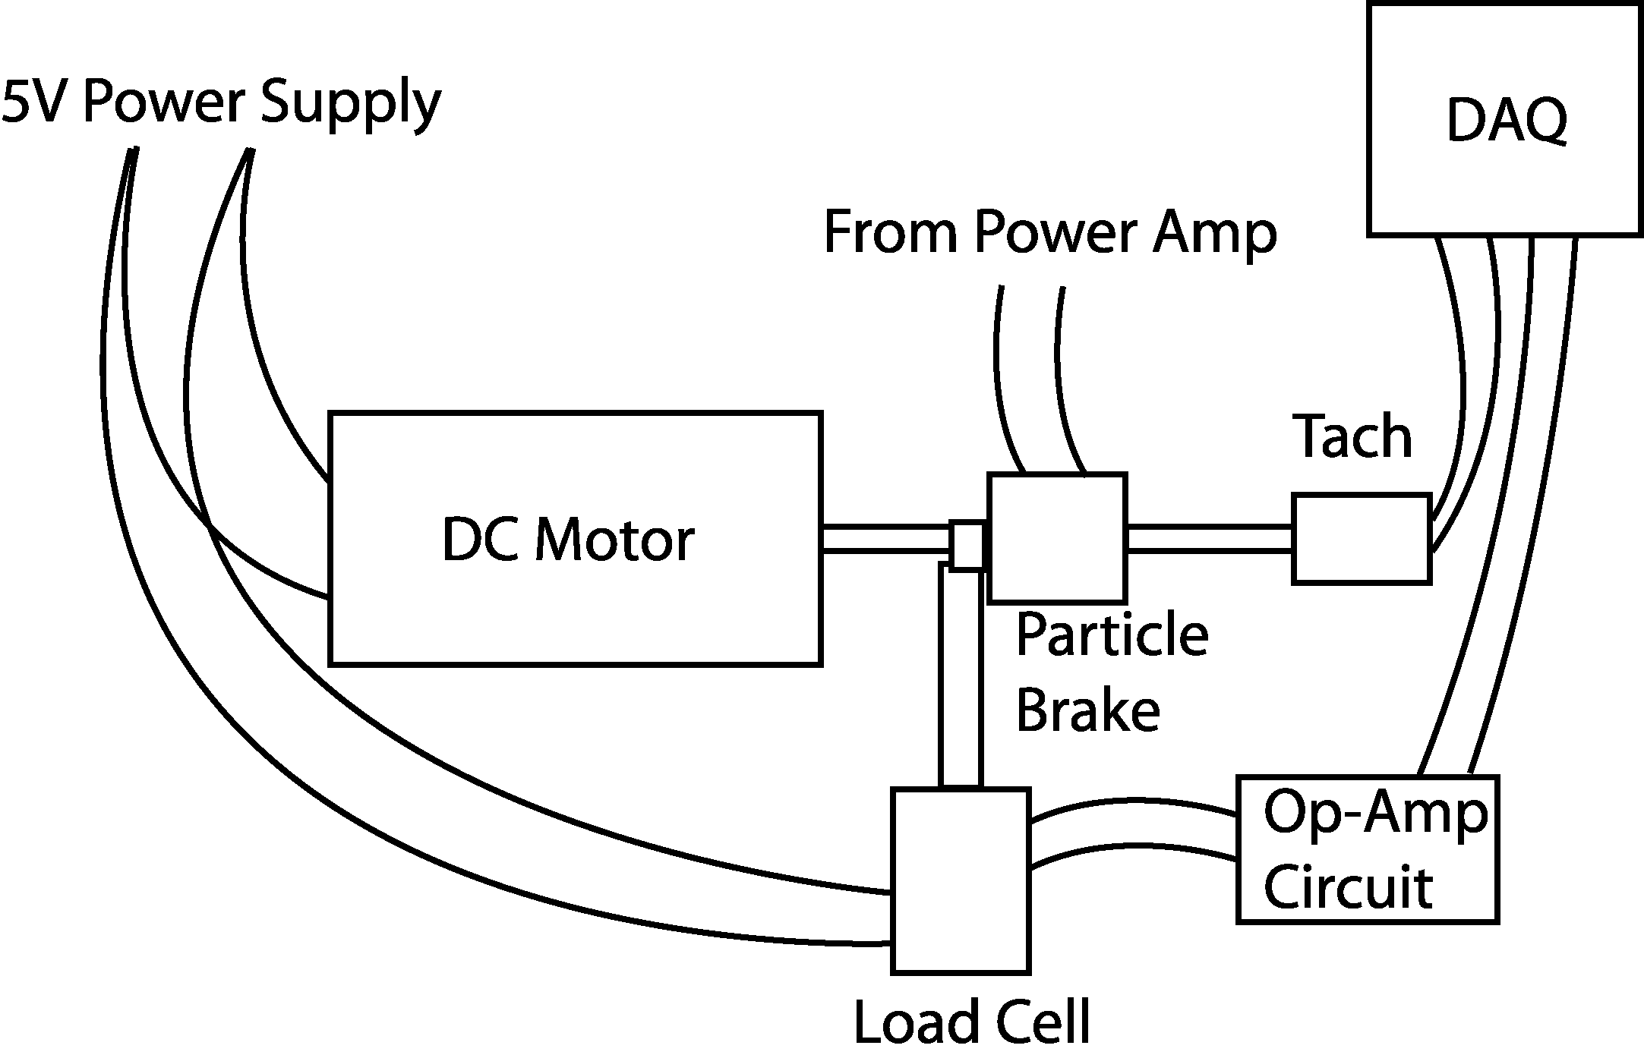
Figure 2: Experimental setup schematic.
Take a look at the mounted hardware, there is a magnetic particle brake attached between the motor and the tachometer. A constant voltage will drive the motor from the bench power supply. A clamp attached to the particle brake will be attached to the cantilever force transducer that you calibrated in the previous lab. The particle brake will be controlled from the computer via the power amplifier. The computer will use CVI to generate the signal to the particle brake. The voltage will incrementally step up creating an incrementally larger load torque on the motor. After each increment of the particle brake voltage signal, adequate time will pass to allow the system to reach steady-state conditions. Voltage levels will then be taken from the load cell and the tachometer, which can then be translated into torque and speed, respectively. The CVI program automatically converts the tachometer signal to speed in rad/sec using the calibration coefficient supplied by the manufacturer, namely 0.5V/1000rpm.

Pre-lab Exercise
Show that the maximum power output for a permanent magnet DC motor is:
(4)

Hint: Look at Equations 1-3, set the derivative of Equation 3 equal to zero and solve.

Laboratory Exercise
- Find the lab handout you used for the last experiment, verify that you have the correct experimental setup, locate the resistor and capacitor values you used for the differential amplifier, and rebuild the circuit.

- Connect the load cell to the power supply and the op-amp circuit and balance the Wheatstone bridge according to the directions in the previous lab handout.

- Make sure the power supply is off; using banana cables connect the positive terminal of the motor (red) to the 5V power supply and the negative terminal (black) to ground.

- Connect the bench power amplifier input (V_{ref}) to the DAC0OUT of the DAQ breakout box and connect the power amplifier output (Power + -) to the particle brake inputs (blue input is -).

- Connect the output from your op-amp differential amplifier circuit to ACH0 and connect the tachometer to ACH1.

- Open the CVI program folder on the computer desktop and double click the CVI program entitled DYN.exe.

- Turn on the power supply and click the START button on the user interface. When the CVI program finishes it’s data collection save the data to your disk; open the file with Excel and verify the data looks correct. The first column will be speed, and the second column will be voltage from the load cell amplifier circuit.

- With your data in Excel convert the voltage data from the load cell amplifier using the calibration coefficient you determined in the last lab; save the spreadsheet as an Excel file to your disk.

- Repeat step seven three more times. After each run add the data to your Excel spreadsheet.

- With the data in Excel average the four data sets, convert the voltage data into torque measurements, and plot the torque-speed curve for the lab DC motor operated at 5V (label axes and provide units where applicable).

- Use linear regression to calculate the slope and intercept of the torque-speed curve to determine the coefficients of Equation 1 above; record the values in the space provided.
K1= ___________________ N-m-s K2 = ___________________ N-m

Questions
- Estimate the stall torque of the motor from your data.
- Estimate the no-load motor speed from your data.
- Determine the maximum output power of the motor from your data.
- Are the preceding estimates accurate? Explain at least three significant sources of error.

