The goal of this exercise is to measure and plot the torque-speed curve for an electric motor. The principle, the use of a dynamometer to obtain a torque-speed curve, is generally used for many motors and engines.

Pre-lab Exercise
Show that the maximum power output for a permanent magnet DC motor is:
(Hints: Look at equations (1), (2), and (3). Set the derivative of (3) equal to zero to determine the location of the extremum.)

Torque-Speed Curve
A permanent magnet DC motor can easily be characterized by its torque-speed curve. The torque T provided by the motor is inversely proportional to the rotational velocity ω at which it is operated. In mathematical terms, this fact can be stated as follows:
(1)
where K₁ is a coefficient of proportionality - which is the magnitude of the slope of the line described by the torque as a function of the speed - and K₂ is the intercept of the torque axis, generally known as the stall torque. Note that the negative sign implies inverse proportionality. The linear relationship between the torque provided by a motor and the speed at which it operates is specific to the input voltage at the motor’s leads. This is demonstrated in Figure 1, which shows the inverse proportionality of torque to speed, as well as the fact that this relationship is actually a family of curves. Note that the torque-speed curve moves up and to the right with increasing input voltage.
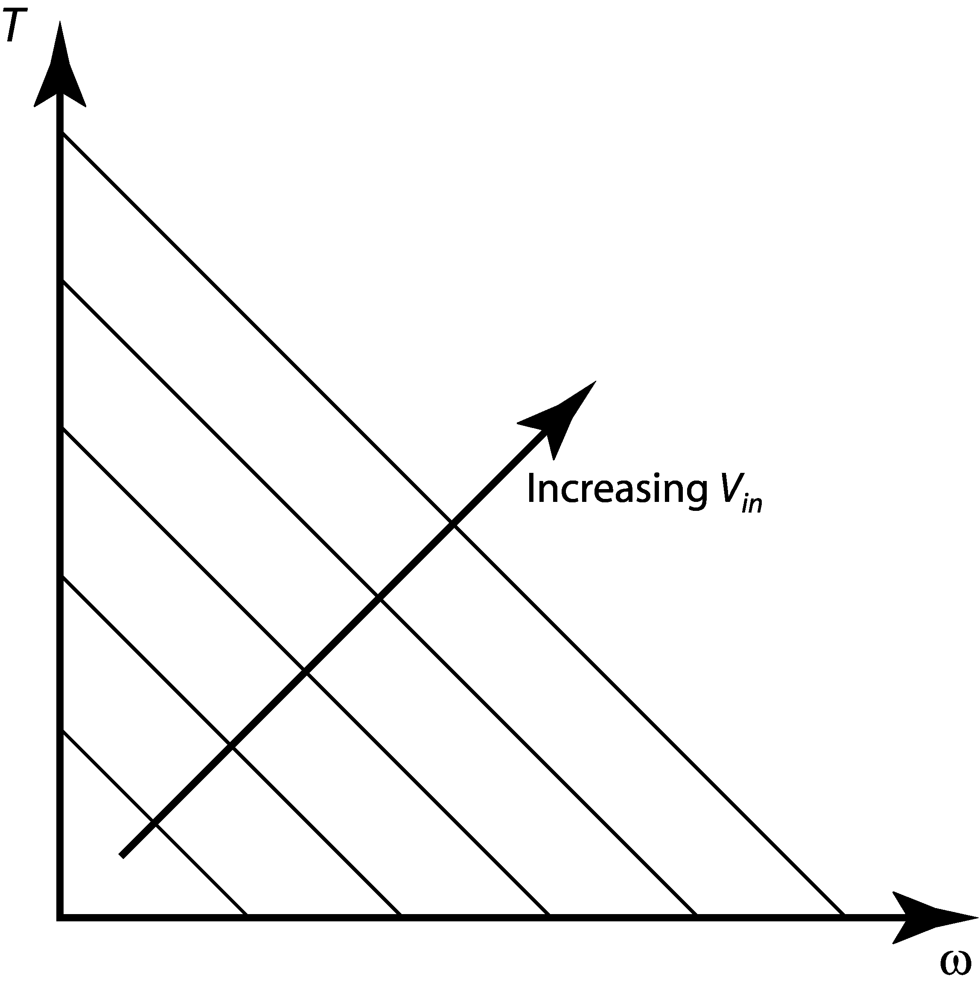
Figure 1. Family of torque-speed curves.
The torque provided by the motor when the rotor no longer turns is known as the stall torque, as introduced above. The stall torque for a particular motor at a specific input voltage is where the torque-speed curve intersects the torque axis. The speed at which the rotor turns when no torque is provided is known as the no-load speed. The no-load speed is called as such since it is the speed at which the rotor will turn when there is no load connected. Although it is assumed that at no-load speed no torque is provided, some torque is required to keep the inertia of the rotor turning and to overcome frictional torques.

The power output should be considered when operating a DC motor. The power P is calculated by multiplying the torque by the speed as follows:
(2)
Note that at stall torque and at the no-load speed, theoretically no power is expended at the motor output. Substituting Eq. (1) into Eq. (2) to get the power as a function of the speed reveals a quadratic:
(3)
Notice that the vertex of this parabola is a maximum, which implies the point of maximum power output.
Dynamometers
Dynamometers measure the torque and the speed of a motor. From these, power is easily calculated. It is desired to make a torque-speed curve for the motor. To do this, it is necessary to obtain many torque-speed data points. Typically, a brake is used to load the motor at different torques. A torque sensor is attached to the brake so that the torque produced by the motor going to the load (the brake) is measured. A tachometer is used to measure the speed.

In our experiment, the dynamometer consists of the DC motor, a particle brake, a tachometer, a torque sensor, a control unit, and a data acquisition system. A simple schematic of the experimental setup is provided in Figure 2.
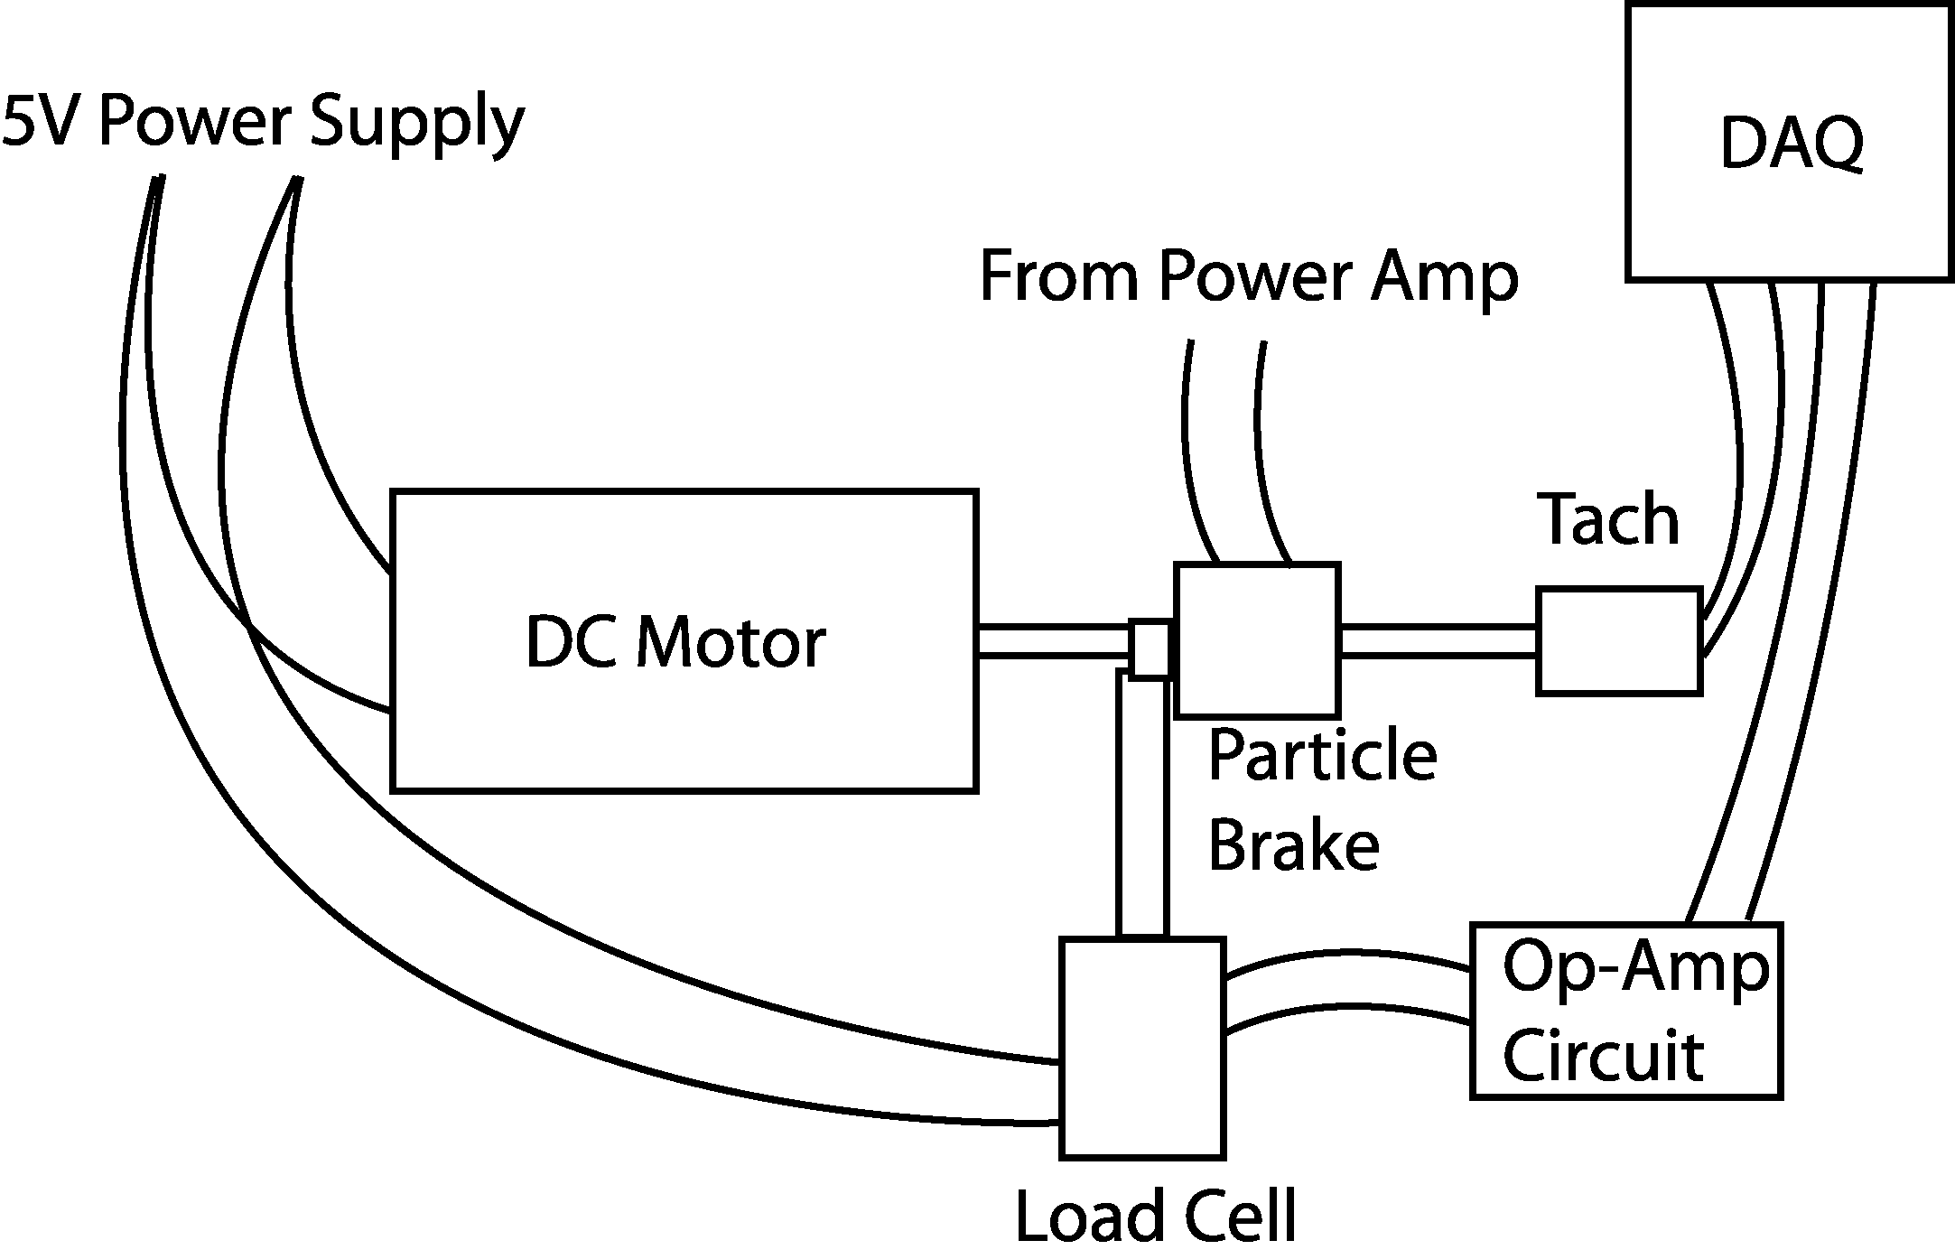
Figure 2. Experimental setup schematic.
Take a look at the mounted hardware, there is a magnetic particle brake attached between the motor and the tachometer. A constant voltage will drive the motor from the bench power supply. A clamp attached to the particle brake will be attached to the cantilever force transducer that you calibrated. The particle brake will be controlled from the computer via the power amplifier. The computer will use CVI to generate the signal to the particle brake. The voltage will incrementally step up creating an incrementally larger drag torque on the rotor. After each step up on the particle brake voltage signal, adequate time will pass to allow the system to reach steady-state conditions. Voltage levels will then be taken from the load cell and the tachometer, which are then translated into torque and speed, respectively. The CVI program automatically converts the tachometer signal to speed in rad/sec from the calibration coefficient supplied by the manufacturer, namely 0.5V/1000rpm. You will need to use the torque calibration coefficient that you experimentally derived last time to convert the load cell signal to torque.

Experiment:
- Find the lab handout you used for the last experiment. Locate the resistor and capacitor values you used for the differential amplifier and rebuild the circuit.
- Connect the load cell to the power supply and the op-amp circuit and balance the Wheatstone bridge just like last time.
- Make sure the power supply is off. Connect the motor to the 5V power supply and ground.
- Connect the bench power amplifier input to AO_CH0 and AO_GND using a banana to BNC cable. Connect the power amplifier output to the particle brake.
- Connect the output from your circuit to AI_CH0. Connect the tachometer to AI_CH1.
- Start the CVI program entitled DYN. Turn on the power supply and click the START button on the user interface. Save the data to disk. The first column will be speed, and the second column will be voltage from the load cell amplifier circuit, which you will need to convert to torque.
- Sensors are normally quite noisy. You may choose to take several sets of data and average the results or ignore outliers.
- Use Excel or Matlab to convert the load cell data to torque. Plot the torque-speed curve for the lab DC motor operated at 5V.
Questions:
- Estimate the stall torque of the motor from your data.
- Estimate the no-load motor speed from your data.
- Determine the maximum output power of the motor from your data.
- Are the preceding estimates accurate? Explain at least three significant sources of error.

