ME 3210 Mechatronics II Laboratory

Lab 4: DC Motor Characteristics

Introduction
Often, due to budget constraints or convenience, engineers must use whatever tools are available to create new or improved systems. While doing so they may use equipment that they understand, but don’t have sufficient data to model their performance. This lab exercise simulates this scenario by having you measure the lumped parameters needed to model a DC Motor.
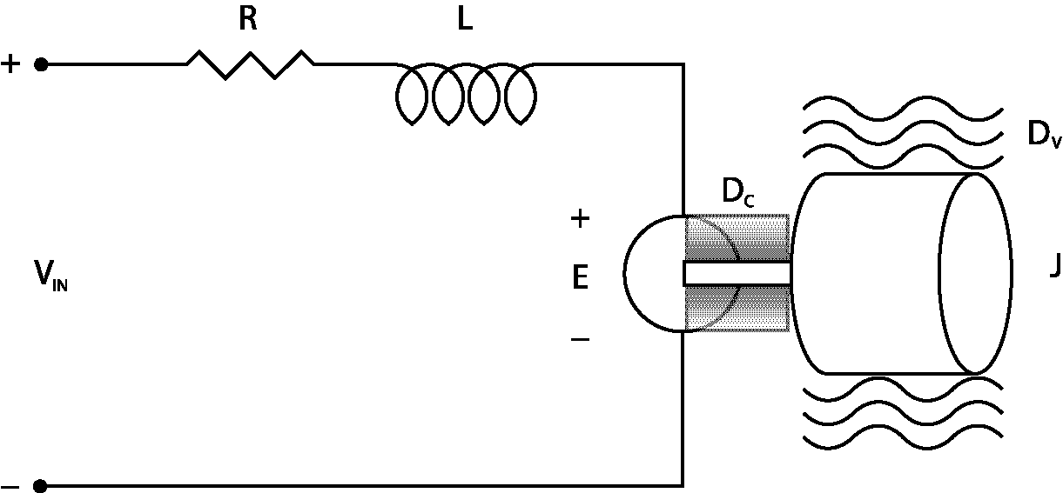
Figure 1: Simple schematic of a DC motor connected to a rotary inertia with viscous damping.
An electromechanical model for a DC Motor is shown in Figure 1. Table 1 below summarizes the parameters required to determine the transfer function of the system in Figure 1.
Table 1: DC Motor Parameters.
Name | Motor Resistance | Inductance | Back EMF Constant | Motor Torque Constant | Mechanical Time Constant | Coulomb Drag | System Rotational Inertia | Electrical Time constant | Viscous Drag
Symbol | R | L | K_{e} | K_{t} | _{mech} | D_{c} | J | _{elec} | D_{v}
SI Units | Ω | H | V/rad/s | N-m/A | s | N-m | kg-m² | s | N-m-s

The applied voltage is V_{in}. The copper windings in the motor cause a certain amount of resistance and electrical inductance, labeled R and L. As the rotor spins, a voltage is induced which is in opposition to the applied voltage. This is known as the back electromotive force, or the back EMF, labeled E in the figure. The back EMF is linearly related to the motor's angular velocity  by the constant K_{e}, which is known as the back EMF constant. Kirchhoff's voltage law around the electrical circuit yields
(1)
where I is the current in the motor windings in amperes. The output torque of the motor is linearly related to the motor current I by the constant K_{t} as follows:
(2)
where K_{t} is the motor’s torque constant. It can be shown from conservation of energy that K_{t} must be proportional to K_{e}, resulting in the following conversions:
(3)
(4)
Notice that if SI units are used (Equation 3), the same numeric value is kept for the motor constant and the back EMF constant.
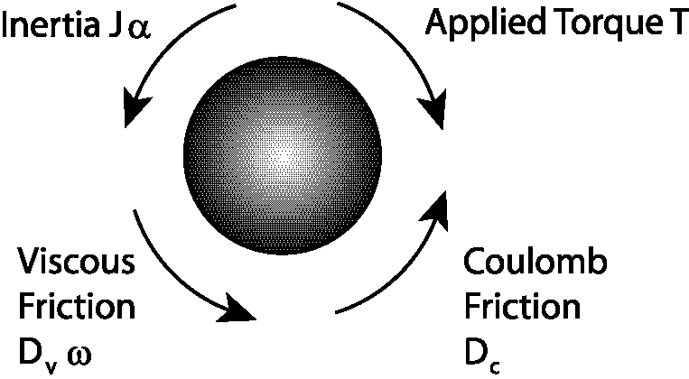
Figure 2: Mechanical side torque balance.
Now we turn our attention to the mechanical part of the system: the rotational inertia. Figure 2 is a free-body-diagram of the torque balance on a DC motor rotor that has no external disturbance torque. Summing the torques (Kirchhoff's current law) results in:
(5)
where signum(ω) means “the sign of ω”. In other words, coulomb friction is independent of velocity, but that the sign of D_{c} changes with . As the velocity increases, viscous drag increases the mechanical loss due to friction. Examples of viscous drag include lubrication in the bearings and aerodynamic drag caused by the load moving in air. The total friction as a function of rotational velocity is depicted in Figure 3.
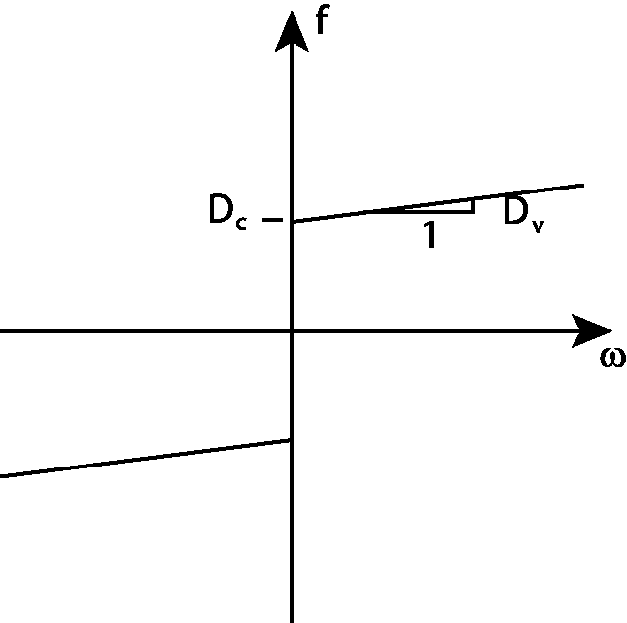
Figure 3: Friction versus angular velocity
Upon inspection of Figure 3 we note that Equation 5 is nonlinear and cannot be modeled with linear techniques. However, when steady-state conditions are satisfied for DC input, the inductance and inertial terms in Equations 1 and 5 vanish, resulting in the following linear equations:
(6)
(7)
It should be mentioned that the lab setups used for this lab do not just consist of a DC Motor. Each setup is mechanically connected to a tachometer, potentiometer, and a rotational inertia. The tachometer, connection equipment, and the other components of the structure affect the inertia and friction forces that will be measured in this lab. The parameters you obtain from this exercise will characterize the whole system, not just the motor. This type of procedure is known as lumped parameterization.

Laboratory Exercise
In this experiment the computer controls the speed of the motor via the power amplifier found on the lab benches.

Determining R, K_{e}, K_{t}, D_{v} and D_{c}.
- Measure the gain of the power amplifier.

  - Connect the 5-Volt power supply to the power amplifier’s input (V_{ref}) using a BNC cable and a BNC to banana adapter (make sure the black lead of the banana adapter is grounded).

  - Turn on the 24-Volt power supply by flipping the light switch at your station up and turn on the 5-Volt power supply.

  - Use a voltmeter to measure the output voltage of the power amplifier (remember the power amplifier outputs are the white and yellow plugs below the word POWER on your bench top power supply).
Voltage from Power Amplifier: ____________________ V.

  - Disconnect the 5-Volt supply from the power amplifier’s input and measure the exact voltage supplied by the 5-Volt supply with a voltmeter.
Voltage from the Power Supply: ____________________ V.
  - Record the amplifier’s gain: ____________________.

- Using a BNC cable, connect the DAC0OUT port of the DAQ breakout box to the input of the power amplifier (V_{ref}) on the bench power supply.

- Connect the motor leads to the power amplifier output plugs (white and yellow plugs) using banana cables.

- Connect the tachometer output to the ACH0 port of the DAQ using a BNC cable and a BNC to banana adapter and ground one of the leads of the tachometer.

- Connect the EXTREF port of the DAQ to the same ground used to ground the tachometer with the black lead of the BNC to banana adapter needed required for the connection.

- Underneath the monitor shelf, behind the POWER connection near the black power amplifier box, there is a white banana jack connected to a current sensor on the amplifier. This output port provides a voltage output proportional to the current sent to the motor. Connect this output to the ACH1 port of the DAQ and make sure the BNC cable shares the same ground as the previous connections (black banana to ground).

- Check your connections and if unsure, have your TA look over your setup before you turn on the power amplifier (24 Volt switch at your station).

- Open MOTORS.exe from the CVI program folder on the computer desktop; in the gain field, type the gain you measured from step one above. In addition, make sure that the correct input channels are selected for the sensors.

- Turn on the 24 Volt power supply and click on the start button of the CVI program; the motor should run in increments of 0.1 volts from –5 V to 5 V.

Note: The motor’s rotational inertia will spin very fast at this stage in the experiment. Make sure that you keep your hands and other precious items away from the rotational inertia. We also recommend supporting the mechanical breadboard of the experimental setup to reduce vibration and the possibility of the setup falling off the bench top.

- Once this is complete, two plots are shown in the CVI program displaying the data. Determine whether the data shown is consistent with your expectations. One plot should resemble Figure 3 above and the other should show a linear relationship between V/ω and I/ω. Ask your TA if you are unsure of your results.

- Once you are satisfied with the data you have collected, save the data to disk by clicking the SAVE button. The data is saved in three different columns corresponding to speed in rad/s, input voltage to the motor in volts, and armature current in amps.

- Manipulate Equation 6 to create a linear expression makes R the slope and K_{e} the y-intercept.

- Open the data you just collected in Excel or Matlab and determine R and K_{e} using linear regression. Record the values you calculate for each below:
R = ____________________ Ω K_{e} = ____________________ V-s.

- Use either Equation 3 or 4 to calculate K_{t} including the proper units; record the value below:
K_{t} = ____________________.

- Using Excel or Matlab, create a figure like Figure 3 above that shows the relationship between motor torque and motor speed. Based on this plot and Equation 7 determine D_{c} and D_{v} and record these values in the space provided.
D_{c} = ____________________ N-m D_{v} = ____________________ N-m-s
Based on these values, which friction term in Equation 7 is the most significant term?

- Quit the MOTORS.exe CVI program by pressing the Quit button.

Measuring the Rotary Inertia, J
The rotary inertia, J, can be determined using the following equation:
(8)
where mech is the mechanical time constant, which is defined as the time it takes for the motor to go from rest to 63% of the final angular speed, and D is the linearized friction (i.e. the most influential friction term in Equation 7). The mechanical time constant can be measured by giving the motor a step input. Since the mechanical time constant is much slower than the electrical time constant, the inertia can be calculated by ignoring the inductance effects (L=0).

- Open 3IN1OUT.exe from the CVI program folder on the desktop.

- Set the output voltage on the right side of the window so a step input of 10 volts is given to the motor. Recall that the amplifier scales the input sent from the computer by the amplifier’s gain measured earlier in this experiment (i.e. output voltage = 10Volts / Amplifier Gain).

- Set Channel 0 for display and make sure the other channels are not selected.

- Choose appropriate values for the sampling rate and number of samples so that you measure at least 5 seconds of data at a high resolution and press start to apply the step input and collect the data.

- Repeat the previous step until you can clearly see the exponential increase in velocity toward a steady-state speed. Save a copy of the data.

- Use a plotting program such as Excel or Matlab to plot the data and graphically determine the mechanical time constant. Recall that the mechanical time constant time constant is defined as the time it takes the motor to reach 63% of the final speed.
τ_{mech} = ____________________ s

- Use Equation 8 to solve for the lumped rotary inertia. Don’t forget to use the proper units.
J = ____________________ kg-m²

Measuring of the Rotor Inductance, L
Much like the last section, the rotor inductance, L, can be determined using the following relationship:
(9)
where τ_{elec} is the electrical time constant defined as the time taken by the current in the motor to go from rest to 63% of the final steady-state current.

- Lock the shaft of the motor so that it cannot turn. The back EMF is zero in this condition.

- Using 3IN1OUT.exe, alter the program settings so that the current going into the motor from the power amplifier (Channel 1) is measured the next time the program is run.

Note: The next few steps are a little tricky. Remember that the electrical time constant is a very short amount of time (on the order of milliseconds). Keep this in mind as you perform these next steps.

- Set appropriate values for the sampling rate and the number of samples for the CVI program.

- Disconnect one lead from the DC Motor, press Start on the CVI program, and quickly replace the disconnected lead to the motor. This is necessary so that you can capture the time when steady-state conditions occur.

- Repeat the previous steps until the data you collect shows an exponential approach to a steady state voltage. Record the sampling rate and number of samples and save the data to disk.

- Use a plotting program such as Excel or Matlab to plot the data and determine the electrical time constant _{elec} from the data like you did for the mechanical time constant. Remember that the motor does not start at time zero, so you must remember to subtract the time before you plugged the lead back into the power supply.

- Calculate the motor inductance using Equation 9 and record the value below:
L = ____________________ H.

Questions
Compare your derived parameters to those provided by the motor manufacturer shown in the table below and answer the following questions.
Table 2: Motor parameters from the motor manufacturer.
Parameter | Value
J | 7.0x10⁻⁷ kg-m²
R | 8.822 Ω
L | 5.324x10⁻³ H
K_{t} | 0.1159 N-m/A
K_{e} | 0.1159 V/rad/s
D_{v} | 5.0x10⁻⁵ N-m/rad/s

- Compare your derived J to the one in Table 2 above. Are the numbers different? If so, explain why your measurement is different.
Based on your answer above, how could you verify the manufacturer’s data?

- Compare your estimate of D to D_{v} in Table 2 above. Are the numbers different? If so, explain why your measurement is different.

- Is D_{v} a critical parameter to include in your model of the DC motor if the motor is connected to an external load?
When should you ignore D_{v}?
When should it be included in your model?

