ME 3210 Mechatronics II
Laboratory Exercise 3: Lumped Parameter Characterization of a Permanent Magnet DC Motor

This exercise will enable you to estimate the lumped parameters of a permanent magnet DC motor. In this exercise, you will measure the following parameters:
(1) Motor Resistance – R (Ω)
(2) Back EMF Constant – K_{e} (Volts/radians/second)
(3) Viscous Drag – D_{v} (N.m/radians/second)
(4) Coulomb Drag – D_{c} (N.m)
(5) Mechanical Time Constant – _{mech} (second)
(6) Motor Torque Constant – K_{t} (N.m/Ampere)
(7) System Rotational Inertia – J (kg.m)
(8) Electrical time constant _{elec} (seconds)
(9) Inductance L (henries)

- Introduction

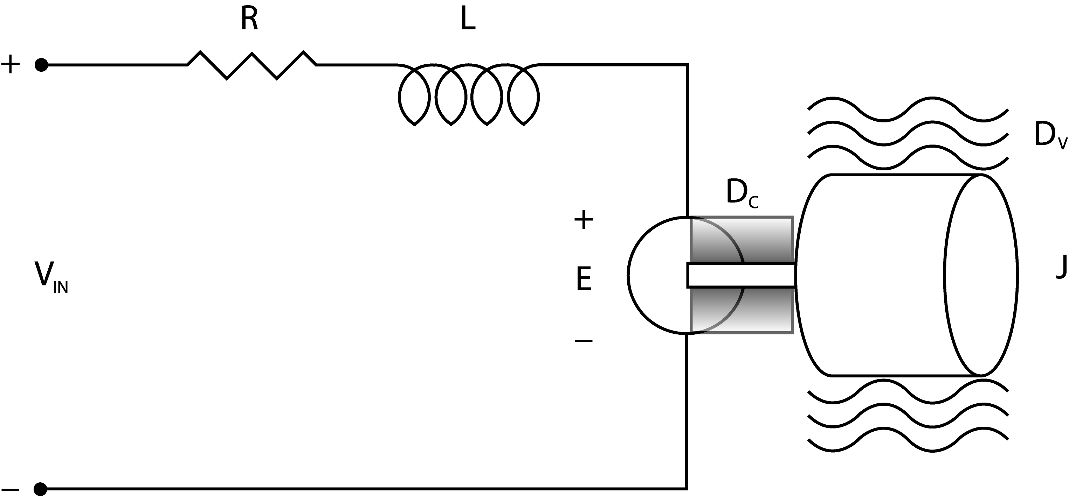
DC motors can be modeled as shown in Figure 1 below. The applied voltage is V_{in}. The copper windings in the motor cause a certain amount of resistance and electrical inductance, labeled R and L. As the rotor spins, a relatively small voltage is induced which is in opposition to the applied voltage. This is known as the back electromotive force, or the back EMF, labeled E in the figure. The back EMF is linearly related to the motor's angular velocity  by the constant K_{e}, which is known as the electric motor constant. Kirchhoff's voltage law around the electrical circuit gives us
Figure 1. Simple schematic of a PM DC motor.
(1)
where I is the current in the motor windings in amps. The output torque of the motor is linearly related to the motor current I by the constant K_{t} as follows:
(2)
where K_{t} is the motor’s torque constant. It can be shown from conservation of energy that K_{t} must be proportional to K_{e}, resulting in the following conversions:
(3)
(4)
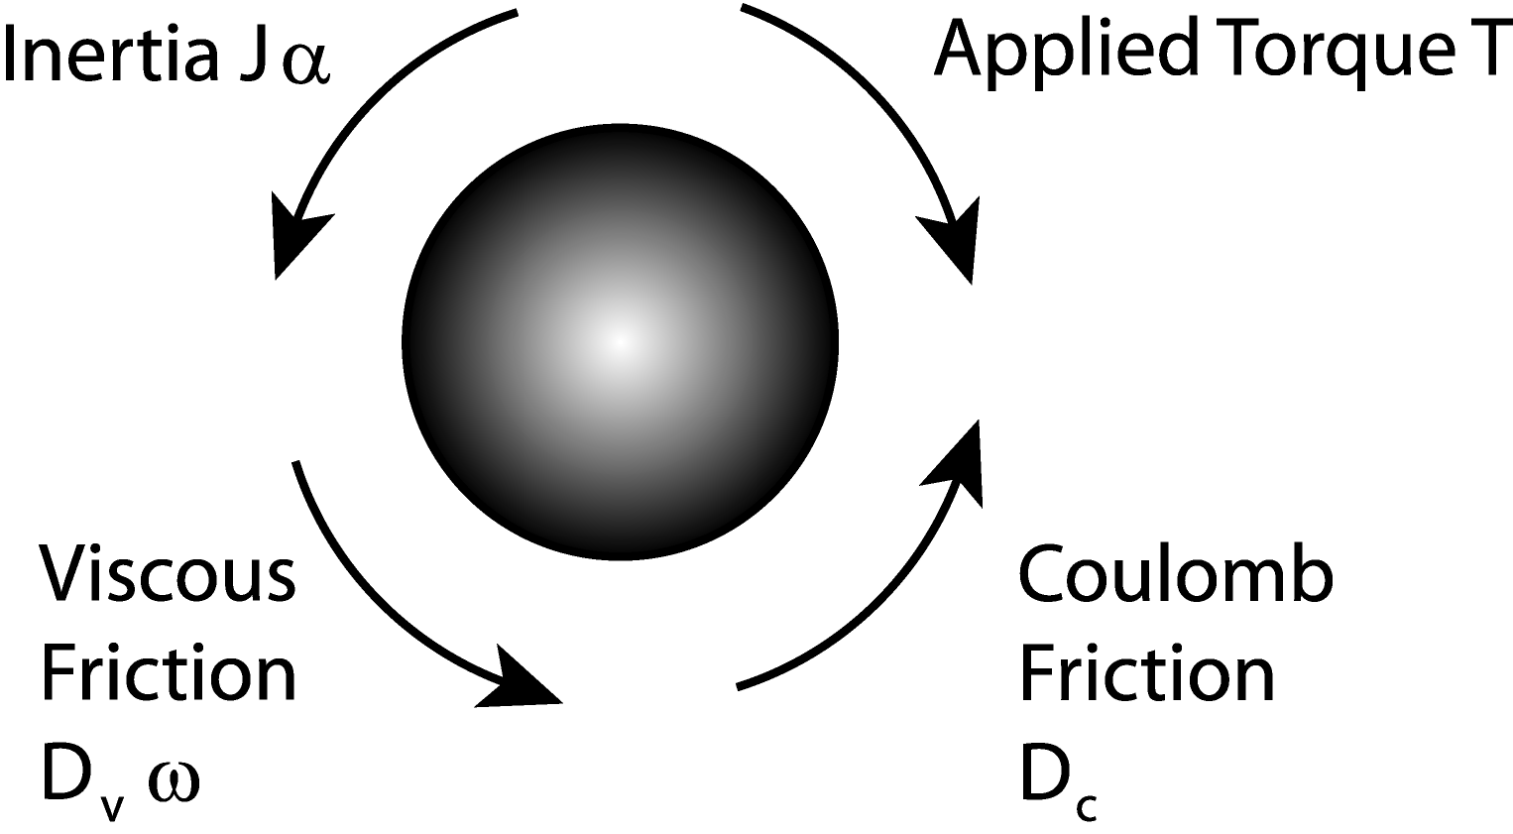
Notice that if SI units are used, the same numeric value is kept for the motor constant. Figure 2 shows a diagram of the torque balance on a motor rotor that has no external disturbance torque. Summing the torques (Kirchhoff's current law) results in:
Figure 2. Mechanical side torque balance.
(5)
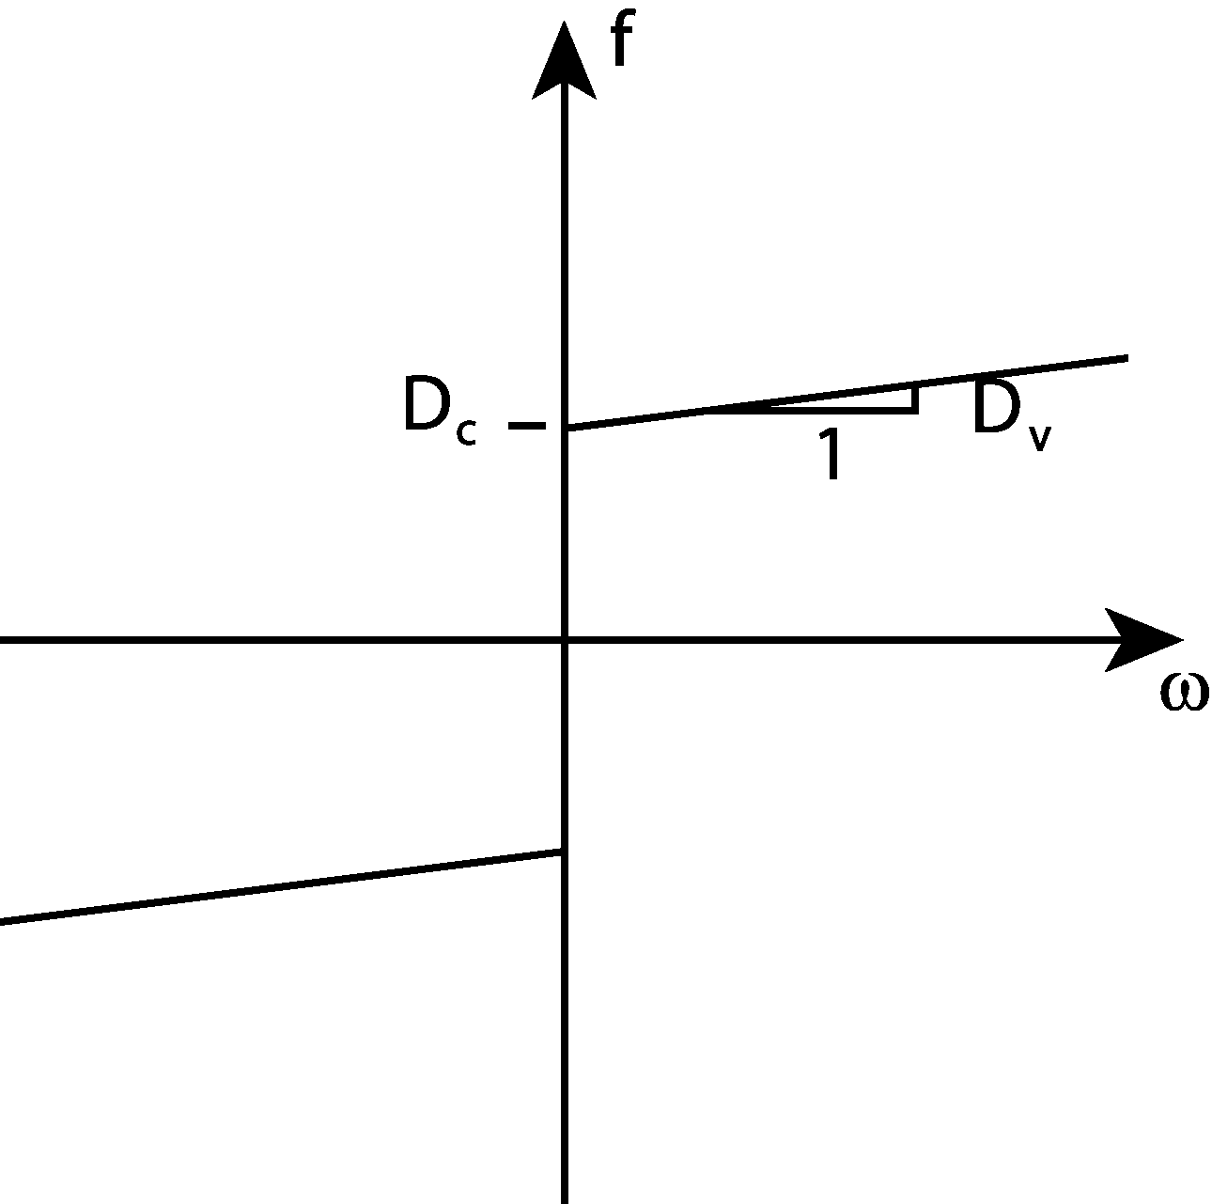
where signum(ω) means “the sign of ω”. In other words, coulomb friction is independent of velocity, but that the sign of D_{c} changes with. As the velocity increases, viscous drag increases the mechanical loss due to friction. Examples of viscous drag include lubrication in the bearings and aerodynamic drag caused by the load moving in air. The friction as a function of speed is depicted in Figure 3. Equation (5) is therefore nonlinear and requires linearization to develop a linear model for the system. When steady-state conditions are satisfied for DC input, the inductance and inertial terms in equations (1) and (5) vanish, leaving the following equations:
Figure 3. Friction versus angular velocity.
(6)
(7)
Note that the tachometer and connection equipment, which are connected to the motor, affects the inertia and friction forces. So do the other components of the structure. The parameters you obtain from this exercise will characterize the whole system, not just the motor. This is known as lumped parameterization.

2) Procedure to experimentally determine R, K_{e}, K_{t}, D_{v} and D_{c}.
In this experiment the computer controls the speed of the motor via the power amplifier found on the lab benches.
- Measure the gain of the power amplifier. Locate the power amplifier's input (V_{ref}), which has a BNC connection. The output of the amplifier is the white and yellow plugs below the word POWER. Use the 5 volts power supply and the potentiometer on the experiment bench to measure the gain of the amplifier at several data points. This value will be used in the experiment to follow.
What is the amplifier’s gain?
- Connect the motor to the computer through the power amplifier. First, connect the power amplifier to the computer via the DAQ as follows. Attach one end of a BNC cable to the V_{ref} connection on the power amplifier. Using a BNC-to-banana plug adapter, connect the other end of the BNC cable to AO_CH0 (blue plug) and ground on the DAQ terminal block. Make sure you reference the grounds between the bench power supply and the DAQ. Next, connect the power amplifier to the motor. Connect the motor leads to the "POWER" amplifier output plugs (white and yellow plugs).
- Connect the tachometer to the computer via the DAQ. Connect the positive lead (red plug) of the tachometer to AI_CH0 (red plug) and the negative lead (blue plug) of the tachometer to the left AI_GND (green plug). Recall that the left ground is for the first row of analog inputs and that the right ground is for the second row of inputs.
- Connect the current sensor to the computer. Underneath the monitor shelf, behind the POWER connection near the black power amplifier box, there is a banana jack connected to a current sensor on the amplifier. This measures the current sent to the motor and gives a voltage output proportional to the current. Connect the "Current Sense" wire to AI_CH1. At this point, make sure that the bench ground it connected to the left AI_GND.
- Check your connections and if unsure, have your TA look over your setup before you turn on the power.
- Open the motor project function. The CVI MOTOR CHARACTERISTIC LAB user interface will appear with two plots and a column of different values.
- In the gain field, check to make sure that the gain you measured for the amplifier is the same as the gain listed. In addition, make sure that the correct input channels are selected for the sensors.
- Turn on the power supply and click on the start button at the lower, center region of the window. The motor should run in increments of 0.1 volts from –5 V to 5 V. After this process two plots will be generated.
- When some acceptable data are collected, save the data by clicking the SAVE button. The data is saved in three different columns corresponding to speed in rad/s, input voltage in volts, and armature current in amps. Keep a copy of the data.
- Manipulate equation (6) to create a line that will give you R and K_{e}. R = Ω. K_{e} = V.s. Use either equation (3) or (4) to get K_{t} including the proper units. K_{t} = . Manipulate equation (7) to create a line that will give you D_{c} and D_{v}. Which friction term dominates? . Based on this, approximate the nonlinear friction as seen in Figure 3 with the dominant friction term. Remember to include the proper units. D = .
3) Measuring the Rotary Inertia, J
The mechanical time constant can be measured by giving the motor a step input. Since the mechanical time constant is much slower than the electrical time constant, the inertia can be calculated by ignoring the inductance effects (L=0) the
(8)
Here mech is the mechanical time constant, which is defined as the time taken by the motor to go from rest to 63% of the final angular speed, and D is the linearized friction.

- Open CVI and run the project C:\CVI\PROGRAMS\LABS\MOTORS\3IN1OUT.PRJ.
- Set the output voltage on the right side of the window so a step input of 10 volts is given to the motor. Recall that the amplifier scales the input sent from the computer by the amplifier’s gain measured earlier in this experiment. The final voltage applied to the motor must be 10 Volts.
- Set channel 0 for display and make sure the other channels are not selected.
- Choose different values for the sampling rate and the number of samples for these different settings. Run the program by clicking on the start button until the step response of the motor can be seen by changing the above values. Make sure that your data does not have aliasing effects.
- Record the sampling rate and number of samples you have in the data. Save the data. Use a plotting program such as Excel or Matlab to plot the data. Graphically determine the mechanical time constant. Recall that the mechanical time constant time constant is defined as the time it takes the motor to reach 63% of the final value. τ_{mech} = sec.
- Use Equation (8) to solve for the lumped rotary inertia. Don’t forget to include the proper units. J = .

4) Measurement of the Rotor Inductance, L
- Lock the shaft of the motor so that it will not turn. The back EMF is zero in this condition.
- Apply a step input (voltage to the motor) and measure the current going into the motor as a function of time. This is done by using the same program as in section 3). This time measure the current going into the motor from the power amplifier by selecting channel 1 to be read. Keep in mind to iteratively set the appropriate sampling rate to avoid aliasing. Run the program as before, only take one lead from the POWER source, and then quickly replace it after pressing START. This is necessary so that you can capture the time when steady-state conditions occur.
- Record the sampling rate and number of samples. Save the data. Use a plotting program such as Excel or Matlab to plot the data.
- Determine the electrical time constant _{elec} from the data. Electrical time constant is defined as the time taken by the current in the motor to go from rest to 63% of the final steady-state current. The motor will not start at time zero, so you must remember to subtract the time before you plugged the lead back into the power supply. The motor inductance can then be calculated by knowing the electrical time constant, _{elec} and the motor resistance R by the following equation.
(9)
L = H.

5) Questions

Show your T.A. how the parameters you derived compare to those supplied by the manufacturer.

- J = 7.0x10⁻⁷ kg.m
- R = 4.84 Ω
- L = 5.324x10⁻³ H
- K_{t} = 1.159x10⁻¹ N.m/A
- K_{e} = 1.159x10⁻¹ V/rad/s
- D_{v} = 5.0x10⁻⁵ N.m/rad/s
- |D_{c}| = 1.39x10⁻² N.m
- D = 2.0x10⁻³ N.m/rad/s

