ME 3210 Mechatronics II Laboratory

Lab 5: First-Order Dynamic Response Thermal Systems

Introduction
The simplest dynamic system is a linear first order system. The time response of a first-order system is exponential. In this lab you will measure the parameters of a simple thermal system, collect data representing the response of the system, determine the time constant for the system, and then use these measured parameters to estimate the time constant a similar but unknown system. The thermal system consists of a temperature source supplying heat to water in an Erlenmeyer flask.

Theoretical Background
The system under investigation for this experiment consists of an Erlenmeyer flask containing water that rests upon an electric hotplate. Given sufficient preheating, the hotplate can be considered an ideal heat flux source q_{s}. A temperature transducer converts the temperature of the water to a proportional voltage signal, which is then measured by the bench DAQ system. Figure 1 presents a schematic of the experimental setup.
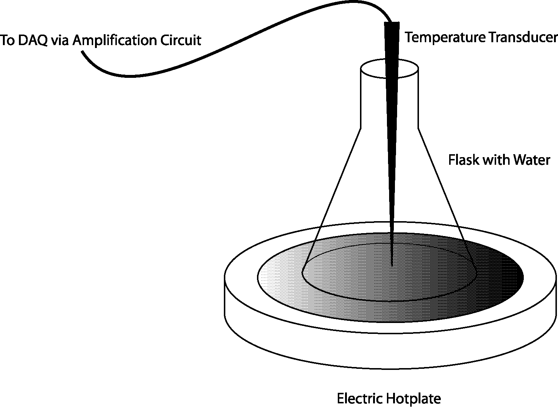
Figure 1: Schematic of the experimental setup for the first-order response exercise.
The water, like all materials, has a heat capacitance C that allows it to store a certain amount of heat energy. The heat capacitance of water is the product of its mass m and its specific heat C_{p} (the amount of heat energy required to raise one kilogram of water one degree Centigrade).
(1)
For the first part of this experiment the mass of the water will be measured directly using an electric balance, and the heat capacitance of the water can then be calculated assuming the following value for the specific heat of water.
(2)
Due to imperfections in the surface of the flask, it is possible that there may be pockets of air between the surface of the hotplate and the water. Although the glass itself is a good thermal conductor, it does offer some resistance to the heat flowing into the water. These combine to form a conduction resistance R_{S} between the temperature source and the water. Heat may also escape the water by passing through the glass and into the atmosphere (convection). For simplicity, we assume that the conduction resistance of the glass and the convective heat loss into the atmosphere can be combined into an effective heat loss resistance, R_{L}. Figure 2 depicts a closer look at the experimental setup and shows the temperature nodes and thermal impedances elements associated with its system model.
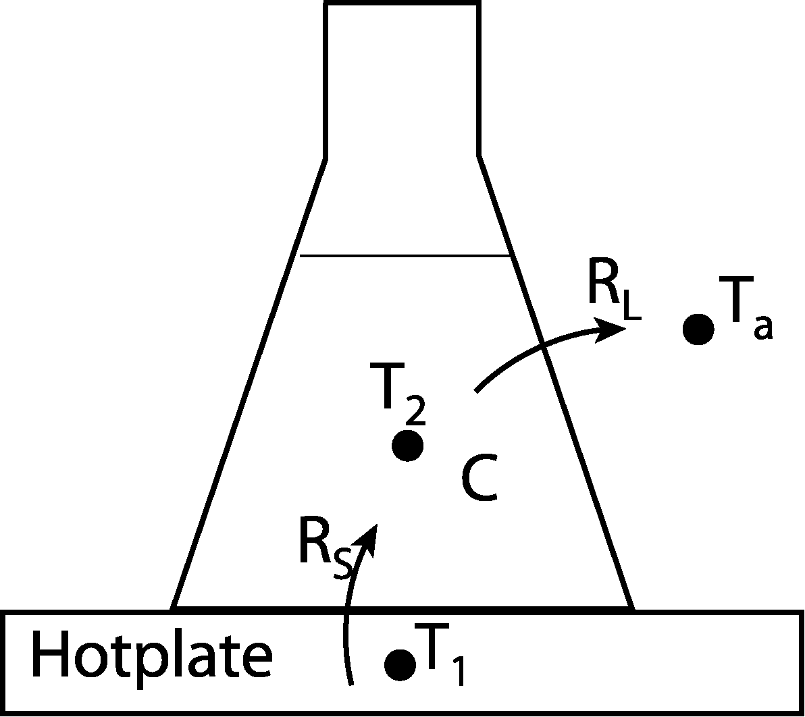  Figure 2: Schematic with measured temperatures  and thermal impedance elements. | Figure 3: Linear graph of the thermal system.

Based on Figure 2 we can draw the linear graph that describes the system as depicted in Figure 3. With the linear graph we can derive the first order transfer function that describes the system response as a function of the input q_{s}.

The step response of a first-order system, like the one examined in this experiment, exponentially approaches a final value (Figure 4). One important parameter that describes how the time response of a dynamic system approaches this steady-state value is the time constant, τ, measured in seconds. Figure 4 shows a generalized first-order response curve and marks the fractional amplitude of the response at each time constant.

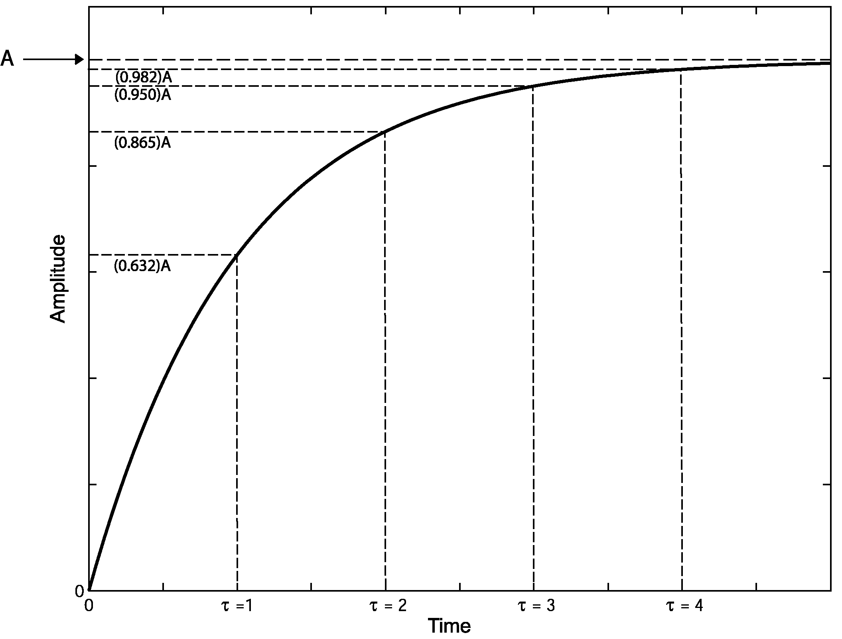
Figure 4: General first-order response with the fractional amplitude at each time constant.

For the thermal system of this experiment the time constant describes the rate at which the temperature of the water, relative to the surrounding air, approaches a steady-state temperature difference.

Semi-log Linear Regression
For the system described in this lab we expect the time constant of the system to be very large (1500–2000s). This provides a problem with measuring the time constant and determining the steady state temperature difference of the system. In order to estimate the final steady state temperature difference we need to collect enough data so that we capture at least four to five time constants (Figure 4 above). If we know the final steady state temperature, then we can estimate the time constant using the relationships in Figure 4. However, if, because of time constraints, we cannot run an experiment long enough to allow the data to approach a steady-state value; how can we determine the time constant and the final temperature? In this case we turn to an analytical approach called semi-log linear regression.

Semi-log linear regression is derived from the general first order time response to a step input. The time response of a generalized first order system is described by the following equation:
(3)
where A(t) is the amplitude as a function of time, A₀ is the steady-state amplitude, τ is the time constant of the system in seconds, and t is the time since the initiation of the step input in seconds. Rearranging Equation 3 yields the following:
(4)
Now taking the natural logarithm of both sides and simplifying of the equation yields the following relationship.
(5)
This result has is similar in form to the equation for a straight line (y = mx + b): where y = ln(A₀ – A(t)), m = –1/τ, and b = ln(A₀). Therefore, if we plot the experimental data in this form we can use linear regression to determine the time constant of the system. However, if the system doesn’t reach steady-state we still don’t know A0; but we can guess a value for A0, perform the semi-log linear regression to determine τ, and verifying the fit by substituting τ into Equation 3 and plotting it on the same axis as the experimental data. Based on the plot a new guess for A0 is chosen and the process is repeated until the theoretical model fits the data collected. This process is often easy to do using a program script written in Matlab like the one provided on the class website (thermoLab.m).

Pre-Lab Exercise

- Derive the transfer function (T_{c}(s)/Q_{s}(s) where T_{c} = T₂–T_{a}) and time response (T_{c}(t)) for the first-order thermal system described in the introduction to this lab (assume a step input for Q_{s}(s) = q₀/s).

- Using this result, derive a symbolic expression for the heat flux source, q_{s}, in terms of (T_{C})_{f} and the mass of the water, m, in terms of τ.

- Use the result from Part a) above to find the time response of water temperature, T₂(t).
Laboratory Exercise:
- Locate a hotplate, plug it in, and switch it on.

- Locate a Fluke 80T-150U Temperature Probe. This sensor converts the temperature experienced at its tip to an output in millivolts proportional to the temperature in degrees Celsius or Fahrenheit (i.e. # of millivolts = °F or °C). Use the temperature transducer and a voltmeter to measure the ambient temperature of the room.
T_{a} = __________________ °C

- Locate an Erlenmeyer flask and measure the mass of the flask using the scale provided; record the value in the space provided.
m_{flask} = __________________ g

- Fill the flask with about 50 ml of water from the container next to the sink, weigh the flask with the water on the scale, and subtract the mass of the flask to determine the mass of the water.
m₁ = __________________ g

- Using a BNC to banana adapter and a BNC cable connect the temperature probe to ACH0 of the DAQ breakout box.

- Using a BNC to banana adapter and a BNC cable connect the negative lead of the EXTREF (black banana) to the negative lead of the temperature probe.

- Open the thermo.vi LabView VI from the LabView folder on the desktop, select the run icon from the toolbar menu (single arrow icon), and set the run time to fifty minutes.

- Place the flask of water on the hotplate, use a test tube clamp to position the temperature probe in the center of the water, and immediately click the ACQUIRE button on the VI.

- While the flask is heating, download the thermoLab.m Matlab script from the class website and save it to your disk.

- Open Matlab, set the current directory to the same location as the thermoLab.m file, and open the thermoLab.m file by typing open thermoLab.m at the command prompt and pressing Enter.

- Examine the thermoLab.m script, take the time to thoroughly understand each line of code, and modify the code in the areas indicated in the comments.

Note: If you don’t understand some of the functions used in the thermoLab.m script type help function at the command prompt, press Enter, and a description of function will print to the screen. If you still don’t understand some part of the Matlab script ask your TA.

- After the fifty minutes is over, save the data file to the directory with the thermoLab.m script using the appropriate button in the LabView VI (use a .dat file extension).

- Make sure the data was saved properly by opening it in some software package such as Matlab or Excel the first column is time in seconds and the second is the temperature T₂ in °C.

- Dump the warm water into the sink, fill the flask with 75-100 ml of room temperature water, place the flask back on the hotplate, replace the temperature transducer, and restart the VI program.

- While the second flask of water is heating , calculate the time constant of the system, the fluid capacitance of the water, the final temperature of the water, and the heat flux source using the thermoLab.m script and Matlab. Record these values in the space provided.
τ₁ = ___________________ s C = ___________________ J/K
T_{2f} = ___________________ °C R_{l} = ___________________ K/W
q_{s} = ___________________ W

- Once the second experimental run has been completed, save the data as before; do not empty the flask yet.

- Use the thermoLab.m script to calculate the time constant, the final temperature of the water, and the predicted mass of the water in the flask; record the values below.
τ₂ = ___________________ s T_{2f} = ___________________ °C
m₂ = ___________________ g (predicted)

- Verify the results of the previous step by weighing the flask with the water in it and subtracting the mass of the flask.
m₂ = ___________________ g (actual)

- Empty the flask in the sink, turn off the temperature probe, clean up your station, and answer the questions at the end of the lab.

Questions
- Compare the predicted mass of the second batch of water to the actual mass. Are they different? If so, suggest at least two un-modeled components of the system that could explain the discrepancy.
- Is a first-order approximation valid for this system? Why or why not?
- Of the three parameters (q_{s}, R_{L}, and C), which does not affect the steady state temperature? Why is the steady state temperature only dependent on the other two parameters?
- How could you reduce the time constant of the system without altering the mass of the water? Suggest at least two methods.

- Describe at least two other first-order systems.

