ME 3210 Mechatronics II Laboratory

Lab 6: Second-Order Dynamic Response

Introduction
Second order differential equations approximate the dynamic response of many systems. In this lab you will model an aluminum bar as a second order Mass-Spring-Damper system.

Second-Order Systems
This laboratory exercise focuses on a second-order mass-spring-damper system formed by an aluminum bar fitted with strain gages. The stiffness of the system is provided by the material properties of the aluminum (Young’s modulus), and the damping is provided by the air drag, and energy dissipation in the aluminum itself. The generalized characteristic equation that describes every second-order system is
(1)
where y is the system output, ζ is the dimensionless damping ratio or damping coefficient, ω_{n} is the undamped natural frequency in radians per second, and f(t) is some forcing function. However, for this lab, the equation of motion that describes the mass-spring-damper system of the aluminum bar is given by the following differential equation:
(2)
The solution to Equation 2 is sometimes referred to as the free response of the system because the system response is not excited by an external force (f(t)=0). There are three different solutions to the free response: underdamped, overdamped, and critically damped solutions. Each depends on the value of ζ. If ζ < 1, then the system is said to be underdamped. For the case of the aluminum bar used in this lab, the damping forces that dissipate the vibrational energy of the system are very small. Therefore we assume that the system is underdamped. The solution to a generalized underdamped system response with a non-zero initial condition is shown below in Figure 1.
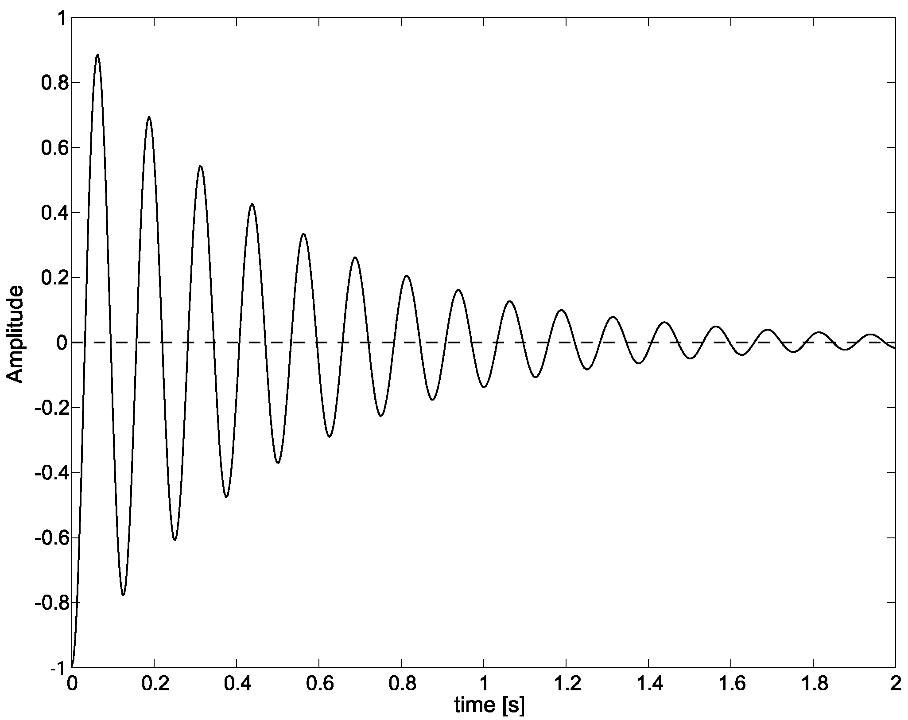
Figure 1: Generalized free response of an underdamped second-order system to non-zero initial conditions.

Determining ω_{n} and ζ Experimentally
One method for experimentally determining the parameters in Equation 1 comes from solving the differential equation and performing some mathematical manipulation. Since the system is unforced only the homogeneous response is needed. The homogeneous solution to Equation 1 is summarized in Equations 2 through 4.
(2)
(3)
(4)
where y₀ is the initial displacement of the end of the aluminum bar and y(t) is the displacement of the end of the bar as a function of time. This solution shows that a decaying exponential scales a sinusoidal oscillation, similar to the response in Figure 1. The time it takes to reach the first peak can be found by taking the time derivative of y_{h} and setting the result equal to zero.
(5)
Since the exponential term theoretically never reaches zero, the time to the first peak can be determined through reduction using trigonometric identities and algebra. This procedure yields the equation for the time to peak, t_{p}, in terms of ω_{n} and ζ.
(6)
The time to peak is measured in seconds. If the system is sufficiently underdamped (ζ < 0.1), then the term under the radical in Equation 6 approaches unity. Therefore we can estimate the natural frequency, ω_{n}, using the following relationship.
(7)
When a system is this underdamped the system response decays very slowly and it often takes a long time before the oscillations settle to a final or steady-state value. Generally, the settling time is defined as the time it takes for the system to enter a region around the system’s final value without leaving. This bounded region is typically defined as a percentage of the steady-state value. For this experiment, the settling time will be defined to be when the system response settles to within 2% of its steady-state value. The settling time can be approximated analytically as the time it takes the decaying exponential of Equation 2 to reach 0.02:
$e^{−{\text{ζω}}_{n}t_{s}}=0\text{.}\text{02}$ (8)
Solving Equation 8 for the settling time, t_{s}, yields the following relationship.
(9)
So, now that we have expressions for the time to peak and the settling time, we can calculate w and z using Equations 7 and 9 by examining the system response and recording t_{s} and t_{p}.

Log Decrement Technique
Another way to calculate ω_{n} and ζ is to use the log decrement technique. This technique is exploits the periodicity of Equation 2 to determine ω_{n} and ζ. The time between successive peaks in the free response of the system is determined by the period, t_{d}, of the cosine function in Equation 2.
$t_{d}=\frac{2π}{ω_{d}}$ (8)
The amplitude of the first peak, which occurs at t_{p}, is defined as x₁. Substituting t_{p} and x₁ into Equation 2 yields the following equation.
(9)
The equation expressing the amplitude of the next peak is:
(10)
Subsequent expressions for amplitude peaks follow this pattern according to the Equation below:
(11)
The ratio of the initial peak to each successive peak is defined by the following expression
(12)
Taking the natural logarithm of both sides of Equation 12 and substituting Equation 8 in for t_{d} yields the following relationship.
(13)
Once again we assume that for small damping ratios the term in the radical approaches unity, resulting in the following:
(14)
This result shows that there is a linear relationship between n and δ(n) that is linearly related to the damping ratio of the system. The damping ratio can be determined through linear regression given values for n and δ(n). The natural frequency, ω_{n}, can then be determined by combining Equations 2 and 8: resulting in the following equation.
(15)

Experiment
- Secure an aluminum bar to the workbench using a large C-clamp.

- Design and build an amplifier circuit like the one in Figure 2 of the Dynamometer I lab. The overall gain should be around 1000. Record the gain below.
k = .

- Determine the relationship between tip deflection and voltage output of your amplifier circuit.

  - Displace the tip of the bar a known distance and measure the output voltage from your circuit.

  - Record the values below.
d = ________________ mm V_{out} = ________________ V

  - Divide d by V_{out} to find the conversion from voltage to displacement. Record the result below:
d/V_{out} = K = ________________ mm/V

- Connect the output from your amplifier circuit to ACH0 of the DAQ terminal block and connect the EXTREF to the common ground of your amplifier circuit.

- Open 2NDORDER.exe from the CVI folder on the desktop.

- Set the sampling rate and number of samples to the appropriate value, deflect the aluminum bar to create an initial displacement in the bar, click the START button, and quickly release the end of the aluminum bar.

- Examine the plot of the data and repeat Step 6 until you capture enough data to capture the moment when a 2% settling time is reached; save the data set with a .dat file extension.

- Open the time and voltage data using Matlab or Excel and plot the data.

- Calculate the natural frequency and damping ratio of the system response using Equations 7 and 9; record the values below:
ζ = ___________________ ω_{n} = ___________________ rad/s

- Determine ζ and ω_{n} using the log decrement technique.
ζ = ___________________ ω_{n} = ___________________ rad/s
Questions

- Is a second-order approximation sufficient to model this system? Why or why not?

- Compare the results from Steps 9 and 10. In your opinion which technique is more accurate? Why?

- Determine the second-order pole locations for the system based on the results from either Step 9 or 10.

- Briefly describe at least two other second-order systems.

