The purpose of this exercise is to study the effects of a PID controller on a motor-load system. Although not a second-order system, a PID controlled motor-load system can be approximated as such with good accuracy. The motor-pendulum system will be examined, and the PID controller will be implemented using CVI Lab Windows.

Pre-lab Exercise Derive the open-loop transfer function for the motor-load system from input voltage to angular position. Neglect inductance effects. Derive the closed-loop transfer function with controller transfer functions G_{c}(s) = K_{p}, G_{c}(s) = K_{p} + K_{d}s, and G_{c}(s) = K_{p} + K_{d}s + K_{i} /s.

(Hint: If you derive the transfer function with the last controller first, the other controllers can be realized easily by setting the appropriate control gains to zero.)

Background In this experiment we will explore the time response characteristics of the motor-pendulum system in a closed loop configuration with various PID controller configurations. The block diagram for the experiment is provided in Figure 1 below.
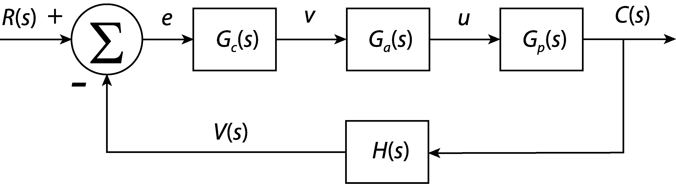
Figure 1. Feedback control loop for the PID experiment.
In this figure, the reference R(s) is provided by CVI as a step of magnitude 1.5 volts from the 0.9 volt initial state. The feedback gain H(s) converts angular position to a voltage signal using a potentiometer. Its value is approximately 1 volt per radian. This signal is fed to the DAQ terminal block. CVI subtracts the signal from the reference to get the error e, which is then input to the compensator G_{c}(s). The PID controller is then provided by the computer. The compensator’s transfer function is given by:
You will be able to adjust the gains using CVI. CVI then outputs a signal v to the bench power amplifier. The bench power amplifier is denoted by G_{a}(s), and its low frequency gain is approximately 4. It is assumed that the power amplifier is a zero-order system because its time constant is so fast, but it is really a first order system whose dynamics are dominated by the rest of the system. The power amplifier sends the control signal u, which causes the motor to turn. The angular position is denoted C(s). This is converted to a voltage by a potentiometer, as noted before. The piece missing from this puzzle is the transfer function of the motor-load system, or plant. Here we revisit the motor characteristics exercise. In the exercise, we learned that the motor-pendulum system has the characteristics shown in Figure 2 below.
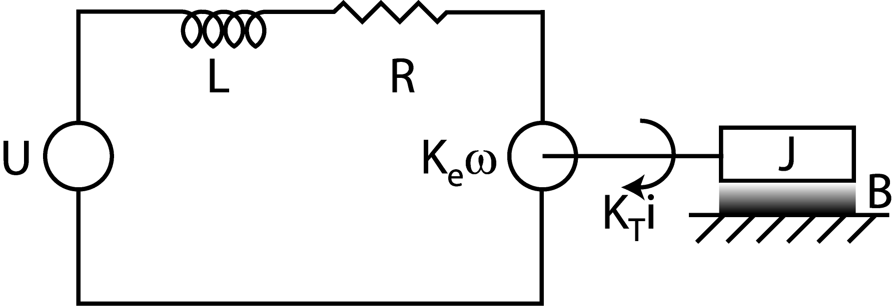
Figure 2. Motor-load system schematic.
We learned that the inductance has a relatively fast time constant associated with it. Because of this, it lends little to the overall time response of the system and can thus be neglected. The derivation of the transfer functions of the systems in Figures 1 and 2 are left to the students as the pre-lab exercise.

Setup You will make a position control system using a motor driven pendulum, a potentiometer to measure angle, and a computer to provide the control. Connect the bench power amplifier input “V_{ref}” to analog output channel 0 (AO_CH0) and ground (AO_GND), and then connect the leads of the motor to the output of the bench power amplifier. Connect the potentiometer pin 1 to +5 volts, pin 3 to ground, and the wiper (pin 2) to analog input channel 0 (AI_CH0). Connect the power supply ground to AI_GND.

Have your TA check your wiring before proceeding. Start the PID program from the CVI folder on the desktop. Ensure that the weights are adjusted so that the pendulum-system is balanced about the motor shaft. Using a voltmeter, adjust the pendulum such that pin 2 of the potentiometer measures 0.9 volts. You must start at this position for each run to follow.

- Effect of proportional gain K_{p}
- Turn the integral and differential gains to zero.
- Starting with a proportional gain of 0.2, give the system a step input by clicking on the “GO” button.
- Incrementally increase the proportional gain by 0.2 and repeatedly run the program until the system behaves oscillatory.
- Once the system becomes oscillatory, continue increasing the gain by increments of 0.3, recording the time-to-peak T_{p} and the percent overshoot %OS. Also record the settling time T_{s}, the rise time T_{r}, the peak output C_{max}, the steady-state output C_{ss}, and the steady-state error e_{ss}. Use a 2% settling time, and recall that rise time is commonly defined as the time it takes for the response to go from 10% to 90% of the final value. Continue until the maximum gain is reached, repeating the measurements for each value of K_{p}. Record your data in Table 1 below.

(Note: If more accuracy than measuring on the screen is desired, click the “Write to File” button to write the data to a DAT file. The data is saved in three columns. The first column is time, the second is the potentiometer signal, and the third column is the step input generated by CVI.)

Table 1. Response characteristics for varying K_{p}. K_{i}=K_{d}=0.
K_{p} | T_{p} | T_{r} | T_{s} | C_{max} | C_{ss} | %OS | e_{ss}

How does increasing the proportional gain affect system response? What are the tradeoffs?

- Approximate the motor-load as a second-order system by accomplishing the following. Calculate the natural frequency and damping ratio for each gain setting (recall the lab exercise on second-order systems). This time, the system is not nearly as underdamped as the other was, so the damping ratio ζ should be calculated according to the following expression:
$ζ=\frac{−\text{ln}\left(\text{\%}\text{OS}\text{100}\right)}{\sqrt{π^{2}+{\text{ln}}^{2}\left(\text{\%}\text{OS}\text{100}\right)}}$ (1)
where %OS is the percent overshoot. The time to peak T_{p} can be used to find the natural frequency ω _{n}:
(2)
It would be wise to enter the numbers from the previous table into an Excel spreadsheet to help with these calculations.
- Using your spreadsheet, calculate the real and imaginary parts of the dominant roots from natural frequency and damping ratio. For a second-order system, the roots are located at the following coordinates:
$\text{Real Part }=−{\text{ζω}}_{n}\text{, Imaginary Parts }=±ω_{n}\sqrt{1−ζ^{2}}$ (3)
- Plot these roots on the real and imaginary axes (on a separate page) and indicate the direction in which the roots move while K_{P} increases. What pattern emerges?

(2) Effect of derivative gain K_{d}
Set the proportional control to 1.5 and vary K_{d}. Measure the system response characteristics for each value of K_{d} and enter them into Table 2 below. (Hint: You should choose K_{d} = 1 as one of your data points for later.)
Table 2. Response characteristics for varying K_{d}. K_{p}=1.5. K_{i}=0.
K_{d} | T_{p} | T_{r} | T_{s} | C_{max} | C_{ss} | %OS | e_{ss}

What effect does the derivative gain have on system response? What are the tradeoffs?

(3) Effect of integral gain K_{i}
Choose K_{p} = 1.5, K_{d} = 1.0, and set the integral control to 0.001. Record the system response data below. Incrementally increase the integral gain until the maximum is reached, recording your measurements as you go.
Table 3. Response characteristics for varying K_{i}. K_{p}=1.5. K_{d}=1.0.
K_{i} | T_{p} | T_{r} | T_{s} | C_{max} | C_{ss} | %OS | e_{ss}
0.001
0.002
0.003

What happens as the integral gain is increased?

(4) Find the transfer function experimentally
With K_{p} = 1.5, K_{d} = 1.0, K_{i} = 0, find the transfer function of the closed loop system. Assume that a second order approximation is appropriate for the response.

G(s) = .

(5) Higher order effects
What higher order dynamic effects have been neglected in our analysis? When would they need to be considered?

