ME 3210 Mechatronics II Laboratory

Lab 7: PID Controllers

Introduction
The purpose of this exercise is to study the effects of a PID controller on a motor-load system. Although not a second-order system, a PID controlled motor-load system can be approximated as such with good accuracy. The motor-pendulum system will be examined, and the PID controller will be implemented using CVI Lab Windows.

Background
In this experiment we will explore the time response characteristics of the motor-pendulum system used in the motor characteristics lab in a closed loop configuration with various PID controller configurations. The block diagram for the experimental system is provided in Figure 1 below.
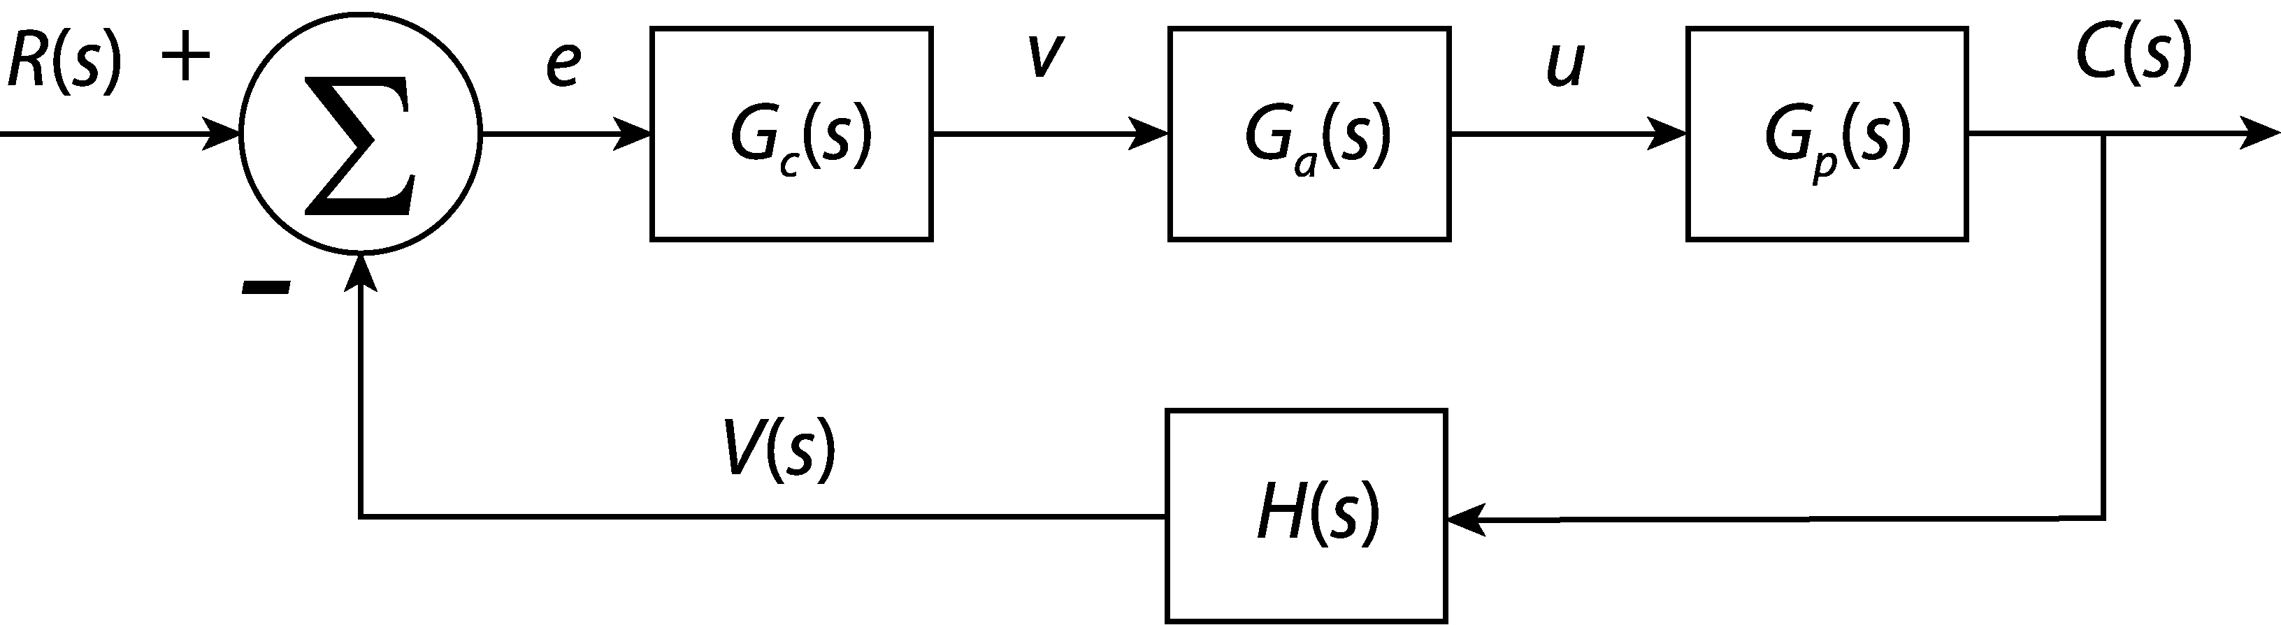
Figure 1: Feedback control loop for the PID experiment.
The reference, R(s), is provided by the DAQ as a step input of 1.5 volts from the 0.9-volt initial state. The feedback gain, H(s), converts angular position, C(s), to a voltage signal using the setup’s potentiometer; approximately 1 volt per radian. This signal is fed to the DAQ terminal block and the CVI program subtracts the feedback signal from the reference to determine the error, e, which is then fed into the PID controller, G_{c}(s). Then, using the CVI program, the computer calculates the appropriate voltage output, v, using the following transfer function.
(1)
where K_{p}, K_{i}, and K_{d} are the proportional, integral, and derivative gains. These gains can be adjusted using the CVI program used in this lab. The controller signal, v, is fed into the bench power amplifier, G_{a}(s), whose low frequency gain is approximately 4. We assume that the power amplifier is a zero-order system because its time constant is so fast, but it is really a first order system whose dynamics are dominated by the rest of the system. The power amplifier sends the control signal u, to the plant, G_{p}(s), which causes the motor to turn and alter C(s). This process is repeated until a steady-state value for C(s) is reached.

The piece missing from the system of Figure 1is the transfer function of the motor-load system, or plant. Here we revisit the motor characteristics exercise. In the exercise, we learned that the motor-pendulum system has the characteristics shown in Figure 2 below.
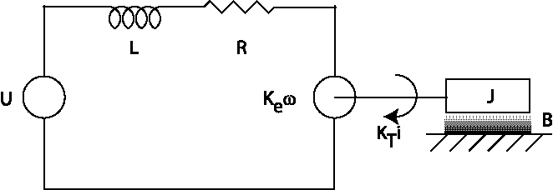
Figure 2: Motor-load system schematic.
We learned that the inductance has a relatively fast time constant associated with it. Because of this, it lends little to the overall time response of the system and can thus be neglected. The derivation of the transfer functions of the systems in Figures 1 and 2 are left to the students as the pre-lab exercise.

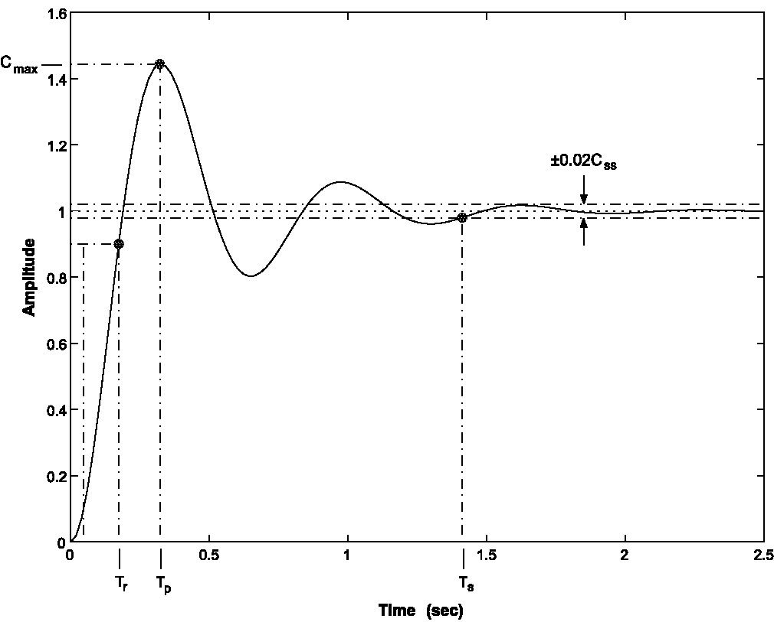
Figure 3: Second-order step response

Second Order Response Characteristics
Figure 3 shows a typical underdamped second-order response to a step input and some of the system response characteristics. These response characteristics can be used to determine the damping ratio and natural frequency of the system. These response characteristics and their definitions are summarized in the following table.

Table 1: Second-order response characteristics.
Name | Symbol | Definition
Rise Time | T_{r} | Time required for the system response to initially rise from 10% to 90% of the steady-state value (measured in seconds).
Time to Peak | T_{p} | Time required for the system to reach the peak system response, C_{max} (measured in seconds).
Settling Time | T_{s} | Time required for the output to settle to within 2% of the steady-state value (measured in seconds): see Figure 3.
Steady-State Value | C_{ss} | The final value of the system response as time approaches infinity.
Peak Response | C_{max} | The maximum amplitude of the system.
% Overshoot | %OS
Steady-state Error | e_{ss} | The difference between the input and the steady-state value.

If the system is underdamped the damping ratio ζ may be calculated using the following expression:
(2)
The time to peak, T_{p}, can then be used to find the natural frequency ω_{n}:
(3)

Pre-lab Exercise
- Derive the open-loop transfer function for the motor-load system from input voltage to angular position. Neglect inductance effects.

- Derive the closed-loop transfer function with the following controller transfer functions:
● ,
● , and
● .
(Hint: If you derive the transfer function with the last controller first, the other controllers can be realized easily by setting the appropriate control gains to zero.)

Laboratory Exercise
You will make a position control system using a motor driven pendulum, a potentiometer to measure angle, and a computer to provide the control.

- Connect the bench power amplifier input “V_{ref}” to analog DACCOUT0 and connect the leads of the motor to the output of the bench power amplifier.

- Connect pin 1 of the potentiometer attached to the motor output to +5 volts, pin 3 to ground, and the wiper (pin 2) to ACH0.

- Connect the EXTREF port of the DAQ to the ground of the bench power supply; have your TA check your wiring before proceeding.

- Open the PID.exe program from the CVI folder on the desktop and ensure that the weights are adjusted so that the pendulum-system is balanced about the motor shaft.

- Using a voltmeter to measure the voltage between pin 2 of the potentiometer and ground, adjust the pendulum until the potentiometer measures 0.9 volts.

- You must start at this position after each time you run the CVI program.

Effect of The Proportional Gain, K_{p}
- Set the integral and differential gains to zero.

- Set the proportional gain to 0.2, and give the system a step input by clicking on the “GO” button.

- Incrementally increase the proportional gain by 0.2 and repeatedly run the program until the system response starts to respond like the exhibited in Figure 3 below.

- Save the data from the previous step with a meaningful filename corresponding to the value of K_{p} (for example if K_{p} = 1.2 the filename could be “Kp_1p2.dat” or “propor_1p2.dat”).

- Continue increasing K_{p} by increments of 0.3 for eight more data sets. Save each data set and fill Table 2 with the appropriate response characteristics corresponding to each value of K_{p}.

Table 2: Response characteristics for varying K_{p} with K_{i} = K_{d} = 0.
K_{p} | T_{p} | T_{r} | T_{s} | C_{max} | C_{ss} | %OS | e_{ss}
- Create a spreadsheet of the data in Table 2 and calculate the natural frequency and damping ratio for each gain setting using Equations 2 and 3.

- Using your spreadsheet, calculate the real and imaginary parts of the dominant roots from natural frequency and damping ratio. For a second-order system, the roots are located at the following coordinates:
(4)
- Plot these roots on the real and imaginary axes and indicate the direction in which the roots move while K_{P} increases. What pattern emerges?

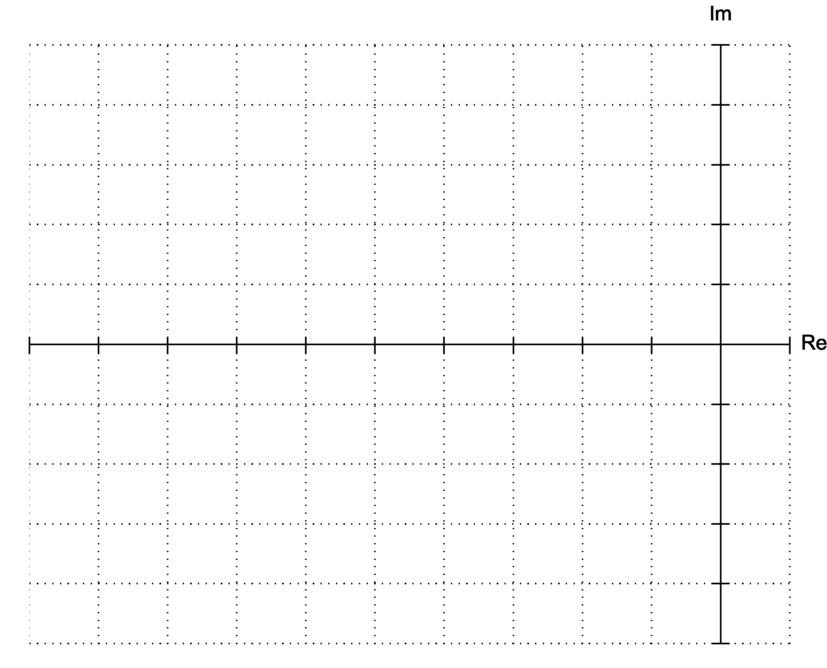

Effect of The Derivative Gain, K_{d}
- Set the proportional control to 1.5 and vary K_{d}. Measure the system response characteristics for each value of K_{d} and enter them into Table 3 below. (Hint: You should choose K_{d} = 1 as one of your data points for later.)
Table 3: Response characteristics for varying K_{d} with K_{p}=1.5 and K_{i}=0.
K_{d} | T_{p} | T_{r} | T_{s} | C_{max} | C_{ss} | %OS | e_{ss}

Effect of integral gain K_{i}
- Set K_{p} = 1.5, K_{d} = 1.0, K_{i} = 0.001 and click “GO”. Save the data as before and record the system response data in Table 4 below.
- Incrementally increase the integral gain until the maximum is reached, recording your measurements as you go.
Table 4: Response characteristics for varying K_{i} with K_{p}=1.5 and K_{d}=1.0.
K_{i} | T_{p} | T_{r} | T_{s} | C_{max} | C_{ss} | %OS | e_{ss}
0.001
0.002
0.003

Questions
- How does increasing the proportional gain affect system response? What are the tradeoffs?

- What effect does the derivative gain have on system response? What are the tradeoffs?

- What happens as the integral gain is increased?

- With K_{p} = 1.5, K_{d} = 1.0, K_{i} = 0, find the transfer function of the closed loop system. Assume that a second order approximation is appropriate for the response.
G(s) =

- What higher order dynamic effects have been neglected in our analysis? When would they need to be considered?

