ME3210 Mechatronics II Laboratory

Lab 05: TA Key for First Order Pre-Lab Exercise
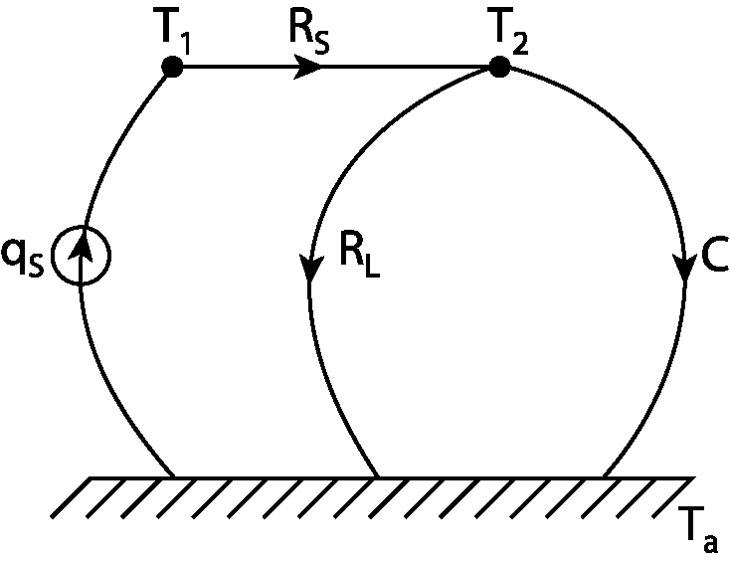
Figure 1: Linear graph of the first-order thermal system.
This is the linear graph for the thermal system for the first-order lab. The nodes T₁, T₂, and T_{a} are measured directly. The reference temperature, T_{a} is room temperature and is assumed to remain constant. The heat flux source, q_{s}, represents the heat transfer rate from the hot plate. T₂ is the temperature of the water measured by the temperature probe. The shaded equations indicate the solutions asked for in the pre-lab.

Part a)
Q: Derive the transfer function (T_{c}(s)/Q_{s}(s)) and time response (T_{c}(t)) for the first-order thermal system described in the introduction to this lab (assume a step input for Q_{s}(s) = q_{s}/s).

Part 1: The transfer function
Apply KCL at the T₂ node:
(1)
Substitute the following relationships:
(2)
(3)
(4)
The result of this substitution is:
(5)
For convenience, define T_{C} = T₂–T_{a} and simplify:
(6)
Take the Laplace Transform of Equation 6:
(7)
Rearranging the equation to find the transfer function T_{c}(s)/Q_{s}(s):
(8)

Part 2: The Time Response
Assuming the step input mentioned in the problem statement and substituting it into Equation 8 yields:
(9)
Use partial fraction expansion to separate Equation 9 into an expression that is a sum of two fractions that satisfy the following equation.
(10)
Multiplying by the denominator of the right side of Equation 10 yields:
(11)
For Equation 11 to be true the coefficients of s on both sides of the equation must be equal. This fact gives rise to the following set of simultaneous equations:
(12)
Solving for A and B yields:
(13)
Substituting this result into Equation 10 yields:
(14)
Taking the inverse Laplace Transform of Equation 14 gives us the time response.
(15)
Equation 15 reveals two important relations for the final temperature and the time constant (you will need these later).
(16)
(17)

Part b)
Q: Using this result, derive a symbolic expression for the heat flux source, q_{s} and the mass of the water, m.

The easiest way to determine the heat flux source is to use Equation 16 (assume the time response has reached steady state).
(18)
To determine a symbolic expression for the mass of the water you must use Equation 1 from the lab handout.
(19)
where C_{p} is the specific heat of water. Combining Equations 17 and 19 gives us m.
(20)

Part c)
Q: Using the result from Part a) above to express the time response of the system as a function of the measured temperatures T₂, and T_{a} as shown in the Linear graph of the system.

This result is almost trivial, but it will be important for when they are entering in the expression needed in the Matlab script that compares the predicted results to the data (lines 34 and 75 of thermoLab.m). Begin by substituting Equation 16 into Equation 15:
(21)
Now use T_{C} = T₂–T_{a} to find the solution.
(22)

